**Barking up the wrong tree! 98% of us can't name five common species from looking at pictures of their foliage**

* **Only one in 50 people were able to identify five varieties of tree**
* **5 per cent could identify five common shrubs and 34 per cent recognised five common wild flowers**
* **TV gardener Alan Titchmarsh says its 'worrying' next generation cannot identify different types of plant**

The survey of more than 2,000 people for BBC Gardeners’ World Magazine found that over-55s were generally much better at identifying plants than the young.

Women scored higher than men on all of the plants they were quizzed on.

If you struggle to distinguish an ash from a birch, don’t worry – you are not alone.

When it comes to identifying some of Britain’s most common types of foliage, it seems many of us are barking up the wrong tree.

Just one in 50 people were able to identify five tree varieties in a study.

In a sign of modern society’s separation from nature, 98 per cent failed to give all of the correct names when shown pictures of the various species.

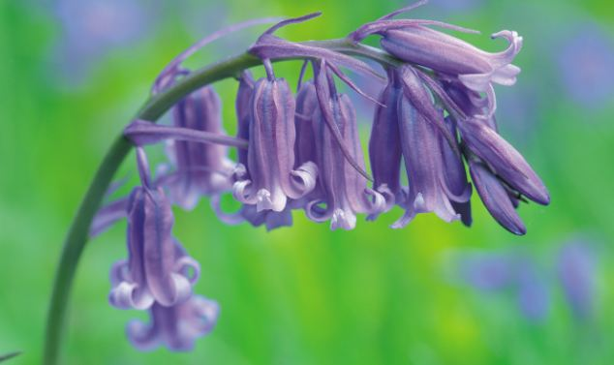

+2

**Some respondents to the survey weren't able to identify some of the UK's most common flowers such as bluebells, pictured**

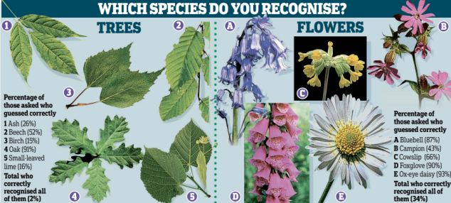

**The species of flowers and trees that people failed to correctly recognise in a survey for Gardeners' World Magazine**

Only 5 per cent could identify five common shrubs, while 34 per cent recognised five native wildflowers.



+2

**Television gardener Alan Titchmarsh warned many people were now more familiar with technology than common plants**

Television gardener Alan Titchmarsh warned many people were now more familiar with technology than common plants. He said: ‘It is worrying that the next generation is not being awakened to the delights of the great outdoors – once common knowledge but now a mystery to millions more familiar with Facebook and Twitter.

‘I was born in an age when tweeting was something sparrows did and a mouse was something that made a hole in your skirting board. If we have no knowledge of the world around us how are we to defend its future properly?’

Among trees, the oak was the most recognised, with nine out of ten correctly identifying it. But only 15 per cent could name a birch and just 16 per cent recognised a small-leaved lime. Daisies were the best known flowers, with 93 per cent of people correctly identifying them.

The most recognisable shrub was an elder, correctly named by 60 per cent of respondents. Lucy Hall, editor of BBC Gardeners’ World Magazine, said: ‘We seem to be losing touch with nature.

Things that used to be common knowledge and part of our common folklore seem to be passing people by.’