ANTALYA
Antalya is the eighth most populous city in Turkey and the capital of its eponymous province. Located on Anatolia's flourishing southwest coast bordered by the Taurus Mountains, Antalya is the largest Turkish city on the Mediterranean coast with over one million people in its metropolitan area.
The city that is now Antalya was first settled around 200 BC by the Attalid dynasty of Pergamon, which was soon subdued by the Romans. Roman rule saw Antalya thrive, including the construction of several new monuments, such as Hadrian's Gate, and the proliferation of neighboring cities. The city has changed hands several times, including to the Byzantine Empire in 1207 and an expanding Ottoman Empire in 1391. Ottoman rule brought relative peace and stability for the next five-hundred years. The city was transferred to Italian suzerainty in the aftermath of World War I, but was recaptured by a newly independent Turkey in theWar of Independence.
Antalya is Turkey's biggest international sea resort, located on the Turkish Riviera. Large-scale development and governmental funding has promoted tourism. A record 12.5 million tourists passed through the city in 2014
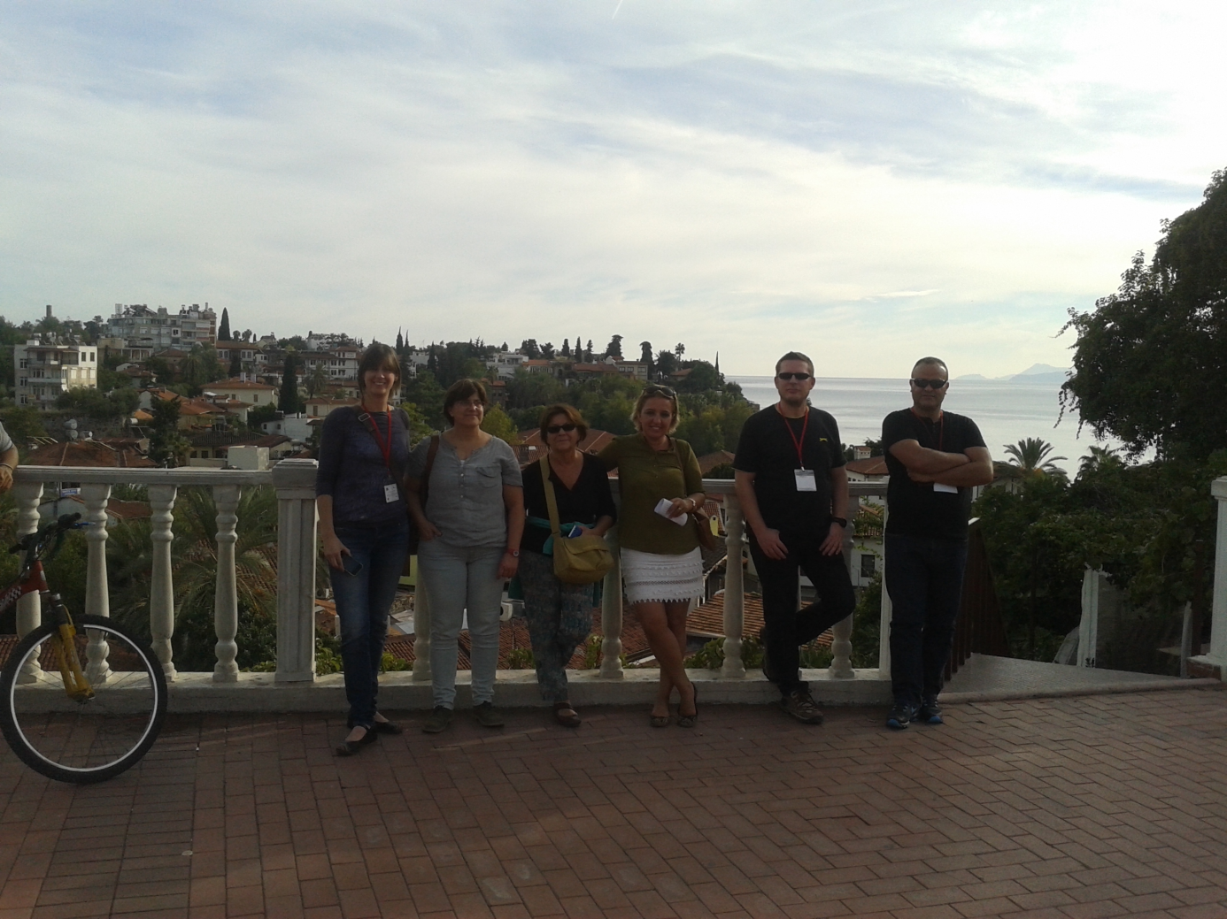

Internatıonal Sand Sculpture Festıval
Every year since 2006 there has been an International Sand Sculpture Festival held in Antalya.
It is organized by Global Design Art Works considered to be one of the largest Sand Events in the world due to the size of the sculptures and the space it occupies. The sculptors who come from all over the world use approximately 10,000 tonnes of sand in an area of 7,000 square metres.
The exhibition is visited by thousands of people and is supported by the Ministry of Culture and Tourism, Antalya Municipality, the Antalya Journalists Association as well as many other organizations in the area.
For the first four years there was a different theme that tied the sculptures together but for the past two years the theme has been Hollywood with models such as Star Wars, Toy Story, E.T, Raiders of the Lost Ark and Shrek to name but a few.
There is even an area set aside where adults and children can learn for themselves some of the techniques used in this form of creative expression.
The sculptures are made using only sand and water although the type of sand is very important. Rough grained sand from the Beach makes working with it difficult, so a lot of sand is brought in from rivers and mountain streams as the particles are smoother.
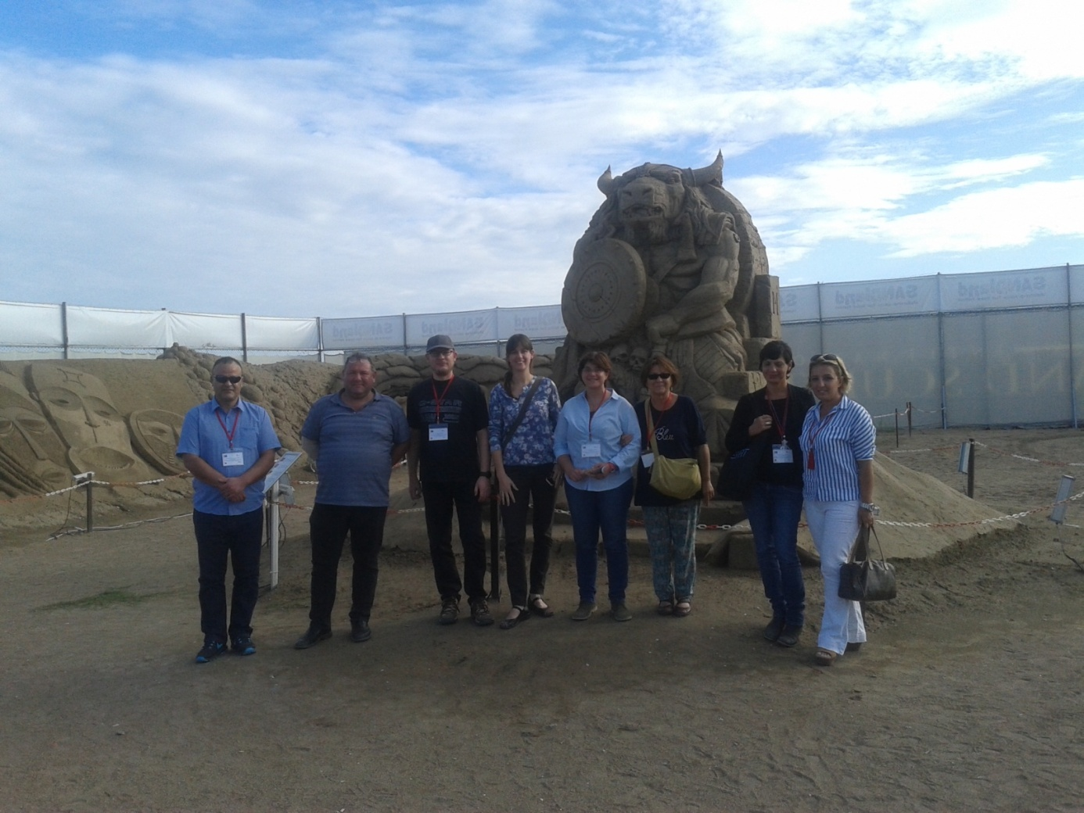

Aspendos Theater has survived to our day fairly undamaged and Aspendos became famous with this theater. This structure with an extraordinarily perfect acoustics hosts every year international and local concerts and festivals. The king of Aspendos announces that he will organize a competition to see who will serve much for the city and says that the winner will marry with his daughter. The artisans who hear this immediately start studying. Finally when the deadline comes, the king analyses everyone’s effort one by one and chooses two candidates. First candidate successes to bring water to the city from far corners of the city by the help of water canals.
The second candidate builds a theatre. When the king is about to decide on the first candidate he wants to analyse theatre for the last time. While he is walking about the top floor of the gallery he hears a voice calling from deep and continuously saying: “the daughter of the king must be mine”. Amazed by the event he searches for the voice but is unable to find where it comes from. This person is absolutely the architect of the theatre who is so proud of the acoustic of his masterpiece and talking on the scene in a feeble pipe. At the end, the architect wins the beautiful daughter and the wedding ceremony is held on this theatre.
This story is about the most important antique work of Aspendos Antique Theatre.
Aspendos, situated near Eurymedon river is founded by Aka civilization in 10 BC. and is one of the richest cities of the antique age. The theatre in here is built up by Roman in 2 AC.
There are 21 seats above and 20 below. In order for the audience not to have difficulty when they are seated stairs were made spreading to the top, while the stairs beginning from the orchestra stage below is 10, this number is 21 at the top beginning of the above diazoma.
The most attractive element of the theatre is it structure. On the first floor of this double-storied building which is made of piled stone there are five doors for the players to come on the scene. Of these doors the big one in the middle is known as porta regia, and the other four- placed two on the left and two on the right is known as porta hospitals. The small doors lined on the orchestra are belongs to the corridors of the cages of wild animals. From the remaining stones it is understood that triangle and half-circle shaped small sculptures and niches for the walls were placed on the ornamental walls.
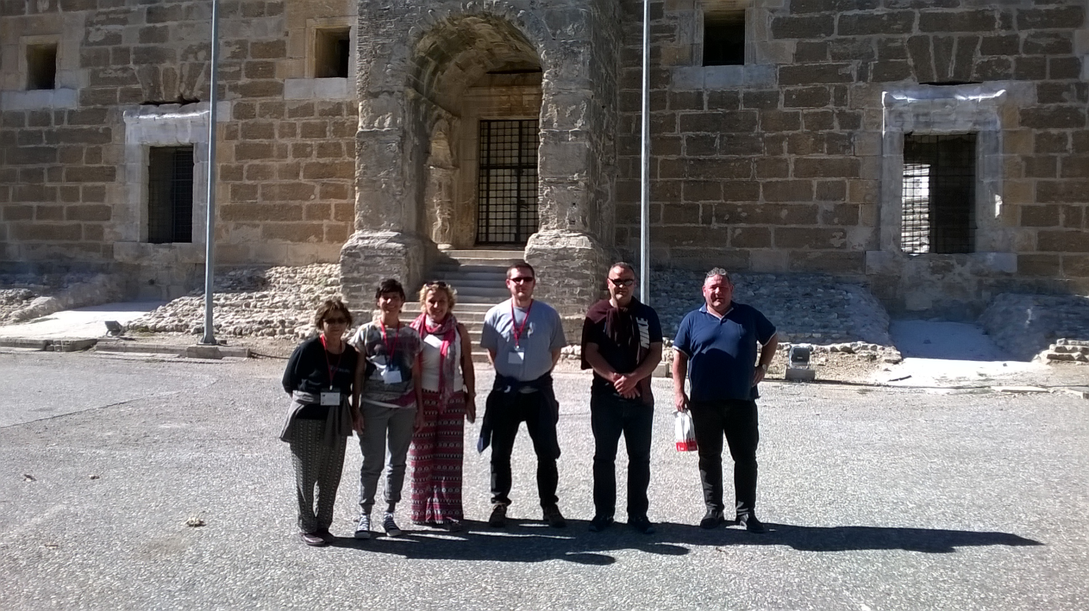

Side (meaning pomegranate) is located in the region of Pamphylia in Anatolia.
One of the first things you notice on arrival at the site is that modern Side is a tourist town Side has a history of great influence and personality. In 333 BCE, Alexander the Great occupied the site and introduced the population to Hellenistic culture which became the dominant tradition until the 1st century BCE. Ptolemy later overtook the site when he declared himself king of Egypt in 305 BCE. Side stayed under Ptolemaic control until it was captured by the Seleucid Empire in the 2nd century BCE. Side was freed from the control of the Seleucid Empire after the defeat of Hannibal and Antiochus the Great. Despite conflicts and changes in control, Side remained prosperous and even minted its own money from 188 BCE to the end of the 1st century BCE. In the 1st century BCE, Side also became an important base for the Cilician pirates and their slave trade and profited from this. With the defeat of the pirates, Side fell under the control of Rome and became part of the Roman Empire. Side began to decline around the 4th century CE with an influx of mountain invaders. It had prosperity on and off through the next few centuries before being abandoned around the 12th century CE.
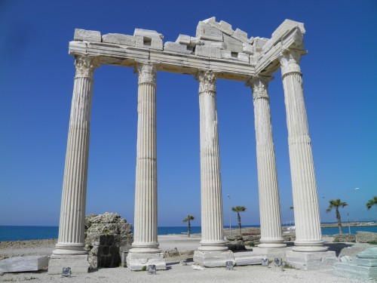
Temple of Apollo, Side

ARCHAEOLOGICAL SITE
Side is a site with a long history which has left behind numerous buildings and ruins for us archaeology and history fanatics to explore. The most complete ruin at Side is the theatre complex which is the largest in the Roman style in the region. The city walls also remain alongside the Hellenistic main gate. There are also the remains of a Byzantine hospital and a basilica and three temples. An aqueduct (probably supplied by water from the Melas River) and nymphaeum (an elaborate fountain building spanning three stories and decorated with marble reliefs) can also be seen in a fair state of preservation near the city gates.
The state agora is still visible within the sand dunes of the eastern beach at Side. There may also have been a library at this site. The ancient harbour was constructed during the Hellenistic period and is located on the southeast part of the peninsula next to the temples of Athena and Apollo which are still standing in part on the beaches of Side.
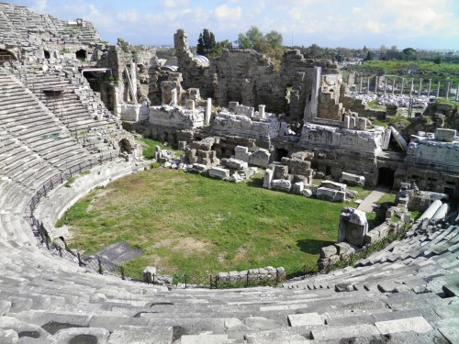
Roman Theatre, Side

The statues are well preserved and the inscriptions well cared for and readable. There are a number of amphorae which have been recovered from the waters around Side and some fragmented displays of the Sidetan language (mentioned previously) which remain undeciphered.

