SMALL HEATH SCHOOL SIXTH FORM CENTRE
Small Heath School & Sixth Form Centre is a Foundation and an Inner-City split co-education 11-18 comprehensive school. It was established in 1983 by the amalgamation as part of the re-organisation of secondary education in Birmingham. The majority of pupils at Small Heath Secondary School are from ethnic minority backgrounds providing the school with multilingual, multicultural classes which can be used as a starting point for learning and generates an awareness of language diversity and an appreciation of differing cultural values.
Small Heath School puts Internationalism at the heart of its curriculum and has a strong commitment to incorporate the international dimension into all aspects of the school life. The school has already achieved the ‘International School Award’ in 2010 and the ‘Reaccreditation for the International School Award’ in 2013.
The first day at school...
Saaeda Ahmed- Multicultural Education & Challenges
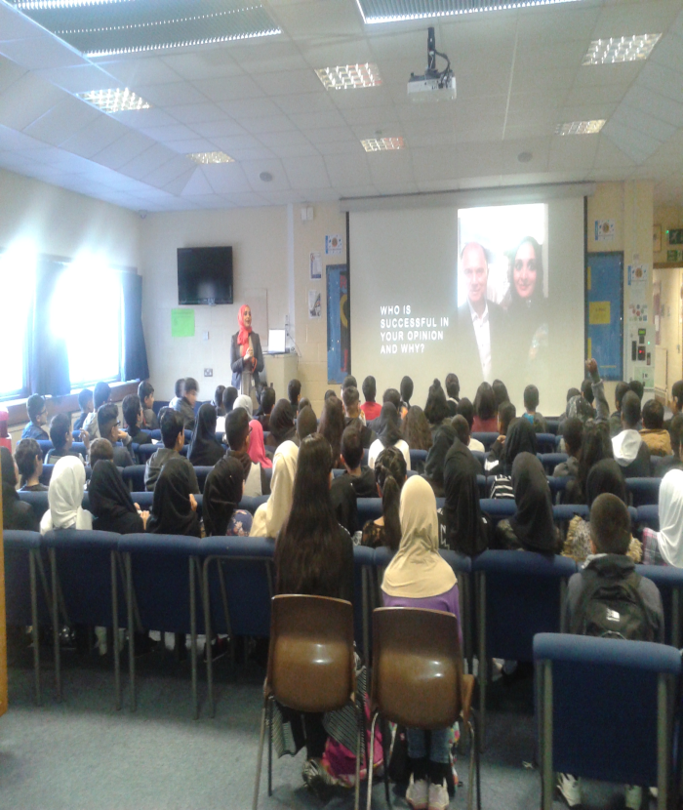
Cultural Literacy Multiplier events:
Charity event- Big Bake off- parents to prepare international cuisine buffet.
Multi-cultural Art workshop- logo printing, School Choir, Textiles workshop.
British Sign Language- Deaf Awareness & Cultural barriers workshop
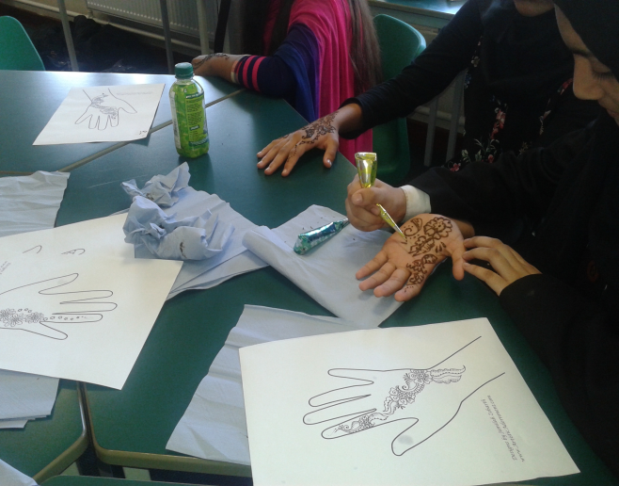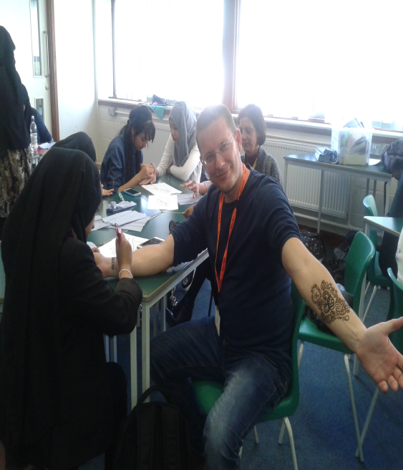
Erasmus cultural event…
Thıs event ıs part of a european exchange programme whıch project focuses on ımprovıng students’ lıteracy skılls,enrıchıng theır learnıng experıences and explorıng dıfferent cultures of europe.
All delegatıons from partner schools presented theır cultures with language sessıons to students ın small heath school sıxth form centre.
Tuesday 18th October 2016
International Education , Multicultural Education
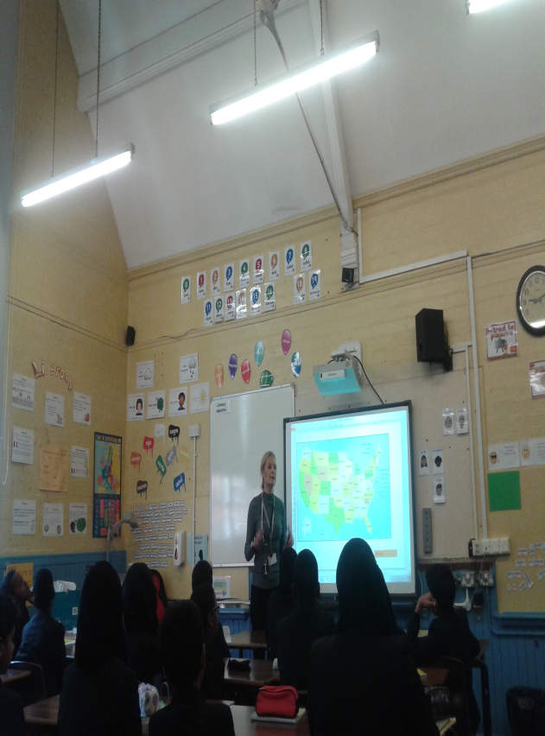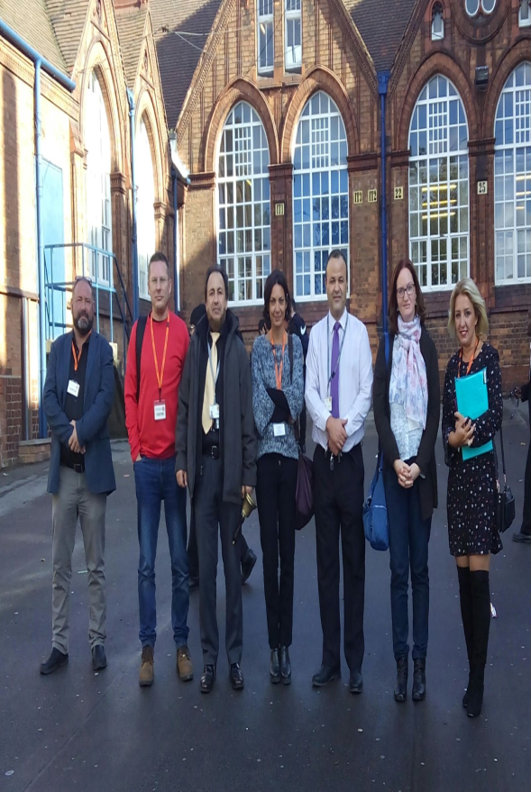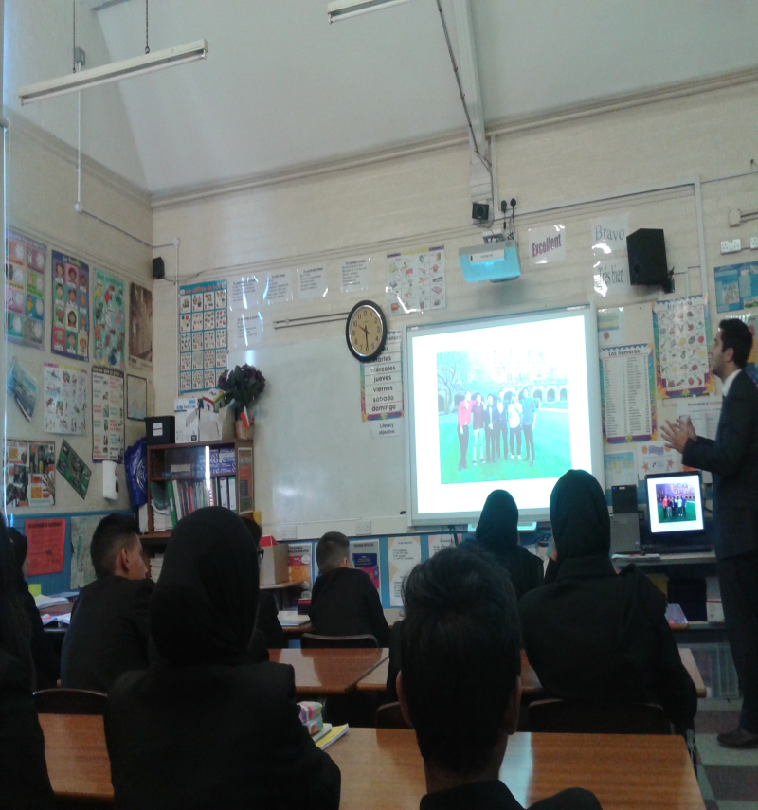
Tuesday 18th October 2016
Second Partner Meeting- Impact of Cultural Literacy Activities- Birmingham Central Library/Art Gallery/Canals
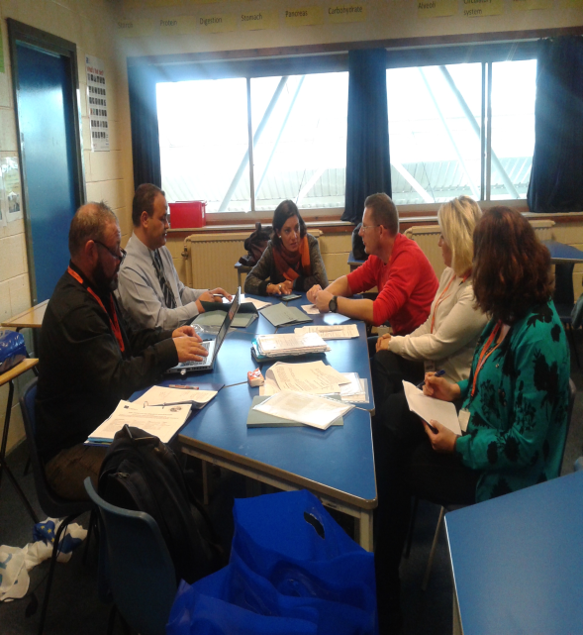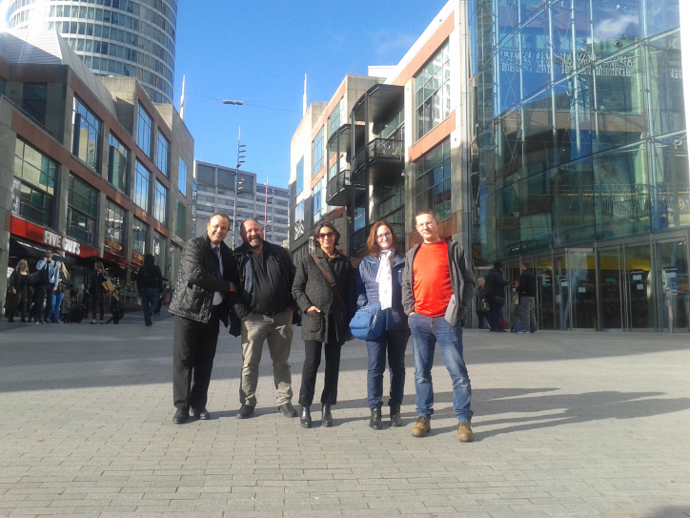
BIRMINGHAM MUSEUM AND ART GALLERY
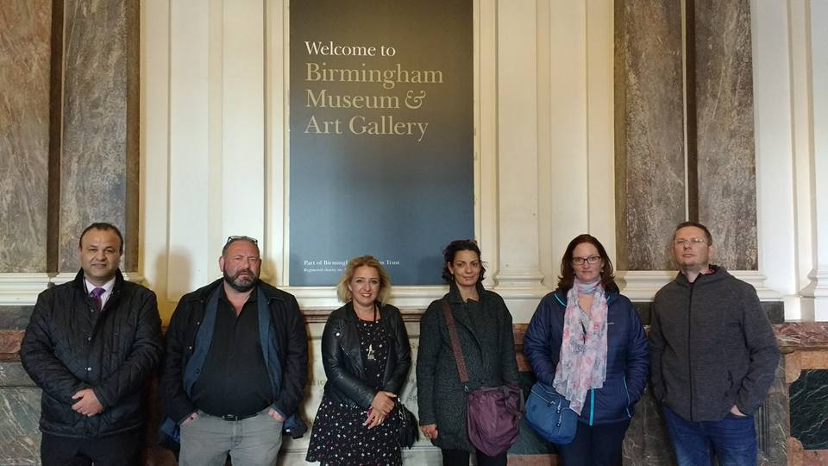
Wednesday 19th October 2016
- The topic of that meeting was preparation for Fifth Partner Meeting- in Slovenia.
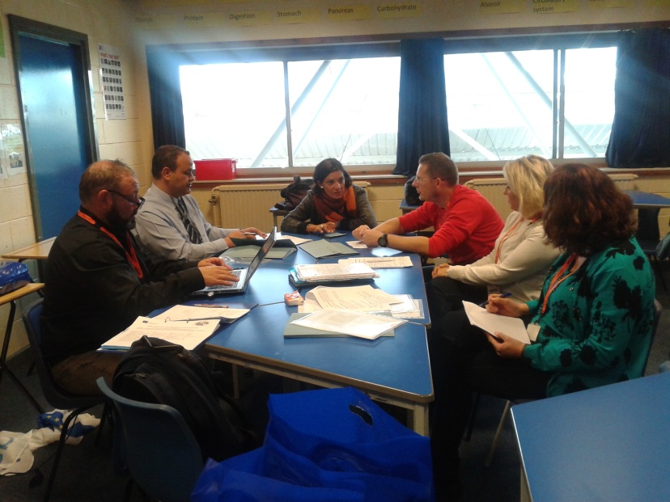
Visit to Strafford-Upon-Avon, Explore the British Cultural Heritage-We visited Shakespear’s house in Stranford Upon Avon.
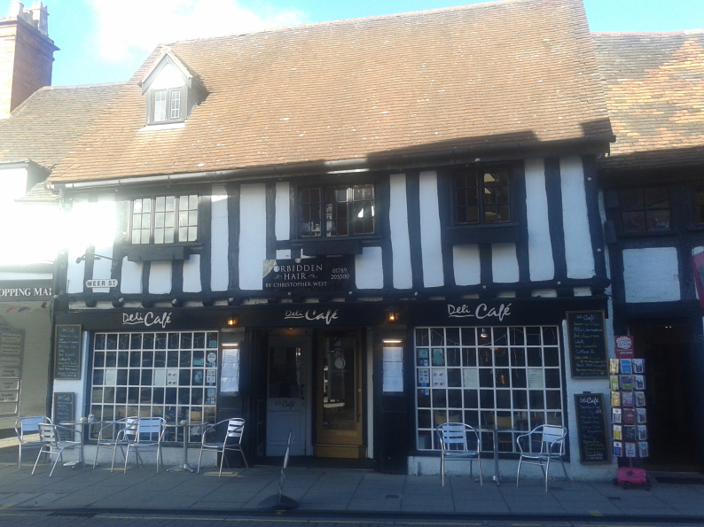
Thank you Imed for your warm welcome, hospıtalıty, and coordınatıng thıs organısatıon))
we have not only developed excellent workıng relatıonshıps but also we have developed consıstent and hopefully lastıng frıendshıps
