mustafa asım cula secondary school
2017
Erasmus +
ECLIPSE PROJECT
ECLIPSE CREATIVITY CLUB

The city of Antalya also has a number of its own festivals, which are unique and designed to promote the city or celebrate its distinctive cultural characteristics.
Many people in Turkey celebrate Republic Day on October 29 by attending performances and participating in traditional processions with flags and musical bands. The Turkish Republic?s founder Mustafa Kemal Atatürk proclaimed Republic Day as Turkey’s most important holiday
What do people do?
Many people go to local stadiums on October 29 to watch performances dedicated to Republic Day in Turkey. Such performances usually consist of theater sketches, poetry readings and traditional Turkish dances. Many school children participate in school performances for parents and teachers. Parades may take place in some cities and politicians may give public speeches on this day. Many people also lay wreaths to Atatürk’s monuments or visit Atatürk’s mausoleum in the capital, Ankara.
In the evening of October 29 many cities have traditional processions with flags and musical bands to commemorate Republic Day in Turkey. The processions usually end with fireworks, which begin after dark.
Public life
Republic Day is an official national holiday in Turkey. Public administration buildings, schools, post offices and many small businesses are usually closed on this day. Public transport schedules may vary. Public transport routes may change in the event of street performances and processions.
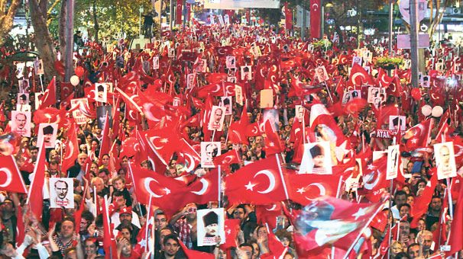

Expo 2016 Antalya was the first International Expo to be hosted by Turkey. The event was organised under the theme “Flowers and Children”, with the motto “A Green Life for Future Generations”. The Expo's main aim was to offer children a unique opportunity to learn about natural resources, sustainable development and ecological options.
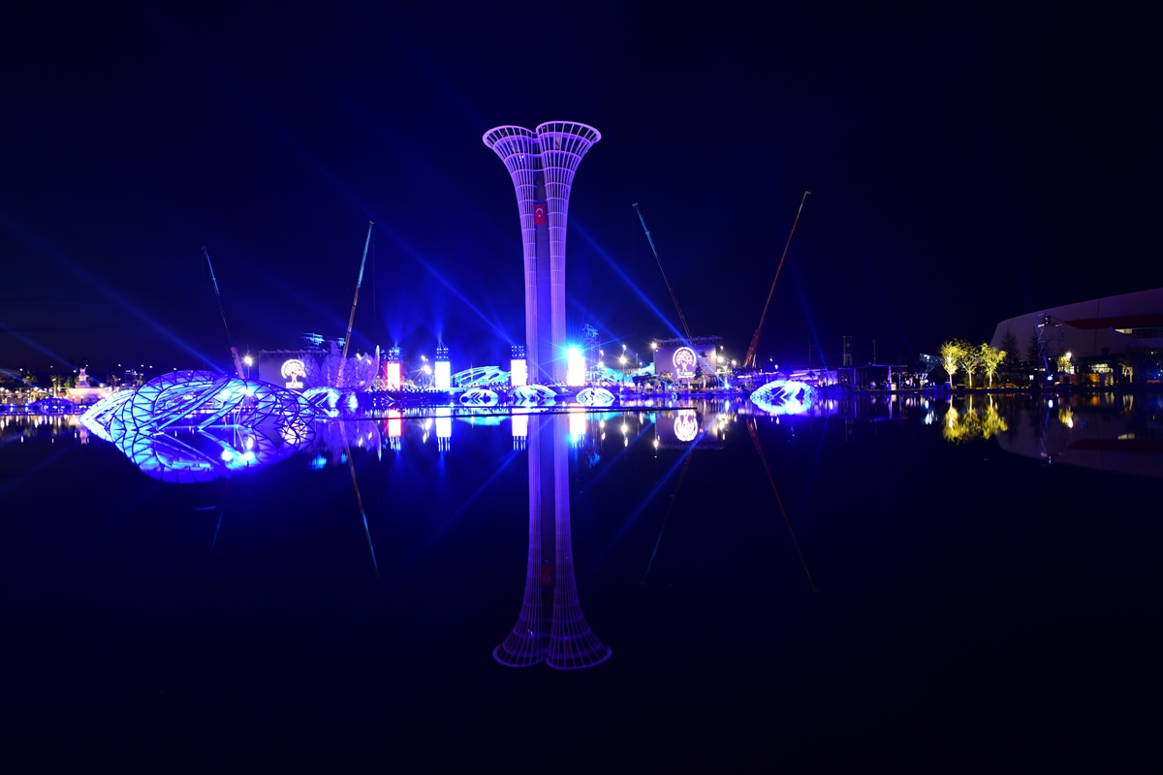
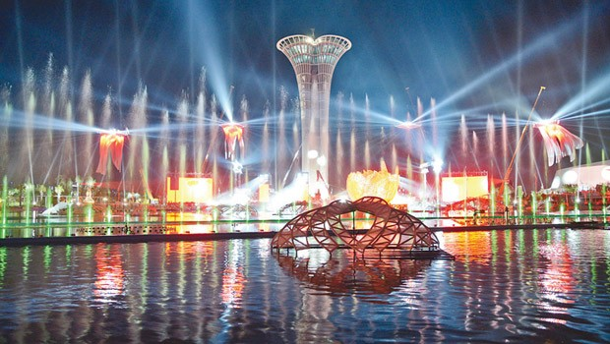
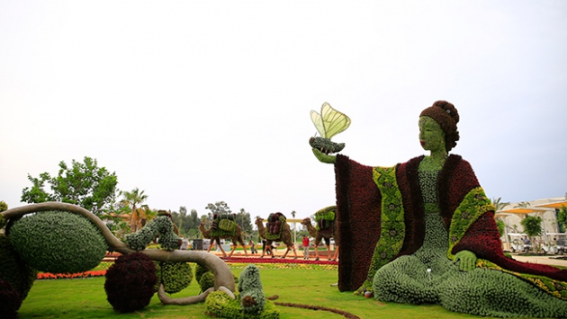
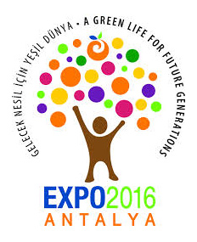

The Antalya Film Festival previously known as Antalya Golden Orange Film Festival (is a film festival, held annually since 1963 in Antalya, is the most important film festival in Turkey. Since 2009, the event, which takes place in the autumn months at the Antalya Cultural Center , has been organised solely by the Antalya Foundation for Culture and Arts and has included an international section within the main body of the festival. The most recent edition of the festival was the 52nd International Antalya Film Festival (November 29–December 6, 2015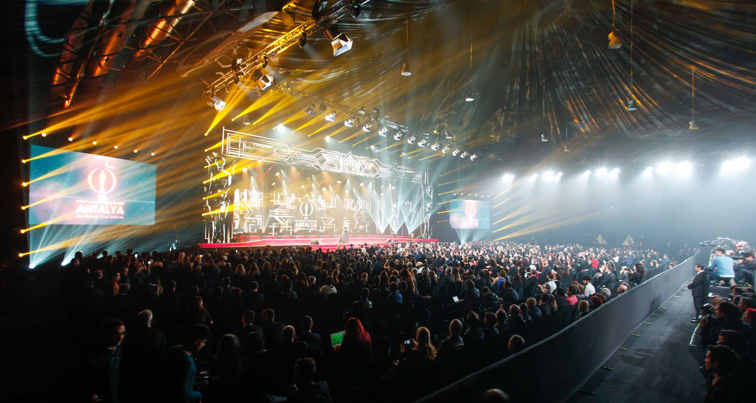
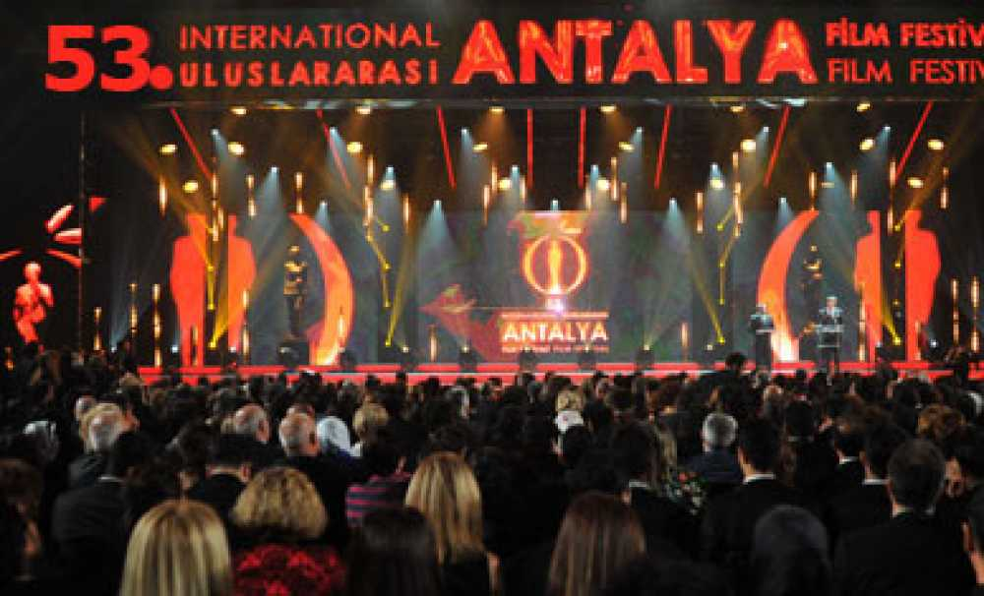
- The Aspendos International Opera and Ballet Festival has been organized by the Turkish State Opera and Ballet Directorate since 1994 with international participation by opera and ballet companies from several different countries. The festival is held annually each June and July in the two-thousand-year-oldancient Roman Aspendos Theatre of Aspendos near Antalya-Turkey. The theatre is noted as one of the best preserved antique theatres in the world, with many original features of the building remaining intact, this festival is a celebration of song and dance, and a showcase for a variety of international performers

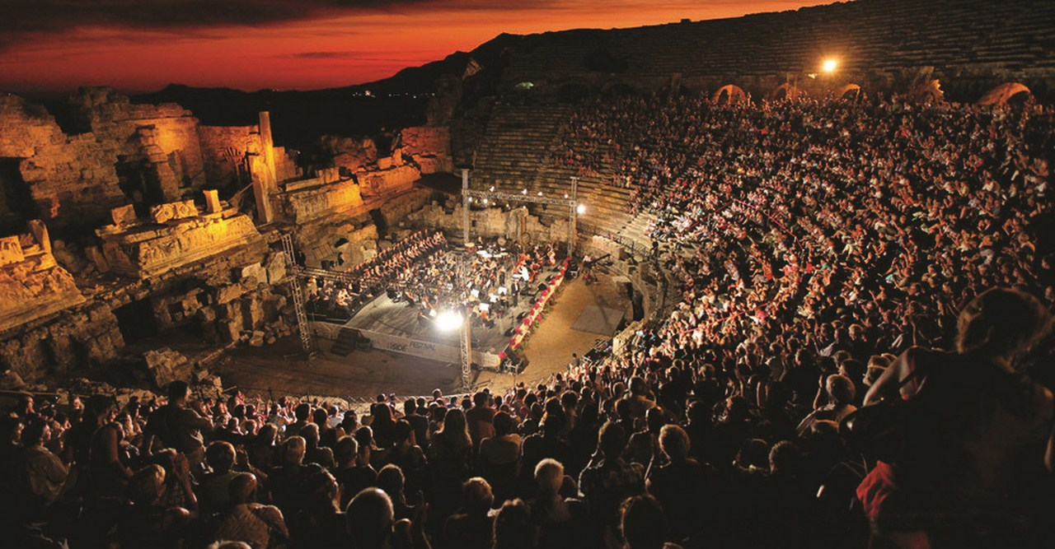
Aspendos Opera & Bale Festivali
Date: June
Place:Serik

St. Nicholas is remembered all around the world, but those in Demre had the privilege of remembering him in his homeland and in his own church. A ceremony was held at the Noel Baba Church in Demre, where St. Nicholas spent his life. The ceremony was led by Hrisostomos Kalaycı of the Istanbul Fener Orthodox Patriarchate, and the approximately 600 participants included clergymen from Istanbul, Athens, Rhodes and Meis, as well Greek Ambassador to Turkey Fotios Ksidas and Greek Consul General to İzmir Hara Skolarikou.

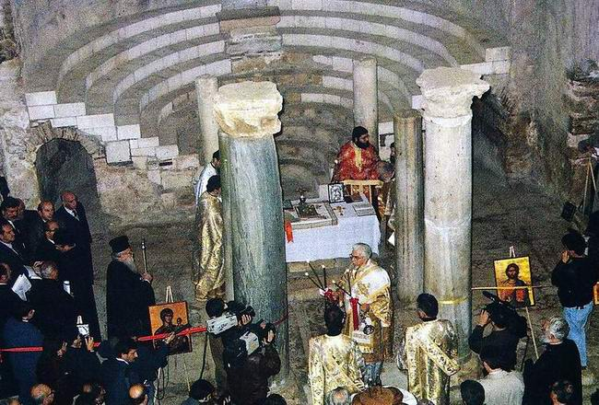
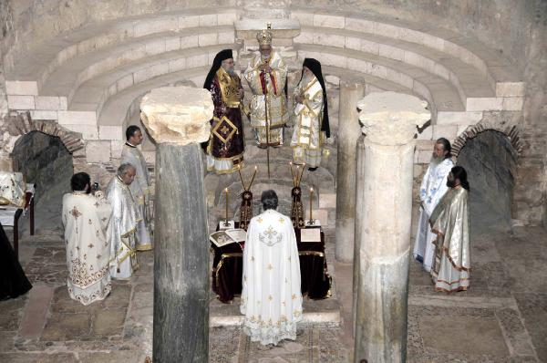
St.Nicholas Ceremony
Date: 4 - 7 December
Place: Demre (Kale)

Six Facts about Santa Claus and Turkey that You Never Knew
1 – Santa Claus was born in the town of Patara on the South West coast of Turkey between the years of 260 and 280AD. Technically, the republic of Turkey was not formed until 1923 so if you want to split hairs, Patara at that time was under Lycian rule.
2 – The true name of Santa Claus was Nicholas and in adult life, he became the bishop of Myra which was a town further up the coast from Patara. It is now called Demre.
3 – When Nicholas’s parents died, they left him a lot of money and made him a wealthy man. He wanted to help people who were poor but he wanted to do it in secret so the agile bishop used to climb on the roofs of people’s houses and drop coins down the chimney. One day, a citizen caught him in the act and his good nature was revealed to the town.
4 – Upon his death, a memorial was erected in the town but it would be a number of years before he gained the holiest of titles and that was as Saint Nicholas. He also became the patron saint of sailors but more specifically of children as he was remembered for giving them nuts, fruit and sweets for good behavior. Bribery was alive and kicking even back then.
5 – December the 6th become associated with the feast of St Nicholas and in later years, a bishop declared December the 25th as the birth of Jesus. Over time, the two celebrations began to fuse together and that was the first connection between Santa Claus, Saint Nicholas and Christmas day traditions.
6 –In the late 1800’s drawings appeared of St Nicholas aka Santa Claus with a beard, pipe and a large belly. The transformation of a humble saint called Nicholas to a fat, jolly man who feasts on mince pies and gets stuck in chimneys, had began. (God knows how the North pole, loyal elves and flying reindeer came about)

5. th Local Products Fair (YÖREX) is organized by Antalya Commodity Exchange with the support of The Union of Chambers and Commodity Exchanges of Turkey (TOBB). The fair took place at Antalya EXPO Center where visitors had chance to visit for 4 days.
The organization hosted 113 stands with 325 participants from 64 different provinces.

