Mustafa Asım Cula Secondary School
HANDS ON Science and Mathematıcs
Eclipse Creativity Club has been working on ‘’Mathematıcs From Past to Today’’
B.C MATHEMATICS
Egypt Pyramıds
Students built their own pyramıds.
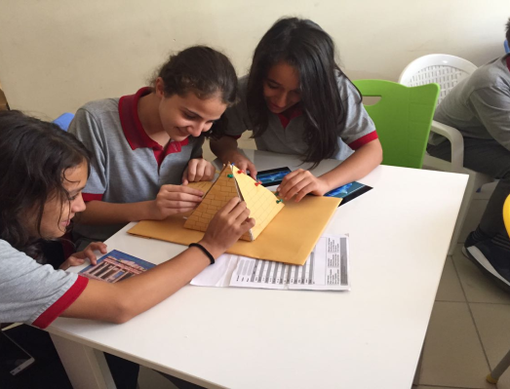
The students created their own clay tablet after researching Babilleon and Greek Mathematics . ‘’First, we gave a thin circle form as a shape to clay and then we pressed different shapes into the clay and we left it for dry.Finally we wrote old letters on the clay. ‘’
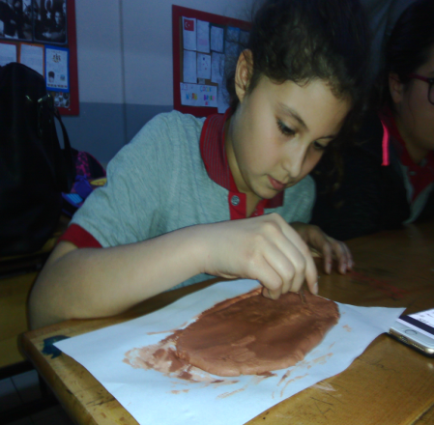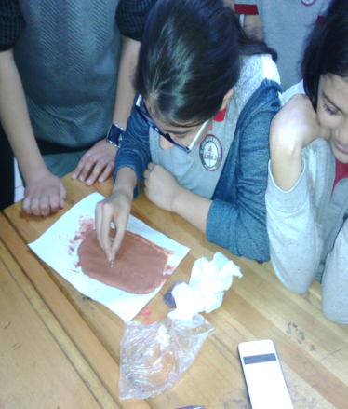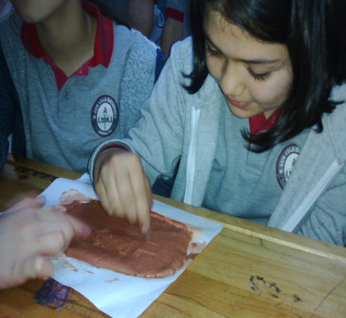
In Eclipse Creativity Club,Students prepared Hands on Maths and Science Corner at school.
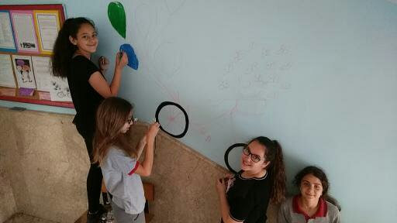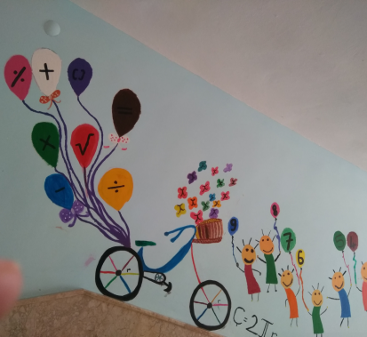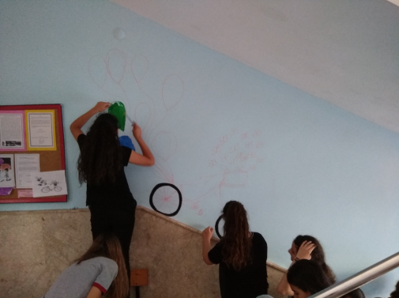

MATHEMATICS IN SCIENCE EDUCATION
CONSTRUCTION of TELESCOPE by ÖZKAN YILDIRIM
- We need a rectangle and two squares of cardboard. 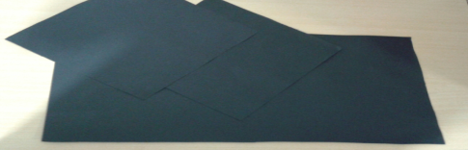
- We make two short cylinders with a long one. 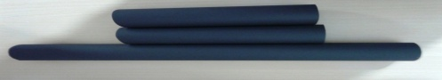
- We combine the cylinders from the square.
- The lens is glued to cardboard 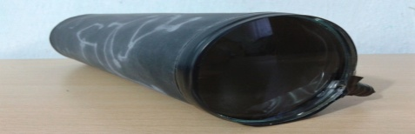
- The telescope is completed . 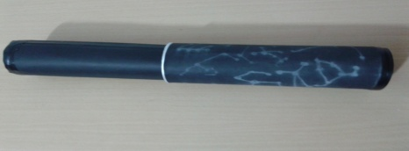
- 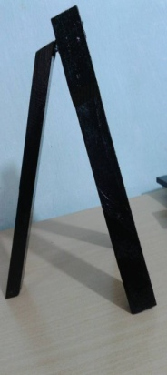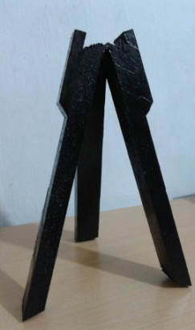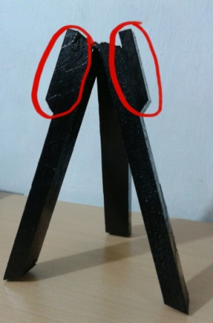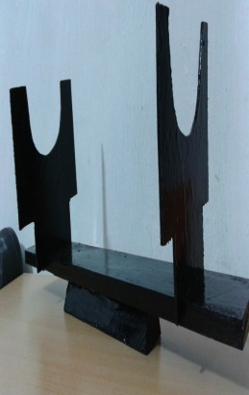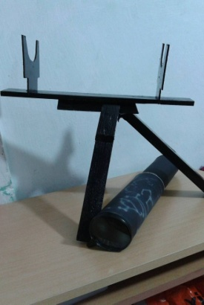
- After constructing the legs of the telescope,it is ready to use.

HOW DID I CONSTRUCT MY ABACUS?
- MATERIALS
- 1 plastic rope,1 wooden frame ,70 beads, 1 glue 1 wood cutter
- First, I took my wood cutter.
- Next, I took my beads and put 10 of the beads on each plastic rope piece.
- Third, I put the plastic rope inside the wooden frame.
- Lastly, I fix the plastic rope to the wooden frame
- 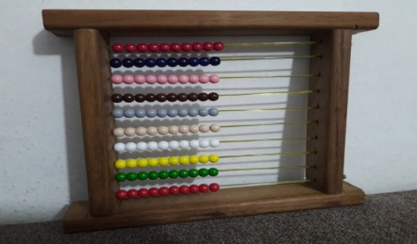
MATHEMATICS IN FINE ARTS
Preparation of ECLIPSE Creativity Club for The Exhibition about MATHS in NATURE
They search Fibonacci sequences and Fractals first.
