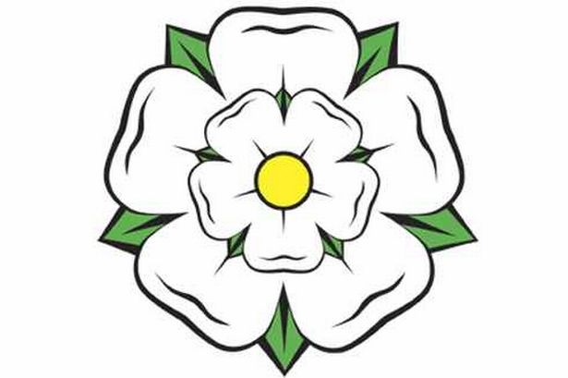
YORKSHIRE

Famous things about Yorkshire
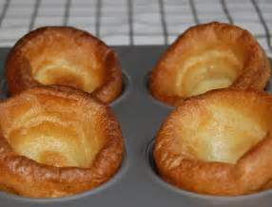
Yorkshire Pudding
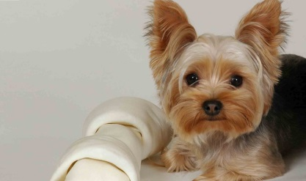
Yorkshire terrier
Yorkshire rose
Yorkshire tea
Yorkshire cricket club
Yorkshire accent
Yorkshire Dales
