INTERNATIONAL STUDENTS’ GROUPS FOR SPORTS ACTIVITIES
THURSDAY, 27.09.2018
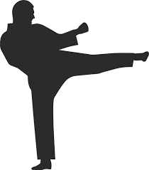KARATE TEAM - 17:30 –Szkoła Podstawowa Nr 2 (Mr Mateusz Garbacz)

- Fabio Pani (Italy)
- Giorgia Pani (Italy)
- Alba Marteles (Spain)
- Lara Navarro (Spain)
- Islinde Teurelincx (Belgium)
- Dawid Solarz
- Monika Błaut
- Jan Lachowski
- Ewa Kania
- Oliwia Nowak
- Julia Wydra

YOGA TEAM - 16:30 – Dom Rzemiosła- II p. (Mrs Magdalena Łyczek)

- Noa Jacobs (Belgium)
- Céline Simoens (Belgium)
- Federica Martis (Italy)
- Lucia Peña (Spain)
- Sonia García Idígoras (Spain)
- Katarzyna Prasał
- Natalia Krakowiak
- Katarzyna Maślak
- Agata Ciołkiewicz
- Julianna Nowek

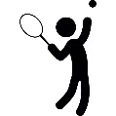TENNIS TEAM - 15:00- Tennis courts in Koczwara (Mr Andrzej Mijas)

- Chiara Corona (Italy)
- Martina Cuccu (Italy)
- Maria Bolea (Spain)
- Paula Moragrega (Spain)
- Julia Pękala
- Julia Kijowska
7. Wiktoria Kos
8. Sandra Obiedzińska
9. Filip Fornal
10. Jessica Sutowicz

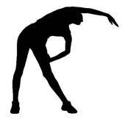FITNESS TEAM - 16:00 Fitness Club, ul. 1 Maja (Mr Mateusz Sikora)

- Lotte Bekaert (Belgium)
- Maaike De Grave (Belgium)
- Ivan Ghiani (Italy)
- Laura Sebastián (Spain)
- Isabel Murillo (Spain)
- Martyna Ziomek
- Nina Kiersznowska
- Adam Pietrusiewicz
- Kasia Osiak
- Sandra Boczek
- Jakub Walkiewicz

I M P O R T A N T
- One student in each group records the activity, the rest take part in the exercise.
- The students who recorded the exercises (four – one from each sports group) work on making short videos presenting all four sports on Friday from 08:00-11:00, the rest of the students work in coloured groups on the set tasks (as stated in the programme).

