**HIKING FROM KOŃSKIE TO SIELPIA**

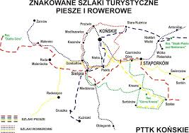

Sielpia Wielka is a picturesque holiday resort in the Świętokrzyskie Province, located near the Końskie municipality, on the Sielpia lake and the Czarna river - a tributary of Pilica.

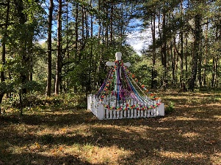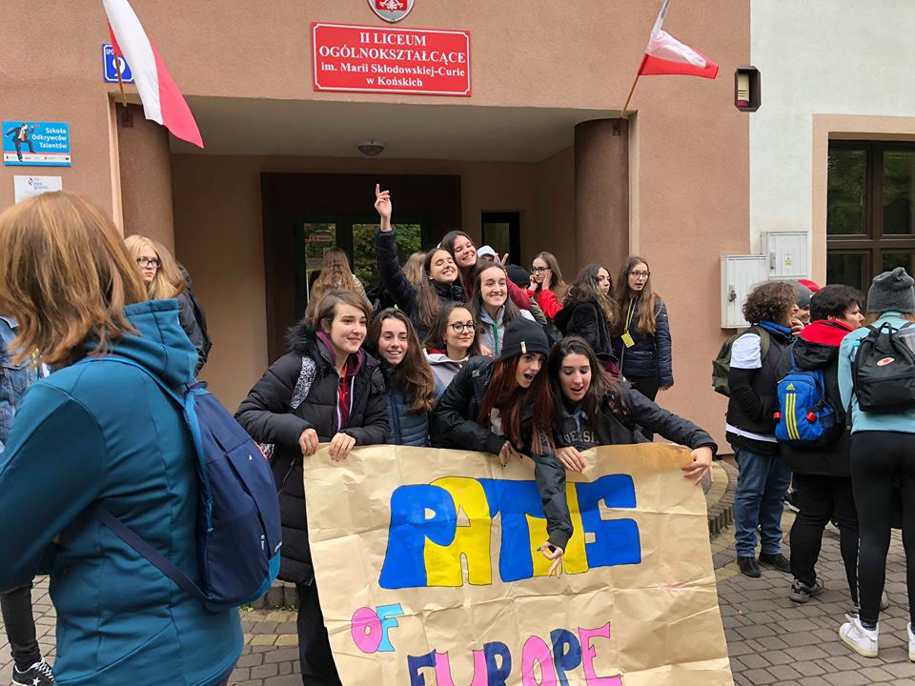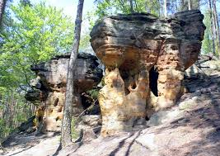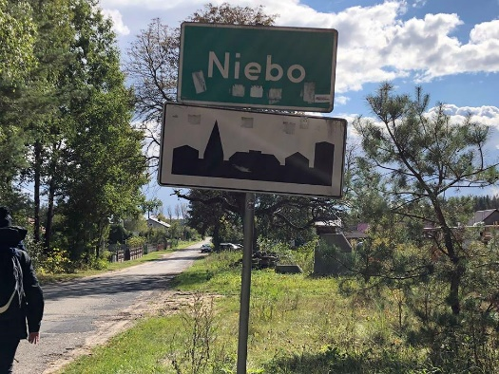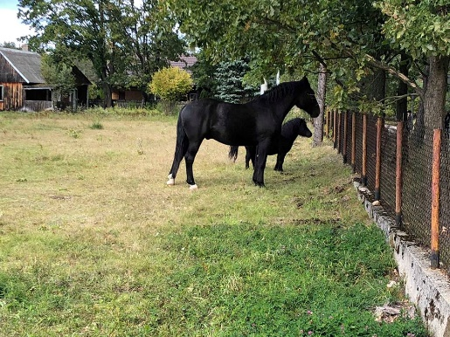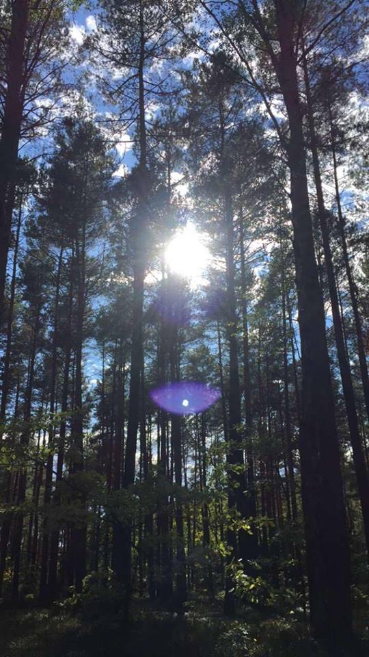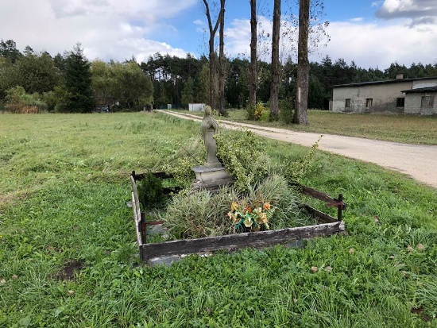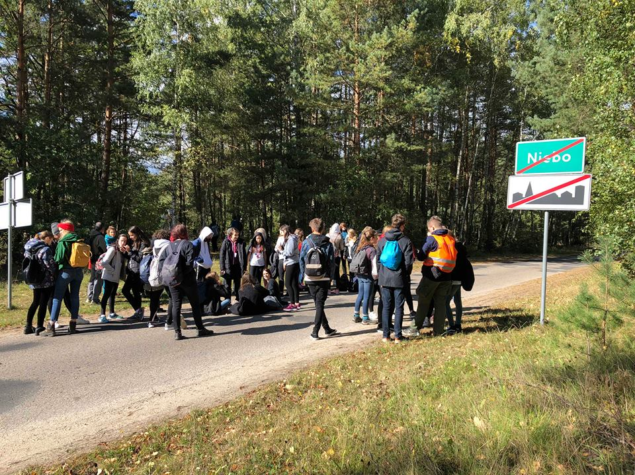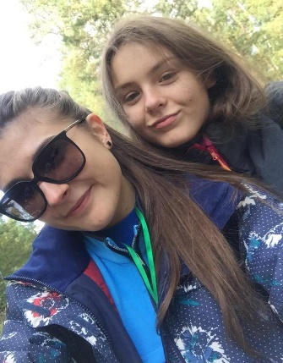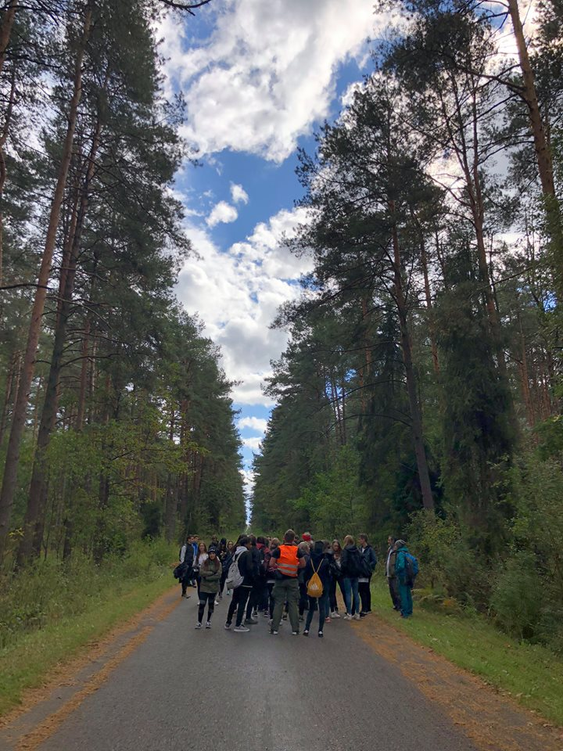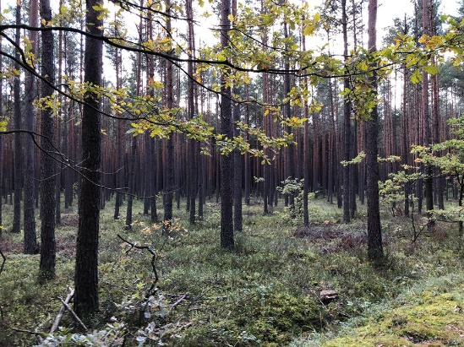

Skałki Hellenistic Nature Reserve near Niekłanie - an inanimate nature reserve in the Konecko-Łopuszniański Area of ​​Protected Landscape in the Stąporków commune, in the Konecki poviat, in the northern part of the Świętokrzyskie province [2], near the town of Niekłań Wielki. Rocks stretch for about 1 kilometer, their height reaches 8 meters.

The greatest treasure of the town is, of course, the Sielpia reservoir. Many holiday resorts have been established here, and Sielpia Wielka itself is surrounded by pine forests, fragrant with resin. It is difficult to get bored here - walking in the woods, cycling along prepared routes or relaxing by the water with the beach, water bikes and kayaks, and fishing.