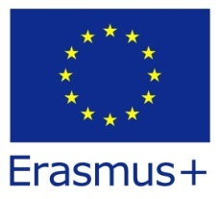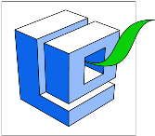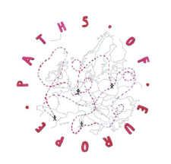
Tasks to be done while hiking from Końskie to Sielpia

RED GROUP: preparation of four didactic boards in Polish and English: (1) The Oak Path, (2) The village of Niebo, (3) the Nature Reserve of “Skałki” Gatniki, (4) Sielpia.
- The boards must include the pictures taken during hiking and the information collected on the way and in the Internet,
- To prepare the project of the boards use the instructions and the workshop area available at this address: http://geopark-kielce.pl/konkurs-edukacyjny-geostanowiska-w-twoim-sasiedztwie-edycja-2017/instrukacja_wykonania_obszar_roboczy_plakatu-2/
- collect natural totem decorations in the forest

Tasks to be done while hiking from Końskie to Sielpia

GREEN GROUP: preparation of a promotional leaflet of the route in Polish and English.
The leaflet must include:
- the course of the route,
- pictures of the best attractions on the route e.g.: The Oak Path, monuments, landscape etc.,
- information about the most important points on the route found on the Internet or in books.
- The size of the leaflet A4 folded in three.
- collect natural totem decorations in the forest

Tasks to be done while hiking from Końskie to Sielpia

BLUE GROUP: preparation of a quiz (different kinds of tasks and questions) for children and teenagers which can be done on the route Końskie-Sielpia.
Quiz must include:
- tasks concerning the route and checking the geographical, historical and natural knowledge,
- agility tasks promoting active tourism,
- other entertaining activities
- collect natural totem decorations in the forest.

Tasks to be done while hiking from Końskie to Sielpia

YELLOW GROUP: preparation of suggestions for amenities so that the route is suitable for people with different disabilities.
Work must include:
- pictures of obstacles for both: the disabled and other forms of tourism (e.g. cycling route) must be taken,
- suggestions concerning the implementation of some changes and facilities for tourists on the route e.g.: where to install benches or litter bins.
- All the suggestions must be presented in the form of an official paper/letter (in Polish and English) to be submitted to the local authorities (Urząd Miasta i Gminy Końskie).
- collect natural totem decorations in the forest

