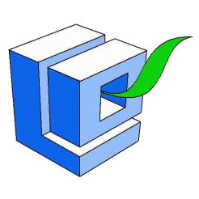
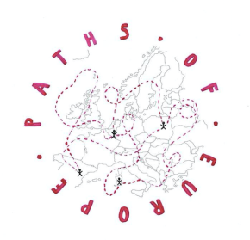
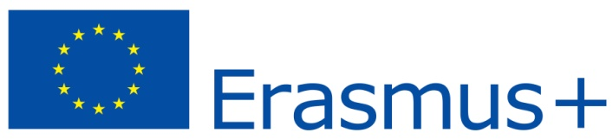
Mr Krzysztof Obratański
Partyzantów 1 Street
26-200 Końskie, Poland

International Student’s Group
From Erasmus + Project
Sportowa 9
26-200 Końskie, Poland

Dear Mr Obratański!

We are International Students’ Group from Erasmus + Project. Four countries are involved in this Project. These are Belgium, Italy, Spain and Poland. The main objectives of the Project are exchange of experience related to the promotion of active tourism; promotion of health and active lifestyle and promotion of the local tourist and nature base. During our trip to Sielpia, we had to do different tasks. Our group was supposed to prepare suggestions for amenities for people with different disabilities. For this purpose, we would like to introduce you to our proposals in this matter.

Our first initiative is to build pavements with low curbs. This will make it easier for people with disabilities to move around and increase their safety on the trail. The fact that it will be available to a larger number of people will makes its popularity will rise sharply. In addition, this investment will give pleasure to those who could not navigate this route for various reasons.

Another our purpose is putting on the trail new notices board. We mean mainly Braille arrays. In this way, we want to help the blind. Thanks to these boards, these people will know where they are at moment. In addition, they will not have to worry about getting lost. Moreover, the investment will initiate development in our region.

The last thing we noticed was lack of trash containers. Because of the lack of trash containers, people throw rubbish everywhere. This, in turn, increases environment al pollution and gradually destroys it. For this reason, there should be trash bins along the entire tourist trail. Installation of these containers will present degradation of the environment and will cause its revival.

I hope that our letter will be considered positively by You. We are sure that the initiatives we have presented will have a good impact on our little city and will contribute to its development to a large extent. We are waiting impatiently for Your response in this matter.

Yours sincerely,
International Student's Group from Erasmus+ Project

Below we present Picture of what the tourist trail from Końskie to Sielpia through Niebo looks like today,

