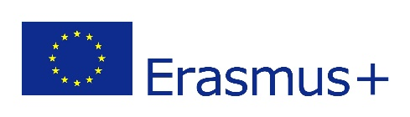
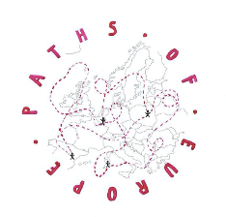
EVALUATION FORM (3rd Meeting, KOŃSKIE, POLAND)
RESULTS – 6 teachers answered the questions
A.- We are interested in your assessment of the preparation and development of this meeting and would like to ask you to complete the form. For each statement, please check if you agree or disagree using a rating scale from “1” to “5”.

1.- Strongly disagree 2.- Disagree 3.- Poorly agree 4.- Agree. 5.- Strongly agree

Categories | Check your responses  Strongly disagree- Strongly agree
 | 1 | 2 | 3 | 4 | 5
Preparation for the meeting:
The information for the meeting was enough. |  |  |  | 4 | 2
The information was timely provided. |  |  |  | 5 | 1
The communication between partners was adequate. |  |  | 1 | 2 | 3
Evaluation of the meeting:
The programme managed to achieve the right balance between the work activities and organized free time activities. |  |  |  | 3 | 3
The objectives were stated clearly. |  |  |  | 3 | 3
The meetings’ objectives were met. |  |  |  | 2 | 4
The program was adequate. |  |  |  | 1 | 5
The program was fulfilled. |  |  |  | 3 | 3
The topics covered were relevant. |  |  |  | 2 | 4
The meeting was perceived as valuable. |  |  |  |  | 6
There was opportunity for interaction among partners. |  |  |  | 3 | 3
There was opportunity for exchanging didactic experiences to know each other. |  |  | 2 | 2 | 2
The organization of the meeting allowed participants to get to know each other. |  |  | 1 | 1 | 4

B.- IMPACT.

Please rate the impacts of the meeting on your:  1.- None 2.- Small 3.- Medium 4.- High 5.- Very significant | Check your responses  None – Very significant
 | 1 | 2 | 3 | 4 | 5
Please rate the impacts of the meeting on your:
Language skills |  |  |  | 2 | 4
ICT skills |  |  |  | 4 | 2
Pedagogical skills |  |  | 1 | 3 | 2
Motivation |  |  |  | 1 | 5
Project management skills |  |  |  | 4 | 6
Increased knowledge about the culture, history and lifestyle  of the city, region and the country you visited. |  |  |  | 1 | 5
The meeting brought you closer to European spirit, promoting tolerance and mutual understanding. |  |  |  |  | 6
Increased knowledge about partner countries and cultures. |  |  |  | 1 | 5
C.- COMMENT

What did you expect from this meeting?
It covers everything I expected: warm welcome, new cultural facts, new places and experience; autonomy, problem solving, adjusting to new situation, improving language, breaking prejudice; respect, responsibility, commitment, seriousness and good manners – and that’s what I got; meeting our partners and discovering Poland.

What could we do to improve future meetings?
Increase the time with host families; closer interaction between hosts and guests, encourage more mixing between countries;

