**OSNOVNA ŠKOLA HORVATI, ERASMUS +, K1 PROJECT: „MORE IS THE BEST CHOICE“**

 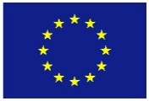  

This publication [communication] reflects the views only of the author, and the Commission cannot be held responsible for any use which may be made of the information contained therein.

**EVERY PUPIL IS IMPORTANT**

