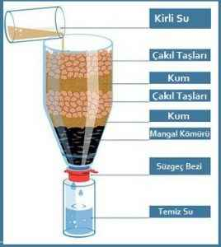

Jack was feeling sick. He realized he had to take a lot of vitamins to be stronger. So he wanted to prepare fruit juice from fruit. He squeezed the fruits with a juicer. He had to prepare the mixture by mixing the juiced fruits with water, but he realized that there was no drinking water left at home. He knew he couldn't do that with tap water, either. Jack needs purification water to prepare his juice. Let's help Jack treat the water.

Materials:

Tap water

Cotton

Piece of cloth

Pebbles of different sizes

Bottle

