5 most pouplaar Podcast Formats: Which One’s Right for You?

1. The Solo Podcast
This might be the podcast you started off with. Basically, you and the listener, chatting away, sharing your thoughts on whatever your podcast topic might be. These days, the solo podcast is limited to very particular niches. For instance, you might be a comedian or a musician. The solo podcast, therefore, is ideal for you to share your unique slant on the world.
While it might seem like an easy solution (and it is when it comes to production), the solo podcast isn’t for everyone. If you’re unsure of your point of view on a subject, for instance, then you might find yourself drying up (that is, running out of things to say, or losing your thread). It’s a good idea, therefore, to have a plan: a format. For a solo show, that might be:
- Introduction
- Topic A
- Transition
- Topic B
- Etc.
- Summary
- Outro
When it comes to production, all you need to do is grab a microphone, find an audio recording app, hit record, and start talking. This is possible on virtually any device, which means you could conceivably publish podcasts on a daily basis (although this is perhaps too regular in most cases).

2. The Podcast Interview
Talking to yourself on a weekly basis can be dull. Even if you liven things up with radio show-style sound effects, just chatting on and on, even with a plan, can prove somewhat limiting.
But if you’re talking on a specialist topic, it’s always a good idea to get input from a fellow expert. To begin with, it gives the audience another voice to listen to. You might well have silky tones that rival Morgan Freeman himself, but there should always be room for someone else.
Image Credit: Kzenon via Shutterstock
How do you bring a guest into the podcast? Several options are available:
- Telephone — Record the interview on your smartphone using a call recording app. You’ll need to sync the data to your computer for editing (unless you have the tools to edit and upload on your phone).
- Skype — If you don’t have a smartphone, you can use Skype on your desktop to call other Skype accounts and telephones. With a Skype call recording tool, the audio will be captured and you’ll be able to package it into your podcast later.
- One-on-One — The final option is to make sure you can get a microphone under the nose of the person you’re interviewing. This may require you to spend money on additional hardware, but the end results should be good. Just remember to check the sound levels before recording commences.
The format for a podcast interview would look something like this:
- Introduction
- Introduce guest
- Discussion
- Summary
- Outro
Clearly, an interview scenario has greater time overheads than a solo podcast. It can also require more software, sound hardware, or both. However, the results can be superb.

3. The Multi-Host Show
For a more varied collection of voices and opinions on a regular basis, the multi-host show is the way to go. Indeed, many podcasters use this option to start with. After all, if you dry up, there’s always someone else available to take up the slack. Execution of a multi-host show can be tricky, however.
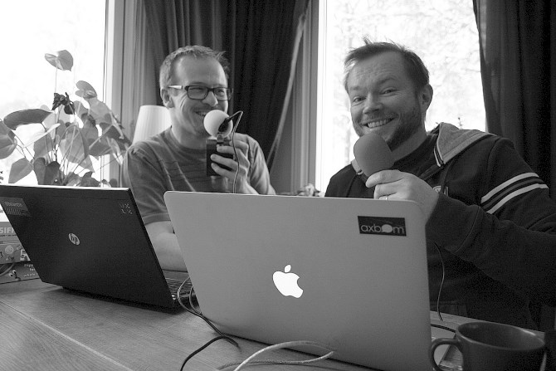Image Credit: James Royal-Lawson via Flickr
You basically have two options: online (which means embracing Skype, Google Hangouts, or another VOIP option), while recording the call (preferably at both ends, just in case one of the recordings fails), and offline. The latter can potentially have a travel overhead for one or more hosts, however. You should also consider transportation of hardware: multiple microphones and a mixer for your laptop or tablet will be required.
Goodbye, Skype: 4 Alternative VOIP Services You Can Record Calls With Goodbye, Skype: 4 Alternative VOIP Services You Can Record Calls With Can't record calls with Skype anymore? Recent changes that break support of third-party apps have left many users frustrated. Could now be the time to try an alternative VoIP call recording service? Read More
Many podcasts use the multi-host format, it’s especially useful if one of the hosts must take a timeout. Typically, a multi-host podcast format follows this structure:
- Introduction
- Catch-up
- Topic A
- Transition (optional as conversation may move organically)
- Topic B
- Etc.
- Summary
- Outro
As a podcaster with 10 years of experience, I’ve found that the multi-host format works well. It’s also possible to combine it with the previous format, and have one or more guests to interview in the show.

4. The Round Table
A variation of the above two formats, this is an approach whereby a single host introduces three or more (perhaps as many as ten) semi-regular guests to discuss a topic.
Commonly found in technology and gaming podcasts (as well as those looking at politics), round tables are typically longer than a standard podcast (perhaps two or three times as long). This is usually because of the range of opinions, so it can help to keep the focus of the podcast quite narrow if you want to keep the duration to manageable levels. After all, you need to consider whether your audience will have time for the whole thing!

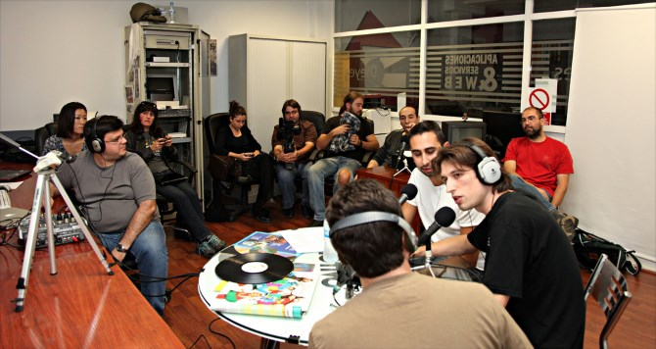Image Credit: David Martín :: Suki_ :: via Flickr
Like multi-host shows, round table podcasts will need to be conducted via your preferred VOIP solution, or in person. Organizing a round table podcast can be time-consuming; however, the format makes it suitable for a live broadcast via Facebook or Google Hangouts/YouTube, in addition to audio-only live broadcasts. In fact, you could even invite a live studio audience!
A round table podcast format would typically run as follows:
- Introductions and profiles of each guest
- Topic discussion
- Audience questions
- Summary
- Outro

5. The Audio Magazine
The final format for a podcast is an eclectic mix of news, interviews, discussions, and perhaps a few gags. It might have a single host or multiple hosts — it’s up to you.
As most podcasts undergo post-production (that is, editing and mixing), having an audio magazine approach means you can collate your content over the course of a week, edit it together with some links, and publish.

All this approach really needs is you and a microphone. If you want to chat to someone remote, you can either hop on a train or Skype them, then record the conversation. All the audio should be synced to your computer, edited together, and published. For one-man podcasts, this is a great way to bounce the format — it’s basically a ready-made pivot!
Here’s how an audio magazine podcast format might look:
- Introduction and rundown of features
- Feature 1
- Feature 2
- Etc
- Listener emails/social network comments
- Summary
- Outro
Listener feedback is always important for podcasts, but in a show where you might be accused of being low on content, it is particularly useful to involve the audience.

