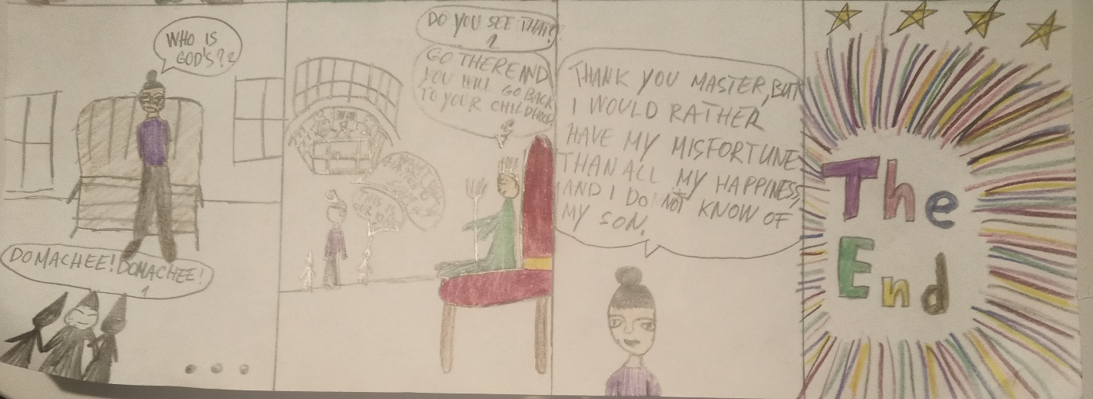
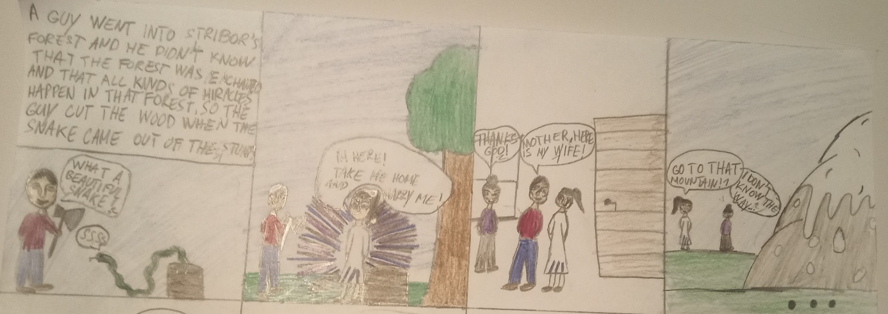
Stribor's forest, by Dora
https://voca.ro/1g02w3ObM46f
https://voca.ro/15Q0T8ABt0ve

