What do French teenagers dream of?

Most pupils dream of having a good life, like Noémie, Gauthier, Emma L., Stella …

Most students like Thomas, Stella, Liam, Dorian, Julie or Nina, dream of winning the lottery and winning a lot of money.
Others like Tristan wants to become an important leader in politics.
Clara J. dreams of becoming a pastry chef.

Elisa dreams of going to Sidney and Jason to Los Angeles.
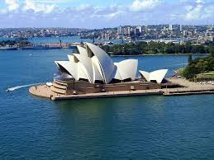
Emma A. dreams of living in California.
Clara V. dreams of flying like a bird.

Enzo wants to become a rugby man.
Pauline dreams of having an ice-rink for her own.
Tristan B. dreams of having his own skyscraper.
Samuel wants to become a journalist.
Morgane dreams of swimming with dolphins.
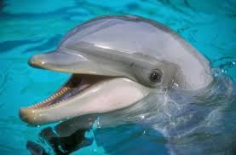
Tolga dreams of studying and having a large family.
Typhaine wants to become a maths teacher.
Léna dreams of travelling.

