Hi !

My first-name is Florian and my name is BERLIN, I'm 13 years old.

I've got brown eyes, and short brown hair. I'm 1m68 tall.

I am very harworking, a little shy, and I'm quite messy but I'm not very jealous.

I'm live in Labruguière, near Castres.
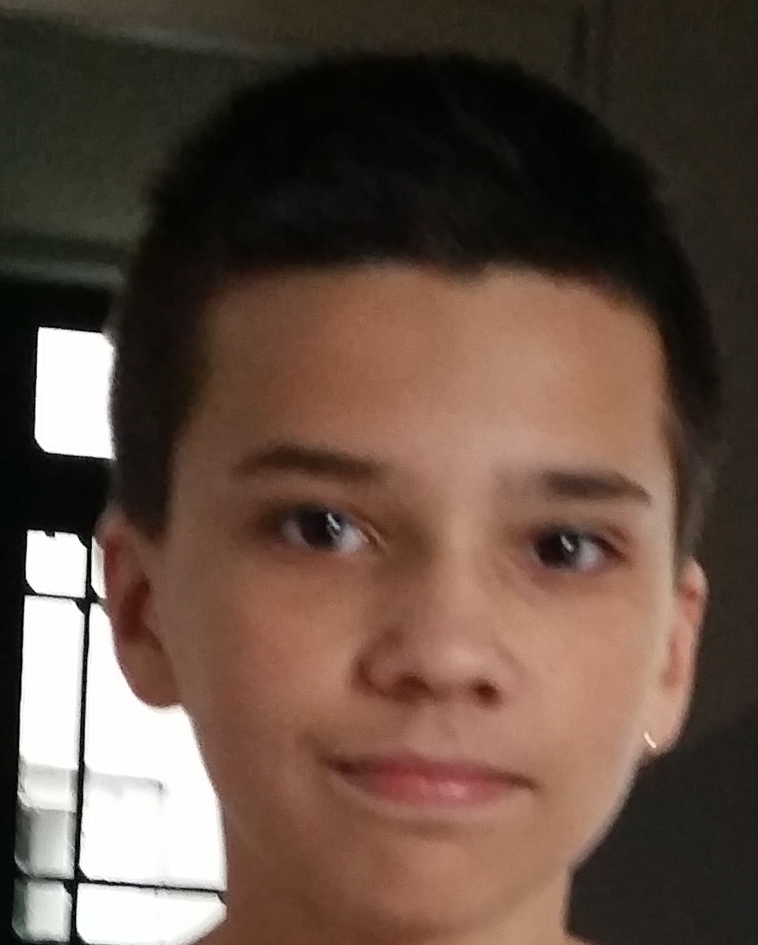
I have an older brother, his first-name is Tristan he's 18 years old, a younger brother, his first-name is Romain and he's 10 years old, and one sister her first-name is Emilie she's 16 years old. My parents are extremely nice !

I have two dogs their names are Cookie and Flash, three cats, two fish, two rabbits and one hamster.
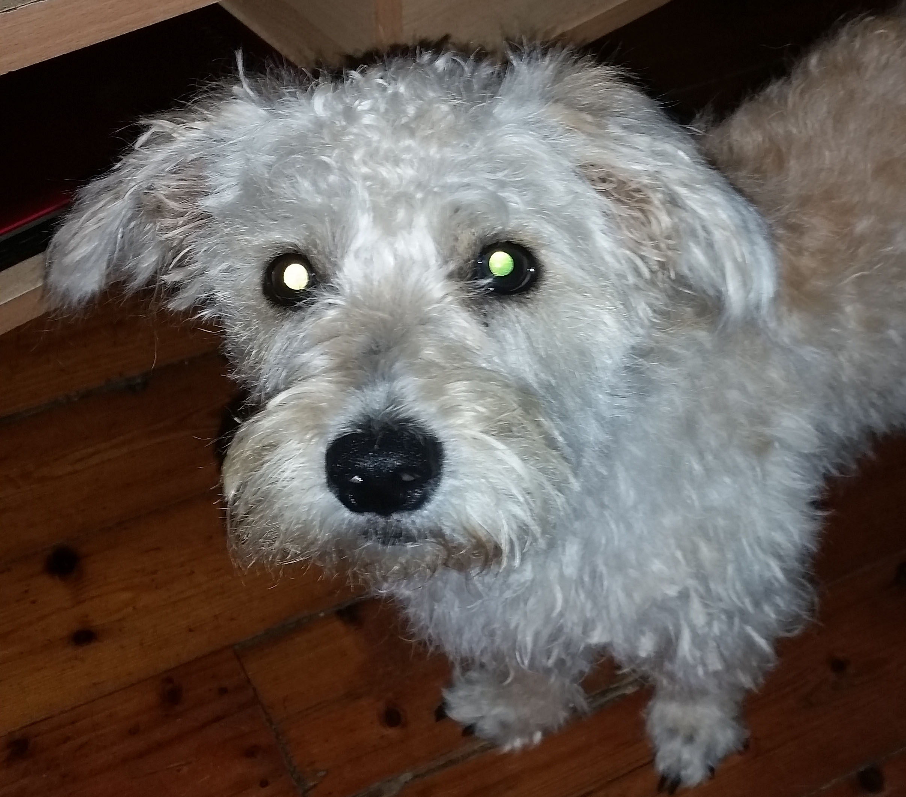
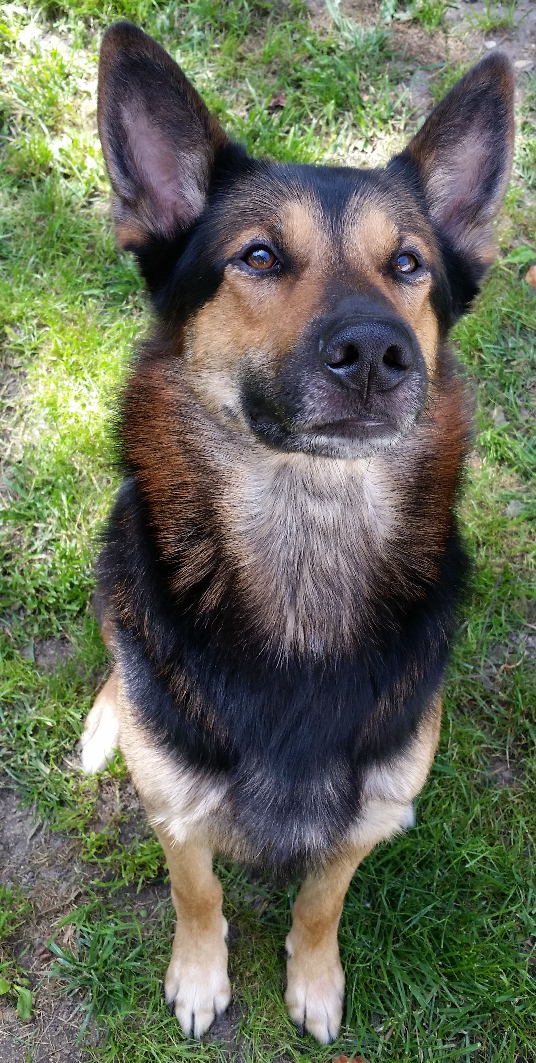
Cookie Flash

I enjoy playing the piano. I like playing with animals very much and I love reading. But I don't like eating vegetables !

At school, my favourite subject are English and Maths but I can't stand Art because it's very difficult !!

My favourite song is Say Goodbye by Theory of The Deadman. And myfavourite book is Hunger Games !

Bye !

- Florian

