Hello!


My first-name is Anaïs and my name is Garrigue, I'm 14 years old.
I've got blue eyes and long blond air. I'm 1m53 tall.
I'm extremely shy, I'm quite lazy and I'm not very hardworking at all.
I live in Saint Affrique Les Montagnes, near Castres.
I've got an older brother, his first-name is Florian, he's 22 years old.
I've got 1 dog and 1 cat.
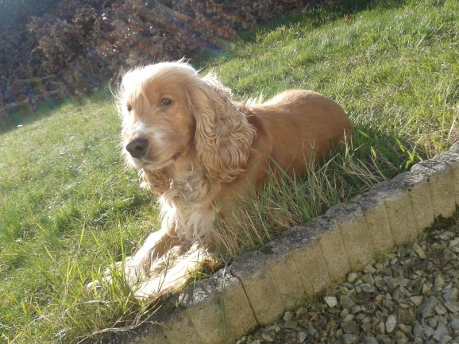
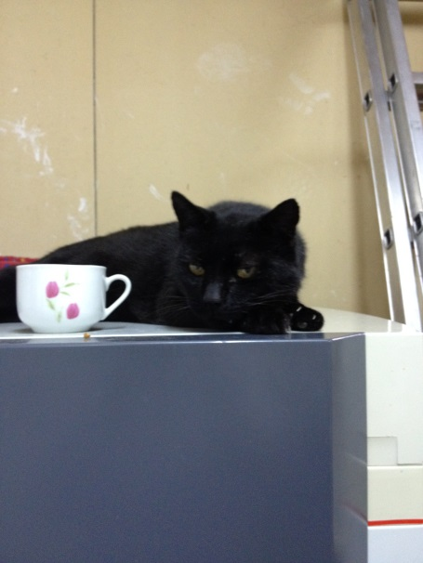
I like horse riding and I love singing.
At school, I like music and French but I hate Sport because it's too difficult.

My favourite band is One Direction.
Bye!
Anaïs

