ABOUT ME

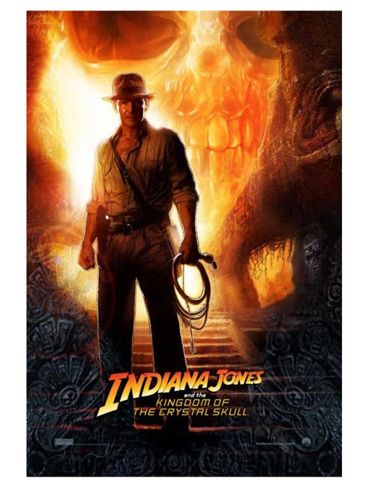Hi ! My name is Ana Buđanec and I'm from Šibenik , Croatia . Just for the info I'm a total geek , I just love anything connected to science fiction like movies , books, comics , serias etc. My favourite movie genre is of course si-fi , but I also like adventure and action movies. My favourite movies are : Star Wars ( original , not the prequels ) , Indiana Jones , Ghost Rider , Transformers ( those directed by Michael Bay),Avengers and The Expendables. 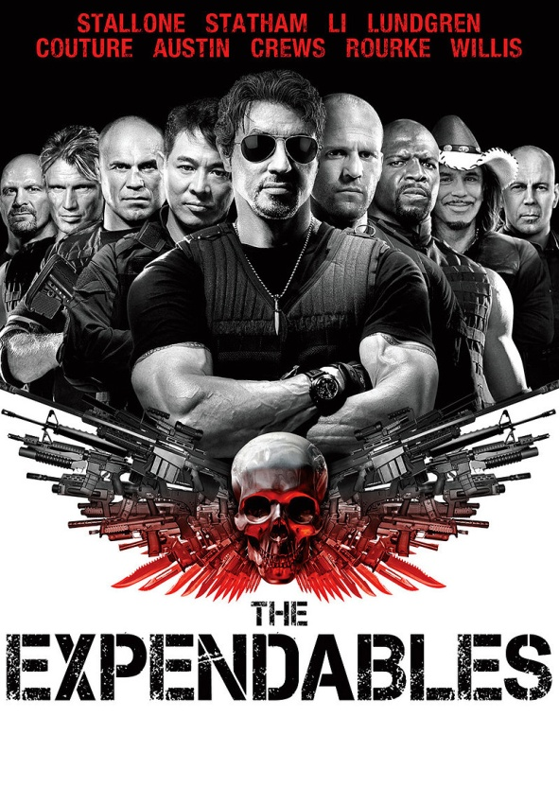From these movies I have to say that The Expendables are an action film and that there's a lot of killing in it , so if you like to see exposions , shooting and blood everyvere I reccomend this film for you ( there's also some humor in it so it's not just shoot ,kill, destroy type of movie ).

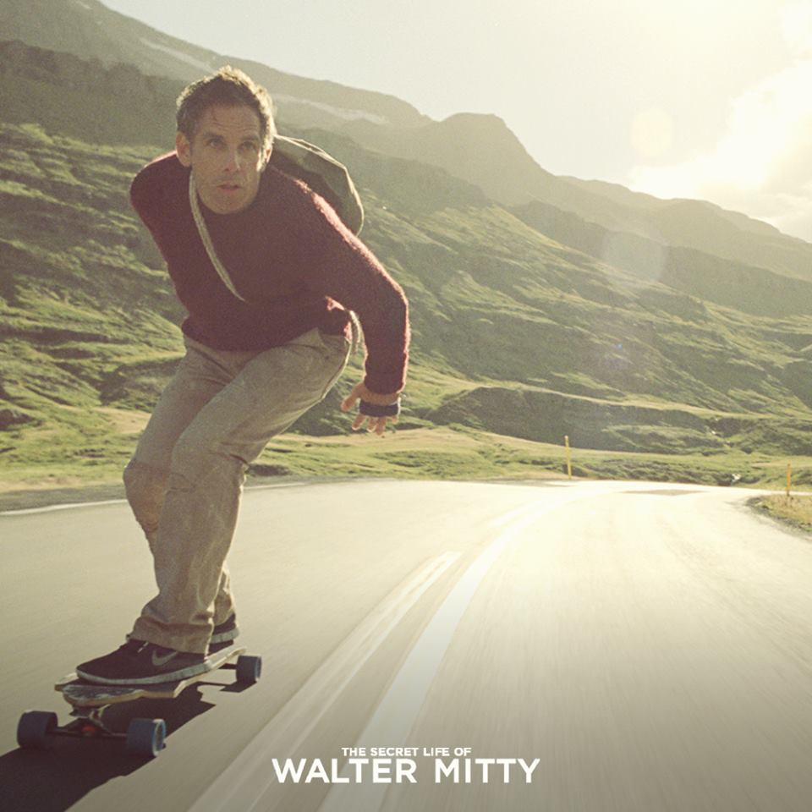 I like actors Tom Hanks , Nicholas Cage , Ben Stiller and Jason Statham . Ben Stiller has acted in so many awesome films that I can't write them all down, but here's some of them : Meet the Fockers , Starsky and Hutch ,Mystery Men , Night at the Museum , Tropic Thunder , The Watch , Secret Life of Walter Mitty …He's kind of my idol because he's an actor , comedian , director, producer and screenwriter and tehniccaly that's all I want to be when I grow up . The music I listen is not very popular with my friends , I listen to groups Smash Mouth , Fun , Imagine Dragons and Swedish House Mafia (google them if jou still have google ) . From singers I listen to just Robbie Williams , he's awesome . 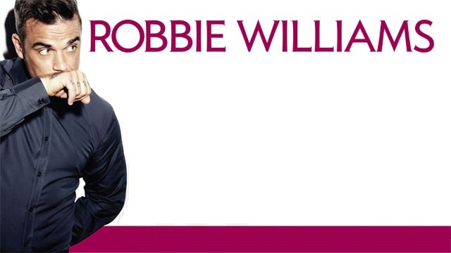From serias I watch MARVEL's 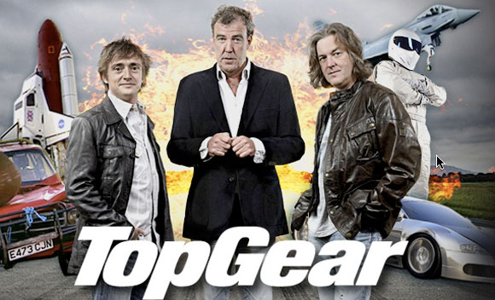Agent of SHEILD , Bones , LEGO Ninjago , The Simpsons , Futurama , Gravity Falls , Sherlock and British Top Gear .

I don't really go for fashion trends I have my own style of dressing so I can't really tell you about fashion now , sorry ,but that's why I know all the Transformers name's and I remember every line from the Ghost Rider and LEGO movie .

Guess that's it , I don't know what to tell you so , bye !!!! ;)