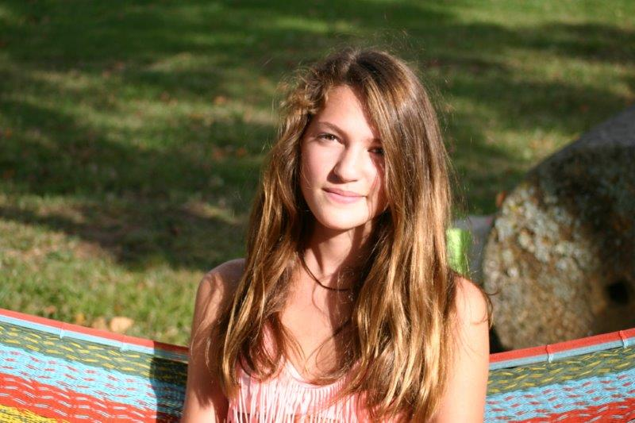

Hello!
My name is Margot CHANUT, I'm 13 years old.
I've got brown eyes and long brown hair, I'm 1m 76 tall, I'm very tall, I know!
I'm absent-minded, a little shy, I'm very hardworking and quite messy.
I live in viviers les montagnes and saix (because my parents are separated) next to Castres, near Toulouse.
I've got one little sister called Ines, she's 4 years old and my stepmother called Delphine. My mother's name is Sylvie and my father's name is Laurent.
I've got one dog and three cats. My dog's name is Dobby, it's very cute! My cats are called Candie, Dina and Pattenrond.
I like dancing and drawing very much but I prefer singing, I love singing!
My favourite singer is M.Pokora! He is too beautiful! I went to see Robin hood, it was really great.
My favourite subject is music because my teacher is very cool but I enjoy Cham too.
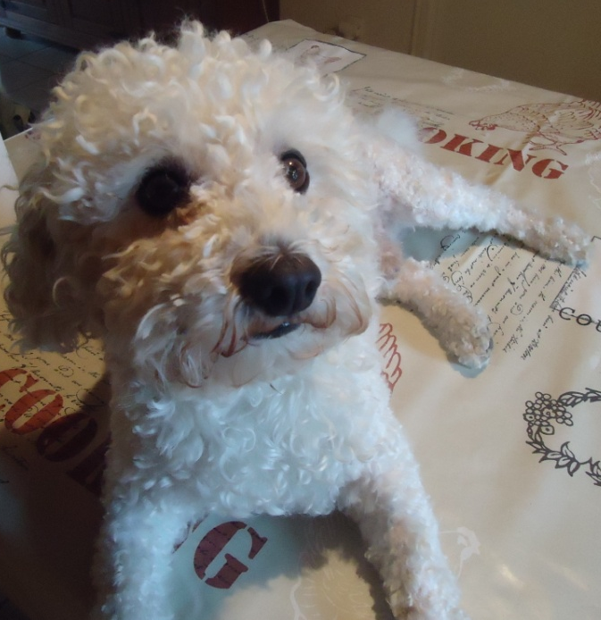
I'm crazy about eating sweets. I know, I shouldn't eat it but I LOVE IT!
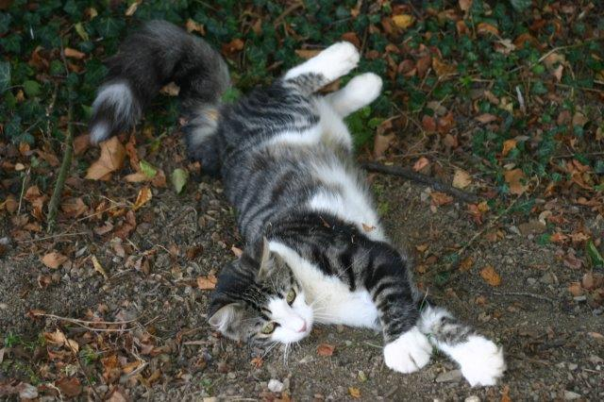
Bye Margot

Pattenrond Dobby

