Hello ! I’m Camille Gau and I’m 13 years old.

I live in Noailhac in France.

I’ve got long brown hair and brown/green eyes. I’m 1m64.

I’m little talkative, I’m a not clumsy and I’m very shy.

I’m an only child but I’ve got a cat, is name is Licorice.

I’m crazy about tennis but I don’t like dancing.

At school I love English and art but I hate technology and sport.

My favorite singer is David Carreira because he sing extremely well.

Bye I can’t wait to meet you !

Camille.

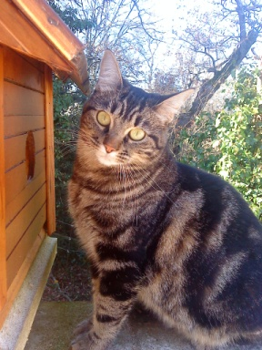 Licorice Me, Camille

