English
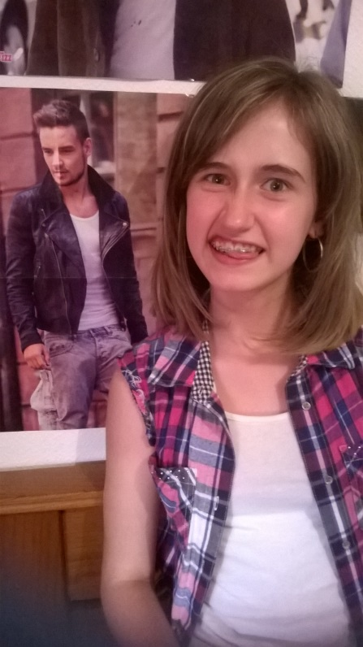

Hi !
My first name is Tessa and my name is KOZLOWSKI.
I’m thirteen years old.
I’ve got blue eyes and short brown hair.
I’m 1m55 small.
I’m very selfish, I’m extremely lazy and I’m a little bit absent-minded.
I live in Valdurenque, in France.
I’ve got two big brothers, their first name are Mickaël and Allan. Mickaël is 29 and Allan 26.
I’ve got two cats and one dog.
I’m crazy about listening to music and I enjoy reading. I love Unicorns !!!
At school, I love English but I hate P.E.
My favourite book is “Who We Are” by One Direction
My favourite band is One Direction because they changed my life.
My favourite song is One Way Or Another by One Direction.
My favourite movie is This Is Us by One Direction.
Bye! ;)
Tessa
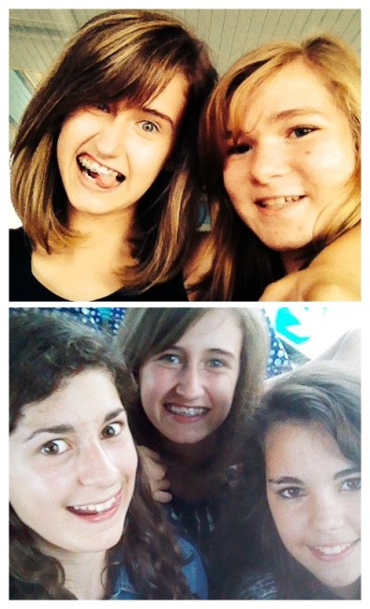 This is my friend and me

This is One Direction!!!!!!!!

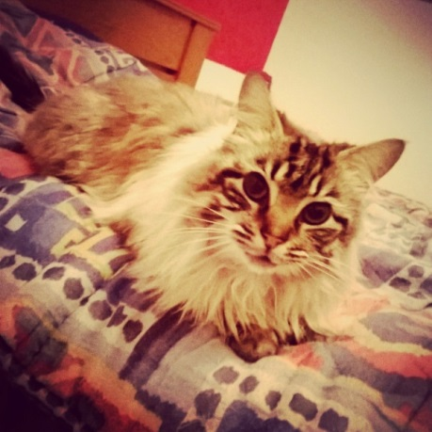 This is my cat, Pacha

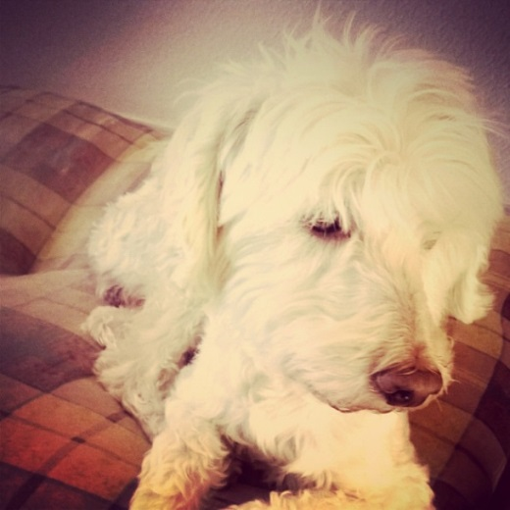 This is my dog, spike

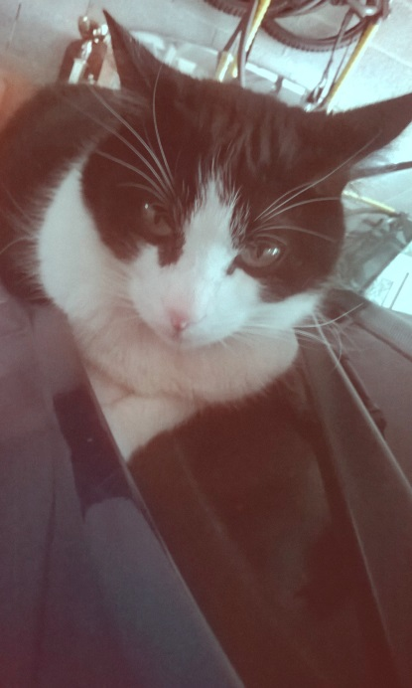 This is Loki, my cat.
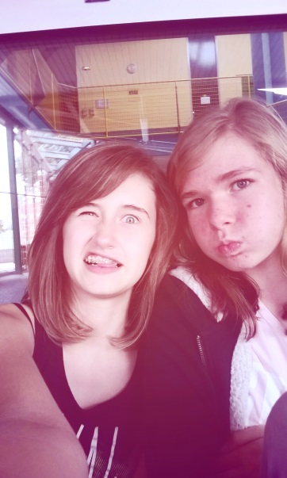 This is me and my best friend!!!

