Pentatonic Heart
(5 tones)

Introduction
Improvisation
Orient Pearl

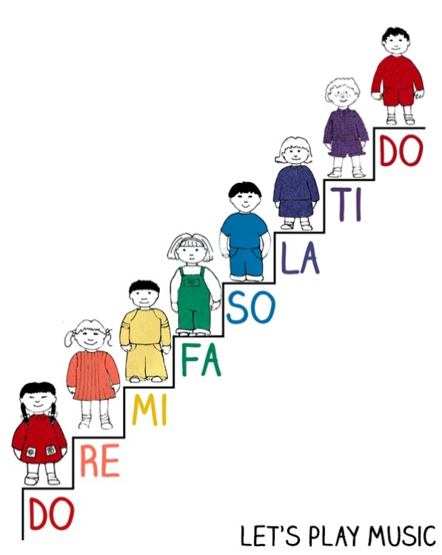

Colour the heart only with the notes of the Pentatonic Scale, using the correspondent colors.

