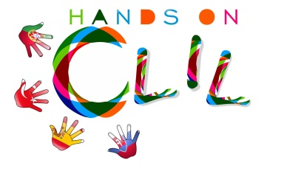

Name and Surname ...............................................................................................................

Date............................................................................

- Read the article and answer the questions:
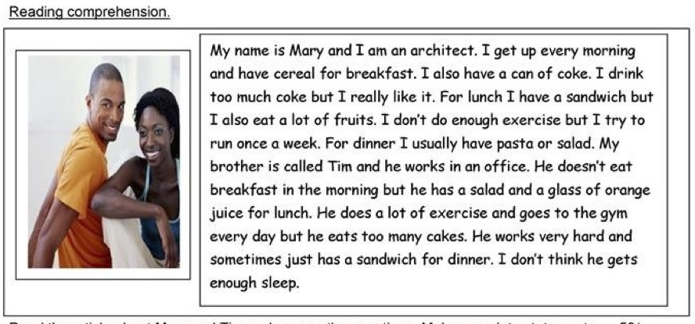

Reading comprehension:

- What does Mary eat in the
morning? ..............................................................................

.............................................................................................................................................

- Who doesn’t drink anything in the
morning? ...................................................................

.............................................................................................................................................

- Who likes eating
sandwiches? .........................................................................................

- Who trains a
lot? ..............................................................................................................

- Who enjoys drinking
soda/pop? .....................................................................................

Writing about healthy habits:

Write about Mary and Tim. In your opnion, which things does Mary do better than Tim to have a healthy life? and Which ones does Tim?

................................................................................................................................................

................................................................................................................................................

................................................................................................................................................

................................................................................................................................................

................................................................................................................................................

................................................................................................................................................

................................................................................................................................................

................................................................................................................................................

Write some pieces of advice to Mary and Tim to have a healthier life: You can use should or shouldn’t.
Ex: Mary should drink more water.

................................................................................................................................................

................................................................................................................................................

................................................................................................................................................

................................................................................................................................................

................................................................................................................................................

2. Complete the vocabulary:
Stew. Meatballs, Rice, Oatmeal, Pizza, Caesar Salad, Stir, Coffee, Tuna Sandwich, Roll up, Yorkshire pudding, Scones, Dice, Salmon, Roast Beef, Grill, Trifle,
Milk, Stuffed tomatoes, Chop, Ice-cream, English Club Sandwich,
Toast, Pancakes, Roast, Tiger Prawns, Fry, Gammon Steak, Yoghourt, Cereals, Steam, Bacon, Muffin, Cookies, Scrumble eggs.
BREAKFAST | LUNCH/DINNER | SNACK | DESSERT | VERBS

Stew. Meatballs, Rice, Oatmeal, Pizza, Caesar Salad, Stir, Coffee, Tuna Sandwich, Roll up, Yorkshire pudding, Scones, Dice, Salmon, Roast Beef, Grill, Trifle,
Milk, Stuffed tomatoes, Chop, Ice-cream, English Club Sandwich,
Toast, Pancakes, Roast, Tiger Prawns, Fry, Gammon Steak, Yoghourt, Cereals, Steam, Bacon, Muffin, Cookies, Scrumble eggs.

