Pentatonic Dice

Introduction
Improvisation
Orient Pearl

Find a partner and play the Pentatonic Dice with him.
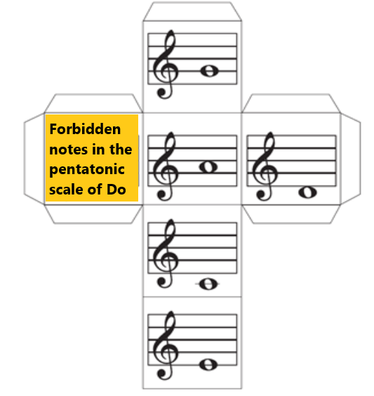
Throw the dice and identify the note. There is one side of the dice for you to name the forbidden notes on the pentatonic scale of Do.

