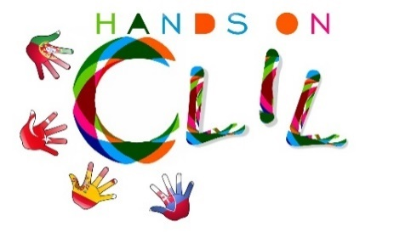
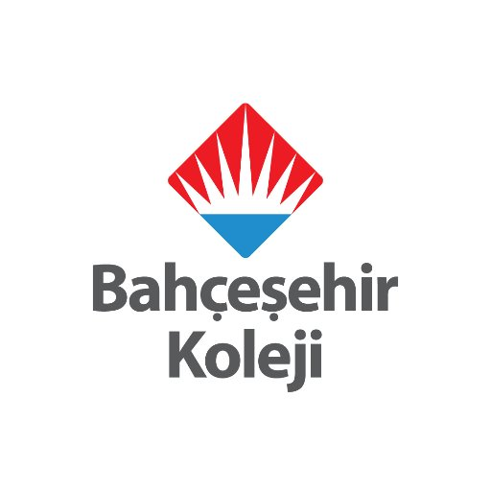

CLIL LESSON PLAN
CLIL PATHWAY: ART | LEVEL: Primary Education (1st grade)
CLIL MODULE: Art and Craft | CLIL TOPIC: Baby Animals
LESSON 1 | TIME: 40 minute
TEACHING AIMS | MATERIALS
- To recognise the different forms of animals  - To identify the meaning of the question “what is the baby cow?”  - To identify the baby animals with basic vocabularies  - To give short answers for the question “ what is this?” | - Projector, slides,  - Board, board marker  - As real material, sticks ,glue, paper, pencil and crayons
LEARNING OUTCOMES - 4Cs
CONTENT | COGNITION
- Slides of different big animals’ picture like cat,cow...  - To identify them as mother form  - To give short answers like “It is a..”  - To make little puppets of animals to talk with stick,paper and glue. | - Identifying different physical apperances of big and baby animals with their names.
CULTURE | COMMUNICATION
- Developing awareness about the animals and their baby form | Language Function: Students can give short answers for the questions like “Is it a...?” as “Yes, It is... or No, It isn’t.”  Vocabulary: big,small, baby, mom,cow,calf, kat, kitten, dog, puppy,chicken, chick...  - Verb: to be  Language structure:  - Is it a mom or baby?/ Yes, It is / No, I isn’t  It is a...
ACTIVITIES
STEPS:
Step 1 – To tune pupils into English
- Teacher /pupils greet each other in English.

Step 2- To help pupils understand what the lesson is about
- Teacher asks the name of some farm animals.

Step 3 – Talking about the mom and baby animals
- Teacher shows a chicken and asks “ is it a baby chicken?”

Step 4 – Introducing the body parts
- Teacher shows the baby chicken and says “It is a chick” by imitating chick sound.
-T “cow,calf,chicken,chick,dog,puppy,sheep,lamb,cat,kitten”
- And gives the other structures
- Teacher lets them repeat

Step 5 – Oral feedback
-Teacher shows the picturs of presentation and wants them to read and repeat together

Step 6 – Post Activity
-Teacher gives papers fo all students. They draw a baby and mom animal. And SS write It’s a cow and It’s a calf then cut them and stick them to the stick and they use them as little puppets

Step 7 – To end lesson
- Pupils tidy up classroom.

Author | School: Bahcesehir College Turkey in Gaziantep-2018 may

