PARTS OF A PLANT

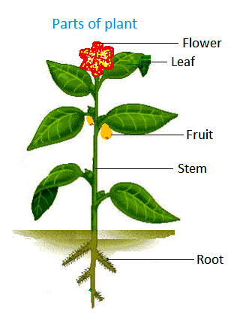
Plants have three main parts: roots, stem and leaves.

• Roots: are in the soil. They obtain food and water from the soil and provide support for the plant.
• Leaves: they breathe and make the plants ‘food.
• Stem: It is the part of the plant that holds up the leaves and flowers. It carries water and minerals up from the roots to the leaves.

CLASSIFICATION OF PLANTS
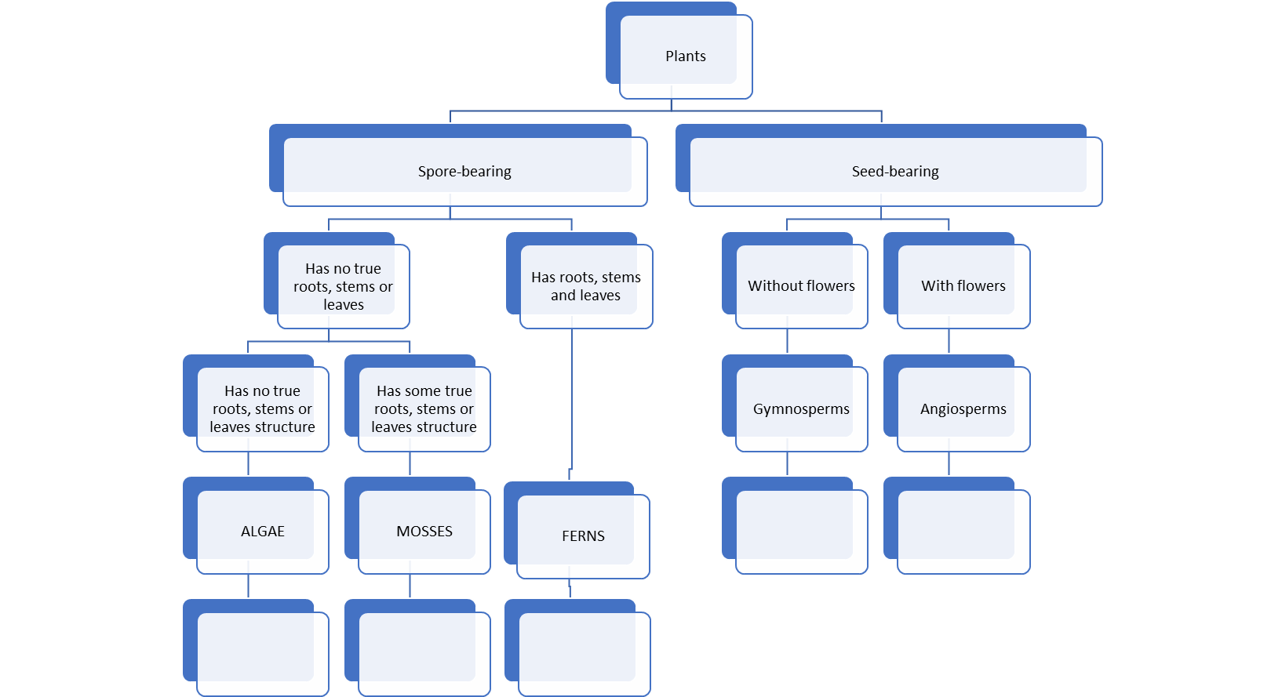

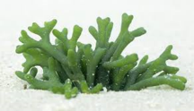
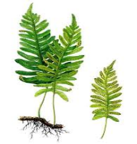
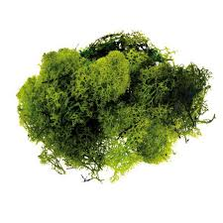
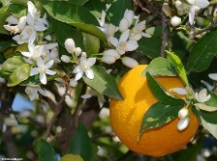
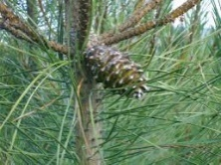

On our planet there are more than 250 000 different species of plants. We may classify all these species in different ways. One of this classification is like the scheme above: plants with spore and plants with seeds. Plants with seeds are the biggest group so plants with spore are the smallest one. Most of the time seeds are in the fruit and fruit comes after the flower. Plants with spores like wet habitats.
ALGAE – Plants that have got no roots, stem or leaves, they also have not conductive vessels.
MOSSES - Mosses are very small and simple plants. They have very small roots which are fixed to the ground, to rocks, or to trees.
FERNS - Ferns have an underground stem and big leaves.
GYMNOSPERMS - They do not have flowers and fruit, but they have naked seeds. Most of them are trees that have evergreen leaves.
ANGIOSPERMS - They have flowers and fruit. The seeds are protected by the fruit.

HOMEWORK
Create a Kahoot about what you have learnt in class about the classification and the parts of a plant.

