PRE /POST-TEST in MUSIC – WORLD MUSIC
GROUP OF STUDENTS: 6TH Grade - 21 students - Age: 10-11

Questions and answers in the pre-test and post-test:
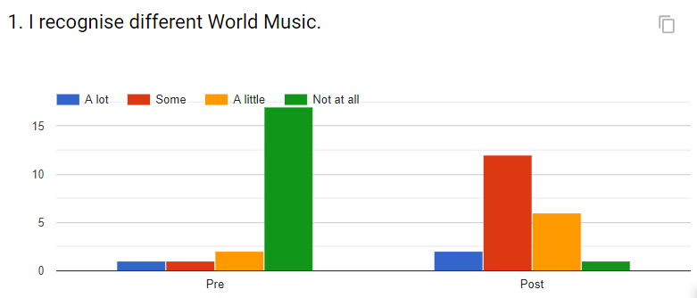
In the pre-test 81% of the students say they don’t recognise different world music but in the post- test 57% says some and 10% recognize a lot, the percentage of “not at all” drops to 5%.

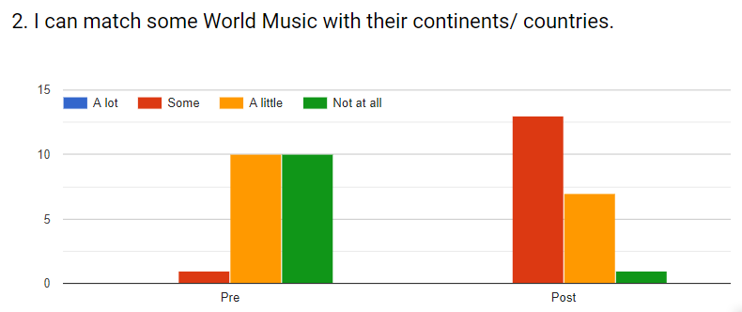
Only 5% of the students can match some World Music with their continents/ countries. After the lesson, 62% refer can match some World Music with their continents/ countries.

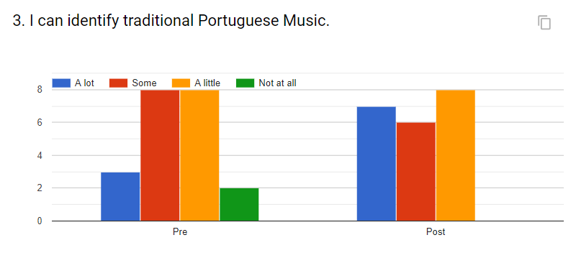
9,5% of the students don’t identify traditional Portuguese music in the pre-test but in the post the students identify “a lot”, “some” or “a little”. We see that 33,3% think they can identify “a lot”.

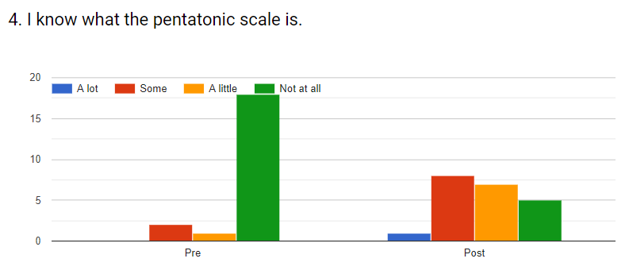
85,7% of the students don’t know what pentatonic scale is in the pre-test but in the post only 23,8%” don’t know what the pentatonic scale is.

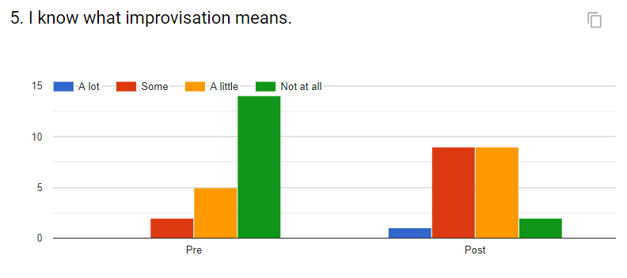
66,7% of the students don’t know what improvisation means in the pre-test but in the post-test only 9,5% don’t know it.

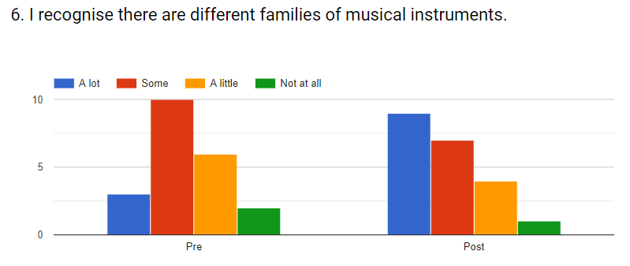
14,3% recognize there are different families of musical instruments, 47,6% recognize some families and 9,5% don’t recognize any in the pre-test. In the post-test, 42,9% recognize a lot and only 4,8% don’t recognize any.

June 2018

