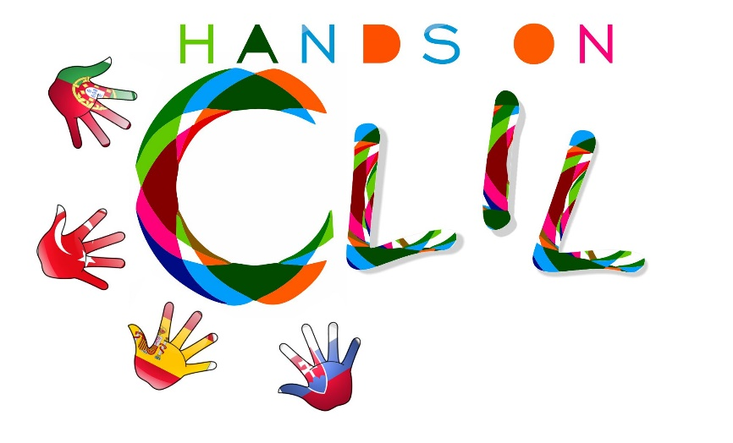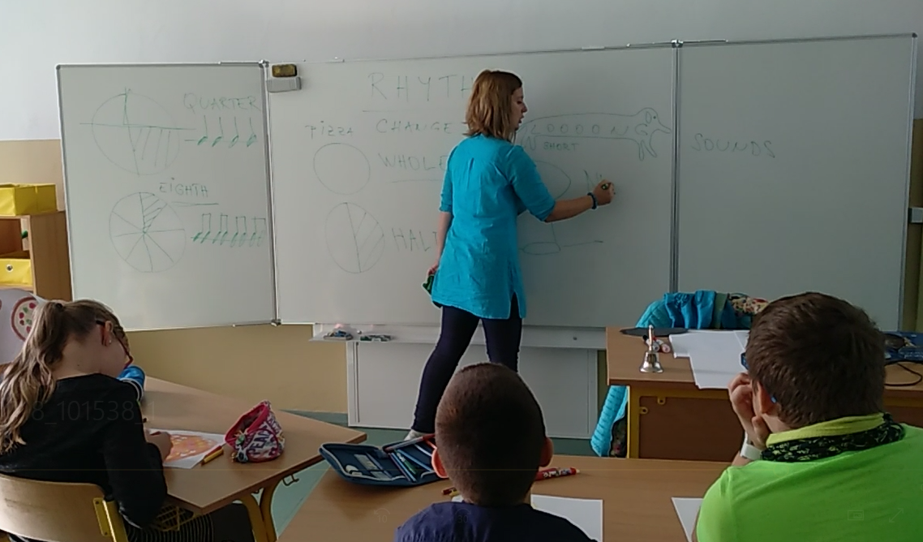

**CLIL TOOL KIT**

**A guide for teachers on how to use CLIL Methodology in Primary Education**



**Author:** Agrupamento de Escolas de Marco de Canaveses (Project Coordinator)



**Copr:** Hands On CLIL, 2017

Strategic Partnerships (Key Action 2)

Project number: 2017-PT01-KA219-035912_1

**Partner Schools**

Agrupamento de Escolas de Marco de Canaveses, Portugal, [www.aescolasmarco.com](http://www.aescolasmarco.com)

ZŠ Škultétyho, Slovakia, <https://zsskultetyhonitra.edupage.org>

CEIP Puig d’en Valls, Spain, <http://www.c07005091.eduwebs.caib.es>

Ozel Gaziantep Bahçesehir Ortaokuly, Turkey, <http://www.bahcesehir.k12.tr/tr>

**Communication Channels**

eTwinning: <https://twinspace.etwinning.net/45364/home>

Facebook: <https://www.facebook.com/handsonclil/>

Website: <https://handsonclil.weebly.com/>

This guide was supported by the Erasmus+ Programme of the European Commission. This publication reflects the views only of the authors, and the Commission cannot be held responsible for any use which may be made of the information contained herein.

The CLIL Tool Kit shall be considered an open educational resource and cannot be used for any commercial purposes. All its contents are free for download at the official project website: (under construction) and eTwinning page: <https://twinspace.etwinning.net/45364/home>.

This work is licensed under a Creative Commons Attribution-NonCommercial-ShareAlike 4.0 International License.

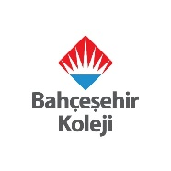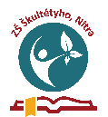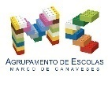

**Table of contents**

1. CLIL TOOL KIT ………………………………………………………………………………………………… 4
2. The principles of CLIL ……………………………………………………………………………………. 5
3. The principles for planning CLIL lessons ………………………………………………………… 6
   1. Hands On CLIL Lesson Plan Template – An example… ………………………. 7
4. Standard classroom language for the pupils …………………………………………………. 9
5. Standard classroom language for the teacher ……………………………………………… 10
6. Monitoring & Assessment in CLIL …………………………………………………………………. 11
7. Appendix 1: A CLIL Lesson Plan Template for CLIL pathways ………………………… 12
8. Appendix 2: A CLIL Pre-and Post-test (Pupil’s perspective) …………………………… 16
9. Appendix 3: CLIL Tool Kit Guide Evaluation (Teacher’s perspective) …………….. 17
10. References …………………………………………………………………………………………………… 18

## **CLIL TOOL KIT**

The aim of this guide is to provide guidelines for CLIL TOOL KIT use within Hands On CLIL project framework for Primary Education.

The objective of the project is to design **4 CLIL Pathways** for the following subject areas and understand its impact on both teachers and pupils teaching and learning paths using bilingual methodology.

* Science
* Arts & Crafts
* Music
* Physical Education

The above subject areas have further been divided into **Modules** as follows, which will be organised around a sequence of **3 lessons** of 90’ each, following a logical sequence growing from the most general class approach towards a more specific approach into the form of a project, presentation, etc.

* **Science**
  + The Amazing World of the Human Body
  + …
* **Arts & Crafts**
  + The Amazing World of Traditional Arts & Crafts
  + …
* **Music**
  + The Amazing World of Music
  + …
* **Physical Education**
  + The Amazing World of Football
  + …

Each lesson will be organised around a **lesson template**, a **pre and post-test** for pupils and a **module evaluation** for teachers, in accordance with the layouts presented in the CLIL Tool Kit.

**The principles of CLIL**

With CLIL – Content and Language Integrated Learning – we name the teaching of any non-language-subject through the medium of a language which is not the mother tongue. It differs from traditional teaching a subject in a foreign language in such a way that with CLIL you focus knowledge of an unknown content using thinking skills to understand, analyse, synthesize, evaluate and communicate about.

The CLIL methodology is organised around some principles generally known as the **CLIL 4 Cs Framework** – Content, Communication, Cognition and Culture – as defined by Do Coyle, 2005, as shown in table 1.

***Table 1.*** *The 4 Cs of CLIL, Do Coyle, 2005*

**The principles for planning CLIL lessons**

Teachers need to structure each lesson plan in detail in order to cover all key issues:

***Table 2.*** *Key principles for lesson planning*

|  |  |
| --- | --- |
| **KEY PRINCIPLES** | |
| **The 4Cs** | Each lesson should contain at least one other element of the 4Cs of CLIL besides Content: Communication, Cognition or Culture. |
| **Prior knowledge** | Invite students to make connections of their prior knowledge and experiences with the new knowledge. |
| **Learning objectives** | What students are expected to learn (content and language). |
| **Activities** | Identify procedures and task-based learning that involve students in real communication. |
| **Materials & resources** | Select from relia, visual materials, videos, songs, etc. Increase visualization because it supports pupils’ understanding and motivation. |
| **Type of assessment** | Observation, self-assessment, pre and post-test, journal/ portfolio, etc. |

Within the Hands On CLIL project framework, each CLIL pathway will be organised around a colour code lesson template, designed by each partner country and to be applied by all partners’ schools. A model will be provided and discussed beforehand within the partnership.

A CLIL lesson generally has the **following steps** performed in English[1]:

**Step 1 - Welcome routine** /tuning into English. Teacher and pupils greet each other (*good morning/good afternoon, how are you?)*. Write the date on the board. Pupils fill in a weather chart…

**Step 2 - Introduction to lesson aim:** pupils are told what they are going to learn and do (Today we are going to…). Teacher invites pupils to answer the pre-test and reflect upon what they know /don’t know about the subject /topic.

**Step 3 - Presentation of new content -** Teacher explains step by step what children have to do and models. Teacher checks if every student understands what they have to do.

**Step 4** - **Pupils do their work.** Teacher walks around the class to check how the children are doing. Teacher helps out (in English).

**Step 5** - **Evaluation.** Teacher checks:

a. If pupils enjoyed the lesson by using smiles/thumbs up;

b. If pupils achieved the learning objectives by asking some questions: post-test.

**Step 6 –** **Wrap of the lesson.** Pupils tidy up and do the Goodbye routine. E.g. chant.

***Table 3.*** *Hands On CLIL Lesson plan Template – An example…*

|  |  |
| --- | --- |
| CLIL LESSON PLAN | |
| CLIL PATHWAY: SCIENCE | **LEVEL:** Primary Education (6th grade) |
| CLIL MODULE: The amazing World of Food | **CLIL TOPIC:** Food Functions, Groups & Nutrients |
| LESSON 1 | **TIME:** 90´ |
|  | |
| TEACHING AIMS | **MATERIALS** |
| - To recognise the different functions of food  - To identify the different food groups and its main nutrients  - To recognise written form of key language  - To develop awareness about food combination that make up a healthy and balanced diet  - To build short sentences  - To work autonomously and proactively, developing collaboratively group strategies | - Pictures of different types of food  - Worksheet 1 – Food Word List (annex 1)  - Worksheet 2 – Food Nutrients (annex 2)  - Worksheet 3 – Advices for healthy diet (annex 3) |
| LEARNING OUTCOMES - 4Cs | |
| CONTENT | **COGNITION** |
| - Recognise the different functions of food  - Identify the different food groups and its main nutrients  - Develop awareness about food combination that make up a healthy and balanced diet | - Identify and sorting food accordingly to its nutrients  - Classify food into different groups  - Select and organise specific information  - Analyse it and report it back to the class |
| CULTURE | **COMMUNICATION** |
| - Develop awareness about what they eat and the importance to develop healthy eating habits  - Recognise the importance of the Mediterranean diet | **Language Function:** Talking about food  **Vocabulary:**  - Natural fruit juice, yoghurt, hamburger, coke, …  - Energy giving (fats, carbohydrates); Body building (proteins, minerals); Regulatory and projective (vitamins, water, minerals, fibre)  **Verb:**  - have got  - can / can’t  **Language structure:**  - I have to drink /eat … /some /very little of /a lot / everyday… because…  - It has got lots of fats /calories /vitamins / minerals  - It has got too much sugar / caffeine / carbon dioxide /… |
| ACTIVITIES | |
| Step 1 – To tune pupils into English  - Teacher /pupils greet each other in English.  - Pupils open the lesson /write the date on their Science notebooks in English.  - Pupils are set into groups of cooperative work in English and set roles like who is going to be the group monitor responsible for reporting back to class the outcome.  Step 2- To help pupils understand what the lesson is about  - Teacher tells pupils what they are going to do. She shows a picture of vegetables and tries to recall what pupils learnt about the food functions, the nutrients and its characteristics. It sticks the picture and its characteristics on the whiteboard as a model.  Step 3 – Talking about food functions and nutrients  - Teacher shows another food picture – hamburger – and elicits oral questions about:  - the food function /food group /main nutrients: What type of food is it? / What nutrients has it got? /It has got fats and carbohydrates. / Does it give you energy? /Can we eat lots of fats? /Is it healthy for you? /Why?  - Teacher and pupils talk about the different food functions /food groups /nutrients.  Step 4 – Group work  - Teacher delivers a food picture per group.  - With the picture, the teacher also delivers 3 colour code worksheets (see annexes) to guide the pupils during their process of sorting and classifying the elements that are part of their food, write the report and the advice for a healthy lifestyle:  - WkS 1 – Food Word List  - WkS 2 - Functions of food, food nutrients & characteristics  - WkS 3 - Advices for a healthy life style  Step 5 – Written work revision  - Going around the groups, teacher reviews with pupils their written assignments, makes suggestions and invites them to copy it to a final A4 paper they will report back to the class.  - Pupils in groups practice their oral report.  Step 6 – Oral classroom report  - Groups’ monitors in turn go in front of the class to report back in English their findings (see videos).  - Teacher and peers provide feedback.  - Pupils stick their final outcomes on the board.  Step 7 – To encourage pupils to reflect on their learning and behaviour /attitudes  - Pupils complete the post-test on classroom content (learning).  - Pupils complete group work assessment sheet.  Step 8 – To end lesson  - Pupils tidy up and say the farewells in English. | |
| EVALUATION | |
| * Immediate feedback after oral classroom report * Completion of pre and post-test (annex 4) * Completion of group work assessment sheet (annex 5) | |

**Standard classroom language for the pupils**

Teach students key language and communication strategies they can fall back on when they are having problems. It also provides them with chunk of language to use in real life situations.

Encourage your students to remember and use in class structures such as:

* *What page please?*
* *Can you repeat, please?*
* *I don’t know / We don’t understand this/that…*
* *We’ve finished /We haven’t finished.*
* *Shall I help him/her?*
* *Excuse me, I don’t understand, How do we say ... in English?*
* *How do we spell...?*
* *Come here, please?*
* *…*

**Standard classroom language for the teacher**

Establishing a set of standard classroom language /routines during CLIL lessons helps pupils understand what is expected of a CLIL lesson, besides providing a safe and comfortable environment for both pupils and subject teacher as they become more confident in the ability of using the second language.

***Table 4.*** *Standard Classroom Language[2][3] for the teacher*

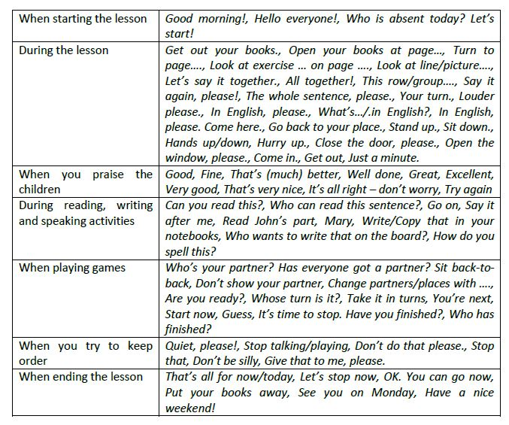

**Monitoring & Assessment in CLIL**

Within the Hands On CLIL framework it is aimed to monitor pupils learning by applying a **pre** and **post-test** for each lesson so pupils get aware of their learning starting point and how far did they get after being exposed to CLIL learning and teaching methodology. It also provides the teacher with information about learner’s performance.

To monitor and evaluate the impact of Hands On CLIL project framework and the present guide on teachers’ professional development, they will be asked to answer a **pre test** on their bilingual methodology knowledge beforehand, and a **post test** after the implementation of the bilingual programme designed. At the end, teachers will also be asked to fill a **CLIL Pathway/ Module Evaluation questionnaire** to evaluate the achievement of project’s objectives.

**Appendix 1 -** A CLIL Lesson Plan Template for CLIL pathways

|  |  |
| --- | --- |
| CLIL LESSON PLAN | |
| CLIL PATHWAY: MUSIC | **LEVEL:** |
| CLIL MODULE: The amazing World of Music | **CLIL TOPIC:** |
| LESSON: | **TIME:** |
|  | |
| TEACHING AIMS | **MATERIALS** |
| - | - |
| LEARNING OUTCOMES - 4Cs | |
| CONTENT | **COGNITION** |
| - | - |
| CULTURE | **COMMUNICATION** |
| - | **Language Function:**  **Vocabulary:**  **Verb(s):**  **Language structure:** |
| ACTIVITIES | |
| Step 1 – To tune pupils into English  Step 2 – To help pupils understand what the lesson is about  Step 3 –  Step 4 –  Step 5 –  Step 6 – To end lesson | |
| EVALUATION | |
| * Immediate feedback after oral classroom report * Completion of post-test | |
|  | |

|  |  |
| --- | --- |
| CLIL LESSON PLAN | |
| CLIL PATHWAY: SCIENCE | **LEVEL:** |
| CLIL MODULE: The Amazing World of the Human Body | **CLIL TOPIC:** |
| LESSON: | **TIME:** |
|  | |
| TEACHING AIMS | **MATERIALS** |
| - | - |
| LEARNING OUTCOMES - 4Cs | |
| CONTENT | **COGNITION** |
| - | - |
| CULTURE | **COMMUNICATION** |
| - | **Language Function:**  **Vocabulary:**  **Verb(s):**  **Language structure:** |
| ACTIVITIES | |
| Step 1 – To tune pupils into English  Step 2 – To help pupils understand what the lesson is about  Step 3 –  Step 4 –  Step 5 –  Step 6 – To end lesson | |
| EVALUATION | |
| * Immediate feedback after oral classroom report * Completion of post-test | |
|  | |

|  |  |
| --- | --- |
| CLIL LESSON PLAN | |
| CLIL PATHWAY: ARTS & CRAFTS | **LEVEL:** |
| CLIL MODULE: The Amazing World of Traditional Arts & Crafts | **CLIL TOPIC:** |
| LESSON: | **TIME:** |
|  | |
| TEACHING AIMS | **MATERIALS** |
| - | - |
| LEARNING OUTCOMES - 4Cs | |
| CONTENT | **COGNITION** |
| - | - |
| CULTURE | **COMMUNICATION** |
| - | **Language Function:**  **Vocabulary:**  **Verb(s):**  **Language structure:** |
| ACTIVITIES | |
| Step 1 – To tune pupils into English  Step 2 – To help pupils understand what the lesson is about  Step 3 –  Step 4 –  Step 5 –  Step 6 – To end lesson | |
| EVALUATION | |
| * Immediate feedback after oral classroom report * Completion of post-test | |
|  | |

|  |  |
| --- | --- |
| CLIL LESSON PLAN | |
| CLIL PATHWAY: PHYSICAL EDUCATION | **LEVEL:** |
| CLIL MODULE: The Amazing World of Football | **CLIL TOPIC:** |
| LESSON: | **TIME:** |
|  | |
| TEACHING AIMS | **MATERIALS** |
| - | - |
| LEARNING OUTCOMES - 4Cs | |
| CONTENT | **COGNITION** |
| - | - |
| CULTURE | **COMMUNICATION** |
| - | **Language Function:**  **Vocabulary:**  **Verb(s):**  **Language structure:** |
| ACTIVITIES | |
| Step 1 – To tune pupils into English  Step 2 – To help pupils understand what the lesson is about  Step 3 –  Step 4 –  Step 5 –  Step 6 – To end lesson | |
| EVALUATION | |
| * Immediate feedback after oral classroom report * Completion of post-test | |
|  | |

**Appendix 2 -** A CLIL Pre-and Post-test (Pupil’s perspective)

**PRE /POST-TEST in SCIENCE - Food Functions, Groups & Nutrients**

The aim of this questionnaire (Knowledge Assessment Questionnaire) is to assess the impact of Science Content Learning by means of bilingual methodology within Primary Education.

**1. I recognise the different functions of food.**

**Pre -** □ A lot □ Some □ A little □ Not at all

**Post -** □ A lot □ Some □ A little □ Not at all

**2. I can identify the different food nutrients.**

**Pre -** □ A lot □ Some □ A little □ Not at all

**Post -** □ A lot □ Some □ A little □ Not at all

**3. I know that Energy giving is mainly provided by carbohydrates and fats in the food.**

**Pre -** □ A lot □ Some □ A little □ Not at all

**Post -** □ A lot □ Some □ A little □ Not at all

**4. I know that for Body building the main nutrients are proteins and minerals.**

**Pre -** □ A lot □ Some □ A little □ Not at all

**Post -** □ A lot □ Some □ A little □ Not at all

**5. I understand that vitamins, water and minerals have a regulatory and protective Body function.**

**Pre -** □ A lot □ Some □ A little □ Not at all

**Post -** □ A lot □ Some □ A little □ Not at all

**6. I can select food that make up a healthy diet.**

**Pre -** □ A lot □ Some □ A little □ Not at all

**Post -** □ A lot □ Some □ A little □ Not at all

**7. I can produce a short text in English describing food functions and its nutrients.**

**Pre -** □ A lot □ Some □ A little □ Not at all

**Post -** □ A lot □ Some □ A little □ Not at all

**8. I can present orally a short text in English describing food functions and its nutrients.**

**Pre -** □ A lot □ Some □ A little □ Not at all

**Post -** □ A lot □ Some □ A little □ Not at all

**Appendix 3 -** CLIL Tool Kit Guide Evaluation (Teacher’s perspective)

**CLIL TOOL KIT GUIDE EVALUATION**

The aim of this questionnaire is to find out the impact of the CLIL Tool Kit Guide in helping the Hands On CLIL participant teachers in implementing bilingual methodology in their classes.

**How prepared are you to adopt a CLIL approach?**

**1. I can explain the key elements of the CLIL approach.**

**Pre -** □ A lot □ Some □ A little □ Not at all

**Post -** □ A lot □ Some □ A little □ Not at all

**2. I can describe CLIL to involve other teachers, students and parents.**

**Pre -** □ A lot □ Some □ A little □ Not at all

**Post -** □ A lot □ Some □ A little □ Not at all

**3. I can select the contents of my subject/ of a topic to be taught in English.**

**Pre -** □ A lot □ Some □ A little □ Not at all

**Post -** □ A lot □ Some □ A little □ Not at all

**4. I can design original learning activities in English.**

**Pre -** □ A lot □ Some □ A little □ Not at all

**Post -** □ A lot □ Some □ A little □ Not at all

**5. I can create my own materials (worksheets, flashcards, presentations) in English to be used in class.**

**Pre -** □ A lot □ Some □ A little □ Not at all

**Post -** □ A lot □ Some □ A little □ Not at all

**Appendix 4 -** CLIL Module Evaluation (Teacher’s perspective)

…

**REFERENCES:**

1. CLIL for CHILDREN (2016). *Guide Addressed to Teachers on how to use CLIL Methodology in Primary Schools*. Report 3/A5- Ver.01 – C4C - CLIL for Children, Erasmus+ STRATEGIC PARTNERSHIPS (KEY ACTION 2), Project number: 2015-1- IT02-KA201-015017, available at: <http://www.clil4children.eu>.
2. Ioannou-Georgiou, S. and Pavlou, P. (eds.) (2011). *Guidelines for CLIL Implementation in Primary and Pre-Primary Education*. PROCLIL. Online publication available at [http://www.schools.ac.cy/klimakio/Themata/Anglika/teaching_material/clil/guidelines forclilimplementation1.pdf](http://www.schools.ac.cy/klimakio/Themata/Anglika/teaching_material/clil/guidelines%20forclilimplementation1.pdf).

1. Adapted from C4C - CLIL for Children Erasmus+ project, Report 3/A5 – Ver.01 – 2016.
2. Table taken from C4C - CLIL for Children Erasmus+ project, Report 3/A5 – Ver.01 – 2016.
3.