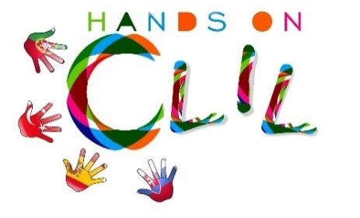
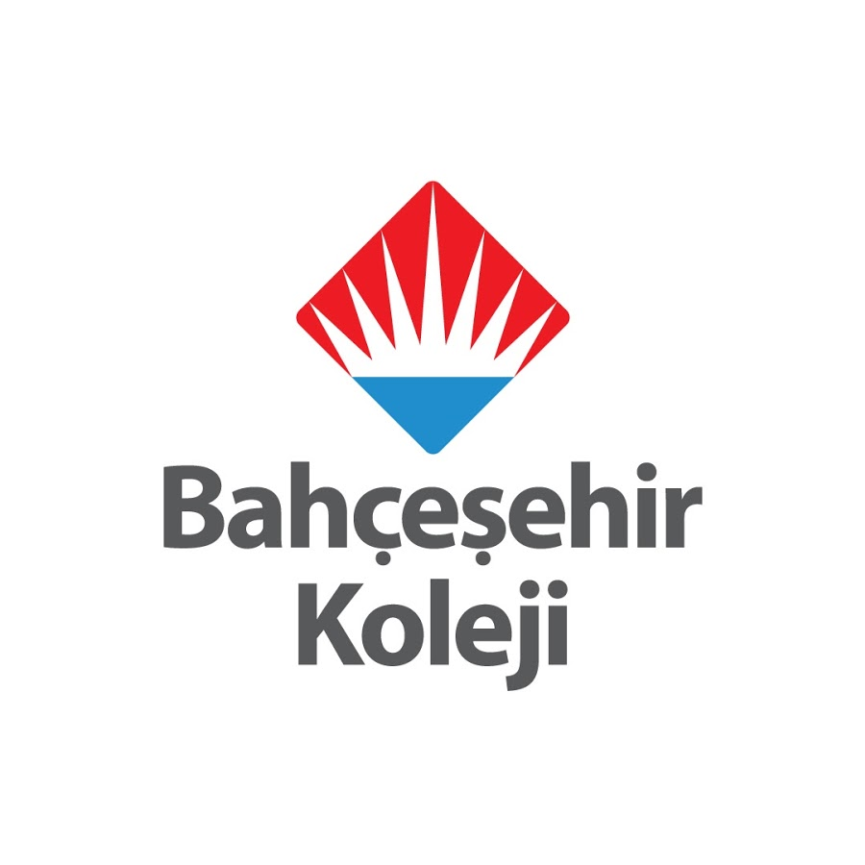

CLIL LESSON PLAN
CLIL PATHWAY: ARTS&CRAFTS | LEVEL: Primary Education (6th grade)
CLIL MODULE: The amazing World of Traditional Arts &Crafts | CLIL TOPIC: CINI ART
LESSON: 4 | TIME: 180’
TEACHING AIMS | MATERIALS
- teachıng aims  -To recognise the different functions of çini art  - To recognise written form of key language  - To build short sentences  - To work autonomously and proactively, developing collaboratively group strategies | - Pictures of different types of traditional cini art  - marker pens  - Worksheet 1 – art Word List (annex 1)
LEARNING OUTCOMES - 4Cs
CONTENT | COGNITION
- - To recognize the different functions of cini art  - Define different art groups  - Recognize the spoken keychain  - Developing yourself about this art | - Identify and sorting work accordingly to its art  - Classify traditional hand crafts into different groups  - Select and organise specific information  - Analyse it and report it back to the class
CULTURE | COMMUNICATION
-- Develop awareness about what cini art is and the importance to develop cini art habits  - Recognise the importance of the traditional hand crafts | Language Function: Talking about traditional cini art  Word: Cini Art,  CINI MOTIF:  DRAWING / MOTIF:  OUTDOOR / INNER WALL:  CERAMIC ART:  VASE:  COLORING:  HERBAL:  DECORATION:  PORCELAIN DECORATION:  Chalk / SAND / KAOLIN:  LINING:  DOUGH:  COAL POWDER:  DRAWING PATTERNS:  VARNISH:  OVEN to:  GEOMETRIC PATTERNS:  MANSION:  PALACE:  TOMB:  Verb:  - have  - can / can not  Language structure:  - to paint / a little / very little / very  ... because ...  - There are a lot of colors
ACTIVITIES
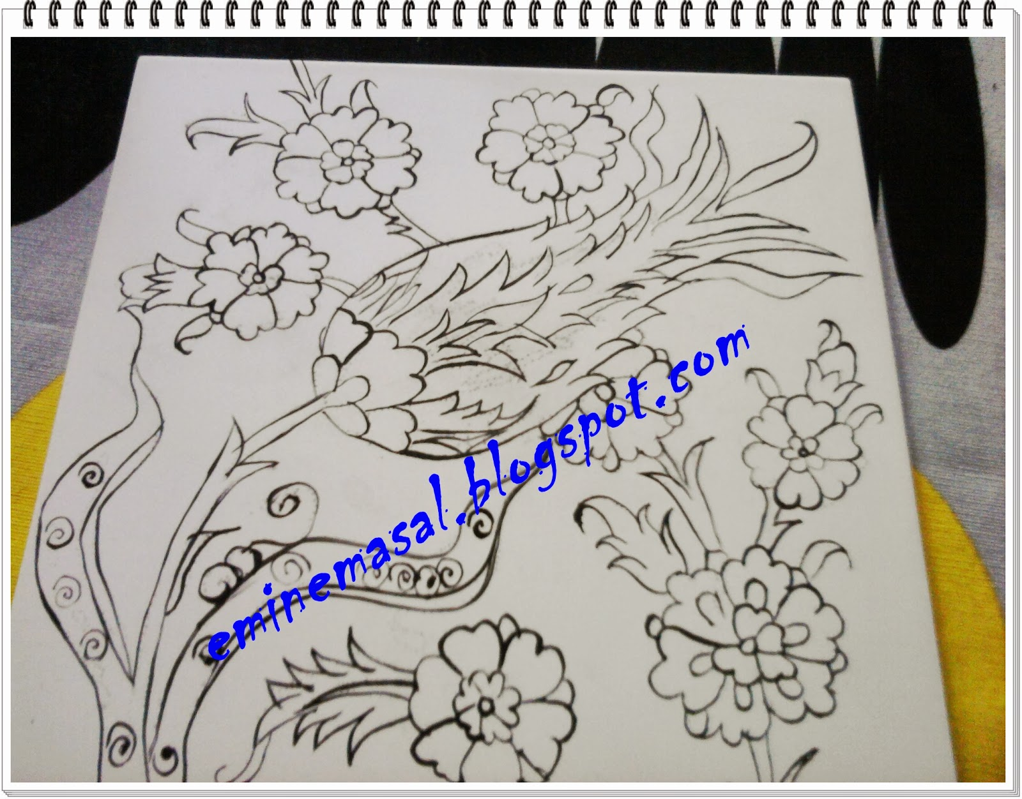

- First start with drawing the basic leaf design on the paper. Drawing leaf design like this is named as composition and its painting is named as “composition paint”.

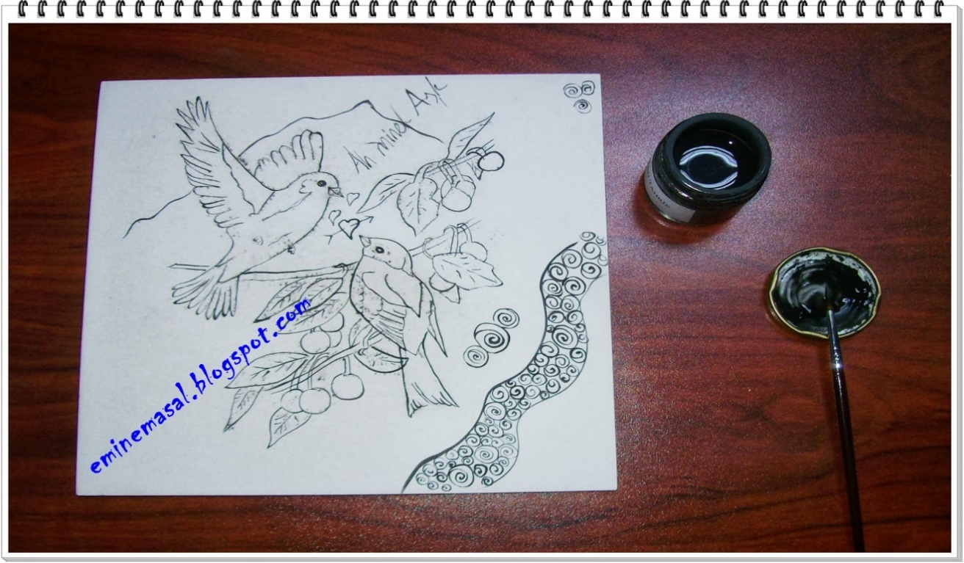

- You need a tile for çini.
- Then choose a design and draw on parchment paper, drill with bean needleon the paper from its contour lines.
- Fill a sock with coal dust and put your paper on your tile and start pressing from the center to out of the paper.Optain a design on tile.

- With your brush, paint your design.

- As drawing be careful holding the brush

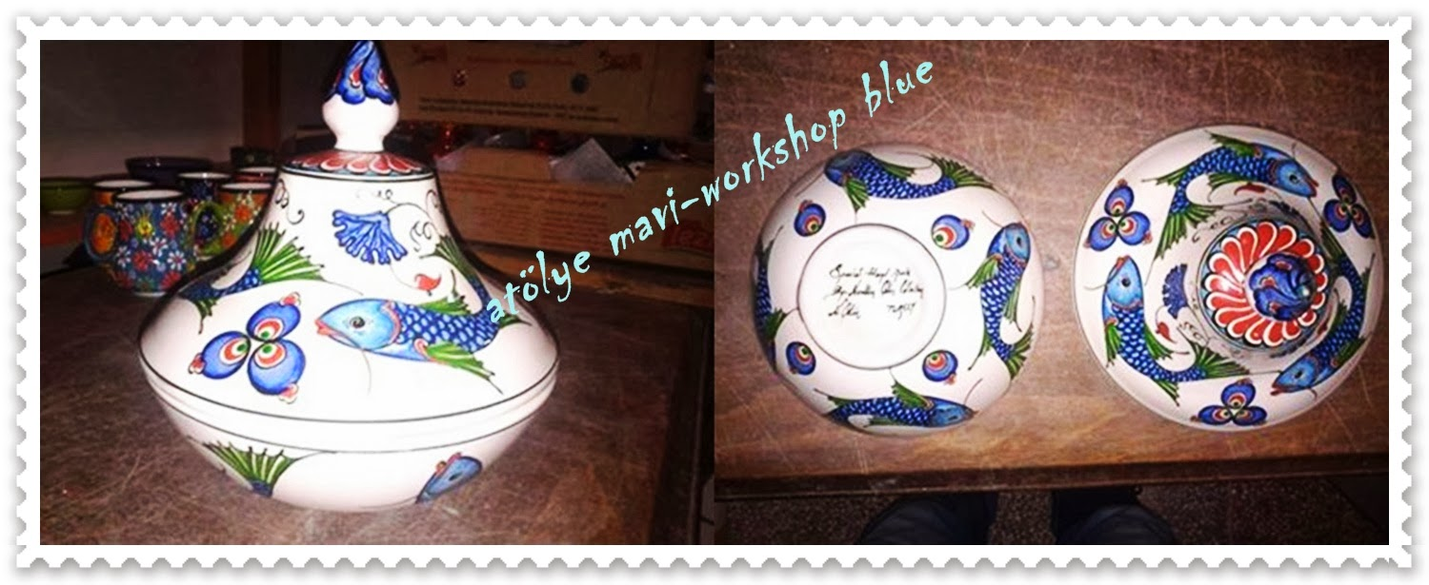

This work belongs to Nurettin Çetin.

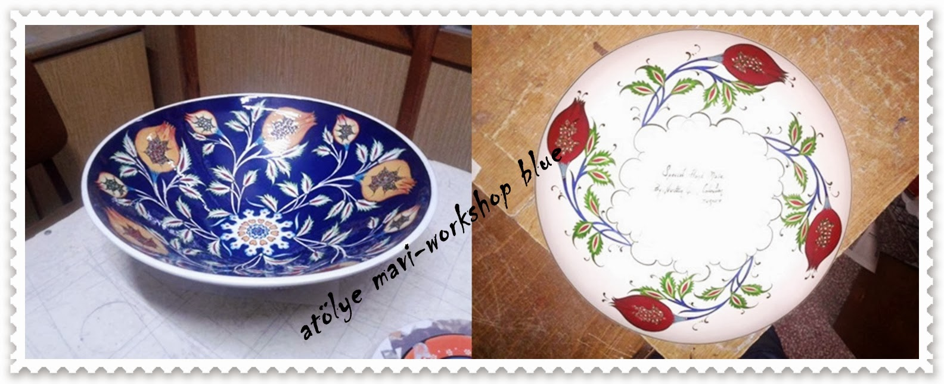

EVALUATION
- Immediate feedback after oral classroom report
- Completion of pre and post-test (annex 4)
- Completion of group work assessment sheet (annex 5)

Author | School:_Gaziantep Bahçeşehir College, 2018

