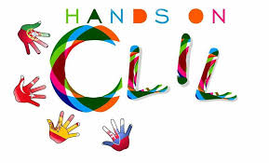
PRE/POST-TEST in CLİL ART LESSON –“COPPER ART”
The aim of this questionnaire (Knowledge Assesment Questıonnaire) is to assess the ımpact of art learning by means of bilingual methodology within Primary Education.
- I recognise the different functions of traditional handcrafts.
Pre - O A lot O A little O Not at all

- I can identfy the different kinds of handcrafts
Pre - O A lot O A little O Not at all

- I know that traditional handicrafts are made entirely of handmade and natural materials.
Pre - O A lot O A little O Not at all

- I know that,COPPER ART is made of ,
zinc
layer
masterpiece
ware
casting
wrought
plastering
press
hammer
Pre - O A lot O A little O Not at all

- I understand that COPPER art needs , natürel materials
Pre - O A lot O A little O Not at all

- I can choose the colors and tones I want in my art work.
Pre - O A lot O A little O Not at all

- I can produce a short text describing English, about the art work I did this week.
Pre - O A lot O A little O Not at all

- I can present orally a short text in english describing about the art work I did this week.
Pre - O A lot O A little O Not at all

- I can use the technical words I learned this week to tell the art work.
Pre - O A lot O A little O Not at all

- This workshop work that I do, develops me in the field of art.
Pre - O A lot O A little O Not at all
Name-surname:
Date: …./…./……………….

