PRE /POST-TEST in ARTS & CRAFTS– THE RELIEF ART
GROUP OF STUDENTS: 6TH Grade - 19 students - Age: 10-11

Questions and answers in the pre-test and post-test:
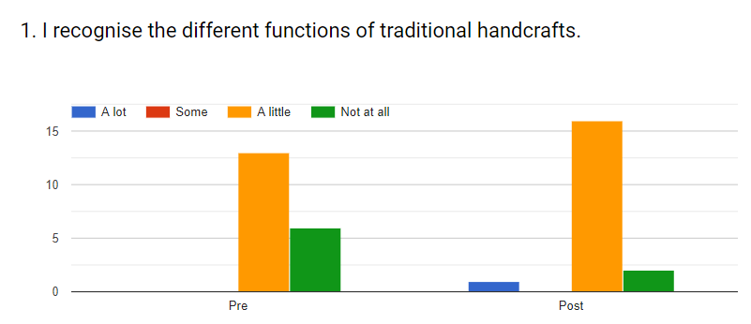
In the pre-test, 68,4% of the students recognize the different functions of traditional
handcrafts “a little” and in the post-test 5,3% recognize “a lot” and 84% a “little”. “Not at all” has been reduce from 31% to 10%.

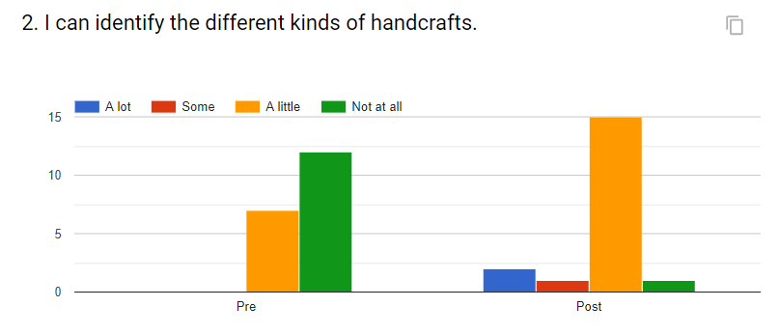
In the pre-test 63% refer “not at all” as far as the ability to identify different kinds of handcrafts. In the post-test only 5,3% can’t identify different kinds of handcrafts.

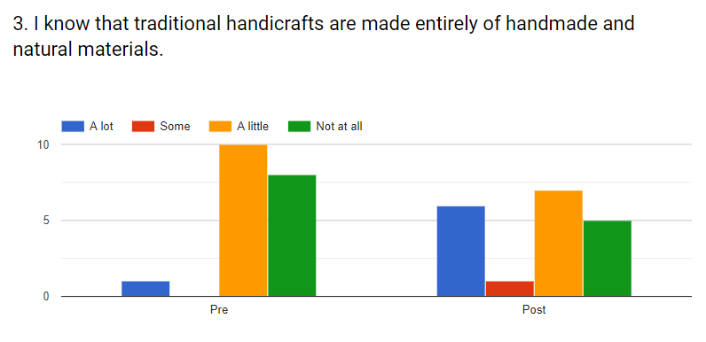
In the pre-test most answers are between “not at all” and “a little”, only 5,3% say “a lot”. In the post-test only 26% can’t identify and there are 31,8% of the students saying “a lot”.

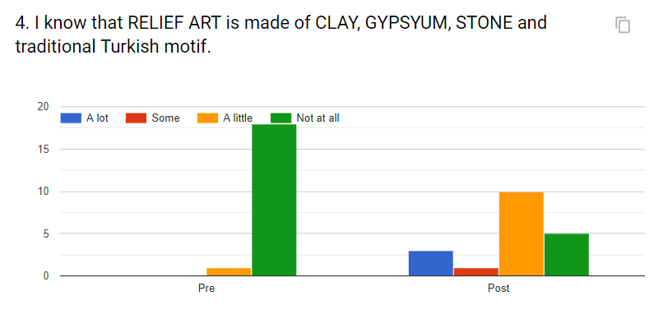
In the pre-test 94,7% of the students answer “not at all”; in the post-test only 26,3% don’t know that relief art is made of clay, gypsum, stone and traditional Turkish motif.

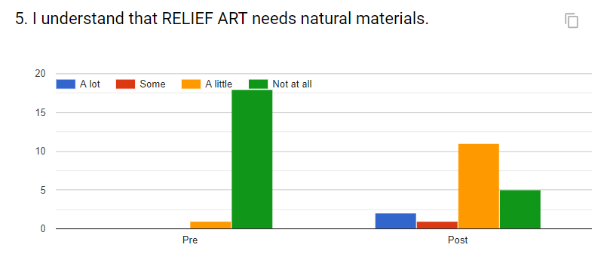
In the pre-test 94,7% of the students answer “not at all”, in the post-test only 26,3% continue not to understand that relief art needs natural materials.

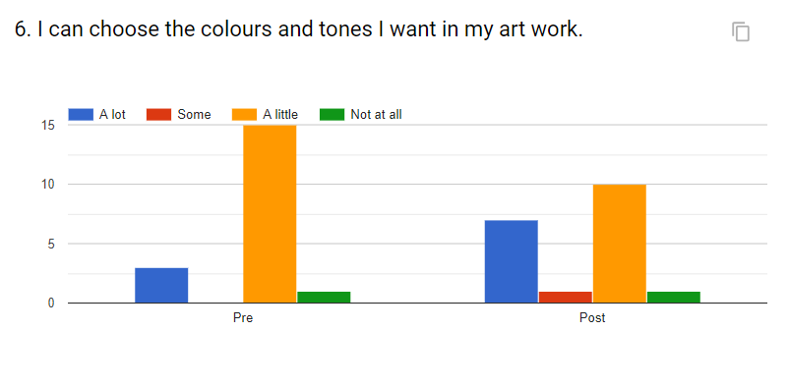
In the pre-test 78,9% of the students answer “a little” and 15,8% “a lot”. In the post-test 52,6% answer “a little” and 36, 8% say “a lot”.

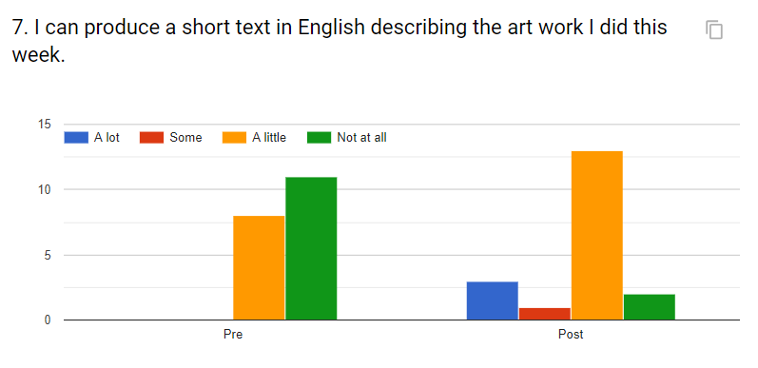
In the pre-test the answers are between “not at all” and “a little”. In the post-test 68% of the students can produce “a little”.

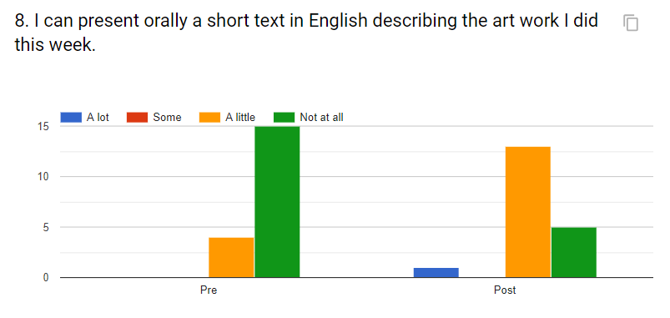
In the pre-test 94,7% of the students say “not at all”. In the post-test only 26% can’t present orally a short text in English describing the art work they did.

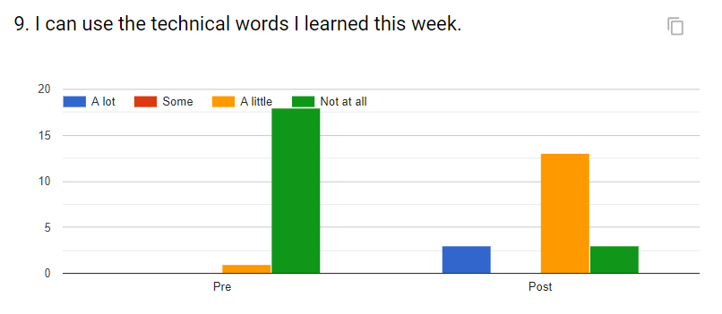
94,7% of the students can’t use technical words in the pre-test and in the post-test only 15,8% recognize that can’t use technical words.

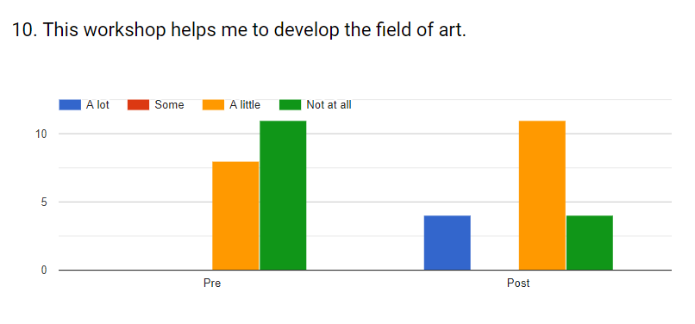
In the pre-test the answers are between “a little” and “not at all”, 42% and 57,9% respectively. In the post-test 21% answer “not at all” and also 21% “a lot”.

June 2018

