PRE /POST-TEST in MUSIC – Music notes and Do Major Scale
GROUP OF STUDENTS: 6TH Grade - 21 students - Age: 10-11

Questions and answers in the pre-test and post-test:
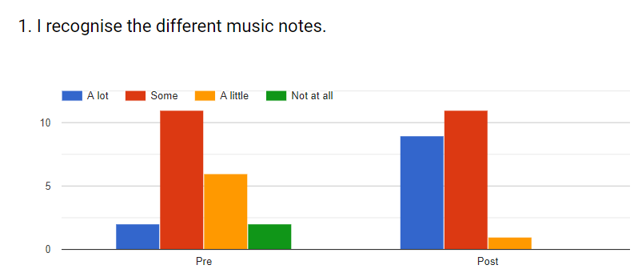
In the pre-test only 9,5% of the students recognize “a lot” and “not at all”. In the post-test no one says “not at all” and 42,9% states “a lot” and 52,4% “some”.

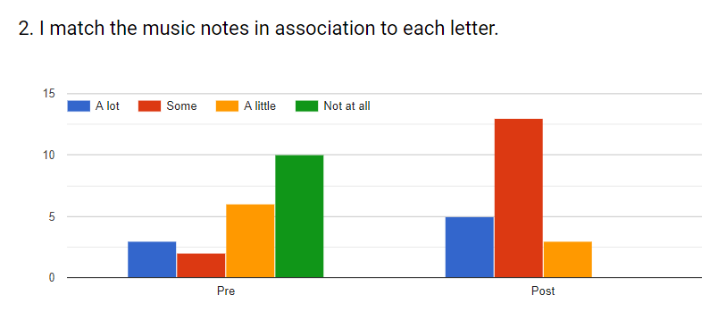
In the pre-test, 47,6% of the students answer “not at all”. In the post-test 61,9% answer that can match “some” and none say “not at all”.

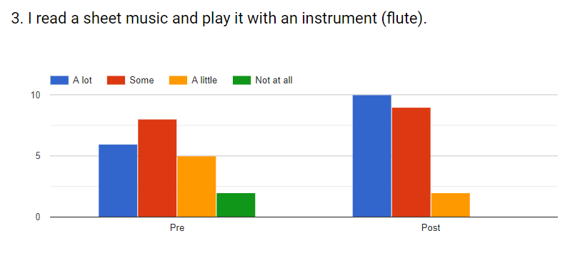
In the pre-test, 9,5% of the students answer “not at all”. In the post-test no one answers “not at all”, and the answers “a lot” and “some” increase to 47,6% and 42,9% respectively.

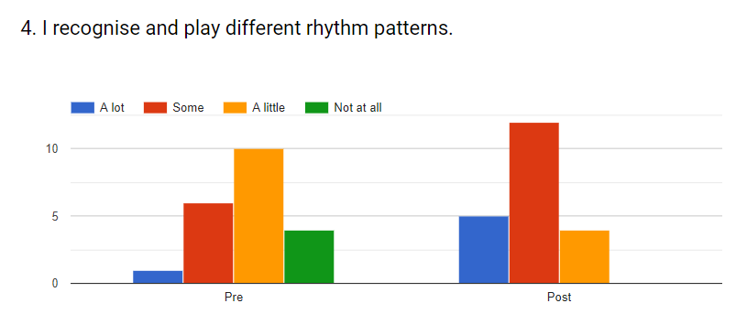
19% of the students don’t recognize and don’t play different rhythms (“not at all”) and only 4,8% recognize and play “a lot”, in the pre-test. In the post-test 53,8% recognize and play “a lot”, 57% “some” and no one says “not at all”.

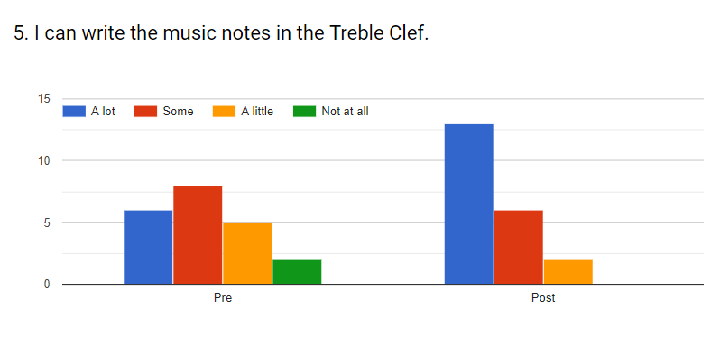
28,8% answer “a lot”, 38% “some” and 9,5% “not at all”, in the pre-test. In the post-test no one says “not at all”, 61,9% answer “a lot” and 28,8% “some”.

June 2018

