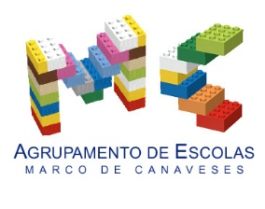
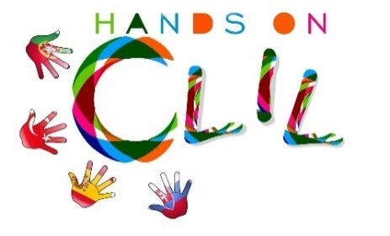

CLIL LESSON PLAN
CLIL PATHWAY: SCIENCE | LEVEL: Primary Education (6th grade)
CLIL MODULE: The amazing World of Food | CLIL TOPIC: Food Pyramid & Healthy Habits
LESSON 1 | TIME: 90´
TEACHING AIMS | MATERIALS
- To recognise the different functions of food  - To identify the different food groups and its main nutrients  - To recognise written form of key language  - To develop awareness about food combination that make up a healthy and balanced diet  - To build short sentences  - To work autonomously and proactively, developing collaboratively group strategies | - Pictures of different types of food  - Worksheet 1 – Food Word List (annex 1)  - Worksheet 2 – Food Nutrients (annex 2)  - Worksheet 3 – Advices for healthy diet (annex 3)
LEARNING OUTCOMES - 4Cs
CONTENT | COGNITION
- To recognise the different functions of food  - To identify the different food groups and its main nutrients  - To recognise written form of key language  - Develop awareness about food combination that make up a healthy and balanced diet | - Identify and sorting food accordingly to its nutrients  - Classify food into different groups  - Select and organise specific information  - Analyse it and report it back to the class
CULTURE | COMMUNICATION
- Develop awareness about what they eat and the importance to develop healthy eating habits  - Recognise the importance of the Mediterranean diet | Language Function: Talking about food  Vocabulary:  - natural fruit juice, yoghurt, hamburger, coke, …  - Energy giving (fats, carbohydrates); Body building (proteins, minerals); Regulatory and projective (vitamins, water, minerals, fibre)  Verb:  - have got  - can / can’t  Language structure:  - I have to drink /eat … /some /very little of /a lot / everyday… because…  - It has got lots of fats /calories /vitamins / minerals  - It has got too much sugar / caffeine / carbon dioxide /…
ACTIVITIES
Step 1 – To tune pupils into English
- Teacher /pupils greet each other in English.
- Pupils open the lesson /write the date on their Science notebooks in English.
- Pupils are set into groups of cooperative work in English and set roles like who is going to be the group monitor responsible for reporting back to class the final outcome.

Step 2- To help pupils understand what the lesson is about
- Teacher tells pupils what they are going to do. She shows a picture of vegetables and tries to recall what pupils learnt about the food functions, the nutrients and its characteristics. It sticks the picture and its characteristics on the whiteboard as a model.

Step 3 – Talking about food functions and nutrients
- Teacher shows another food picture – hamburger – and elicits oral questions about:
- the food function /food group /main nutrients: What type of food is it? / What nutrients has it go? /It has got fats and carbohydrates. / Does it gives you energy? /Can we eat lots of fats? /Is it healthy for you? /Why?
- Teacher and pupils talk about the different food functions /food groups /nutrients.

Step 4 – Group work
- Teacher delivers a food picture per group.
- With the picture, the teacher also delivers 3 colour code worksheets (see annexes) to guide the pupils during their process of sorting and classifying the elements that are part of their food, write the report and the advice for a healthy lifestyle:
- WkS 1 – Food Word List
- WkS 2 - Functions of food, food nutrients & characteristics
- WkS 3 - Advices for a healthy life style

Step 5 – Written work revision
- Going around the groups, teacher reviews with pupils their written assignments, makes suggestions and invites them to copy to a final A4 paper they will report back to the class.
- Pupils in groups practice their oral report.

Step 6 – Oral classroom report
- Groups’ monitors in turn go in front of the class to report back in English their findings (see videos).
- Teacher and peers provide feedback.
- Pupils stick their final outcomes on the board.

Step 7 – To encourage pupils to reflect on their learning and behaviour /attitudes
- Pupils complete the post-test on classroom content (learning)
- Pupils complete group work assessment sheet

Step 8 – To end lesson
- Pupils tidy up and say the farewells in English

EVALUATION
- Immediate feedback after oral classroom report
- Completion of post-test
- Completion of group work assessment sheet

Author | School: AE de Marco de Canaveses, Oct 2017

