PRE /POST-TEST in SCIENCE – PLANTS
GROUP OF STUDENTS: 5TH Grade - 23 students - Age: 9-10.

Questions and answers in the pre-test and post-test:

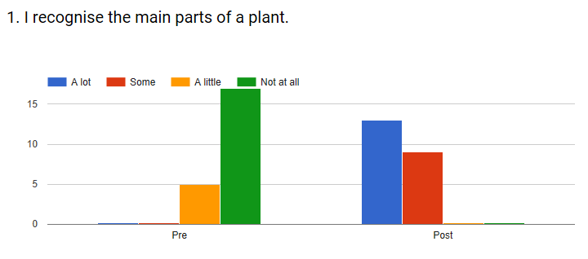
The main parts of a plant were recognised only “a little” by 22,7% of the students all the others didn’t recognise. At the end of the lesson all the students recognised the main parts of a plant “a lot” or “a little”.
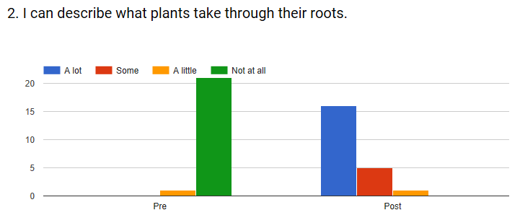
We can see that only one student can describe a little of what plants take through their roots in the pre-test. In the post test no one self-assessed with “not at all” and only one student evaluated with “a little”.
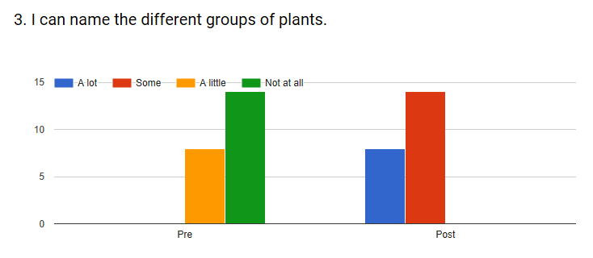
At the beginning, 63,6% of the students don’t know how to name the different groups of plants. At the end we can see that all the students know a lot or some.
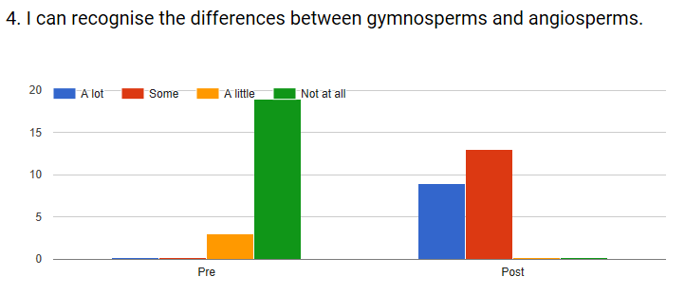
We can see that only two students know the differences between gymnosperms and angiosperms in the pre-test. After the lesson no students self-assessed with “not at all” or “a little”; all recognise “a lot” or “some”.

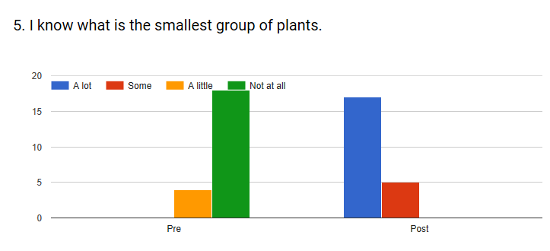
Before the lesson 81,8% of the students doesn’t know what the smallest group of plants is, but at the end 77,3% knows “a lot” and no one “a little” or “not at all”.

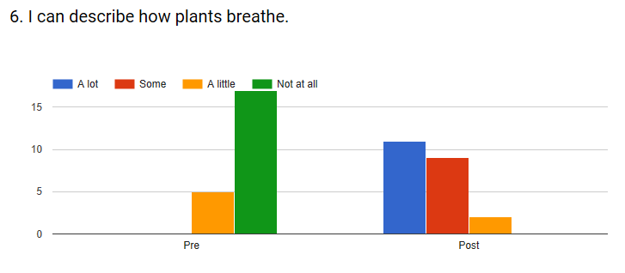
Before the lesson 81,8% of the students can’t describe how plants breath. At the end we can see 91% of the students can describe how plants breath “some” or “a lot”.
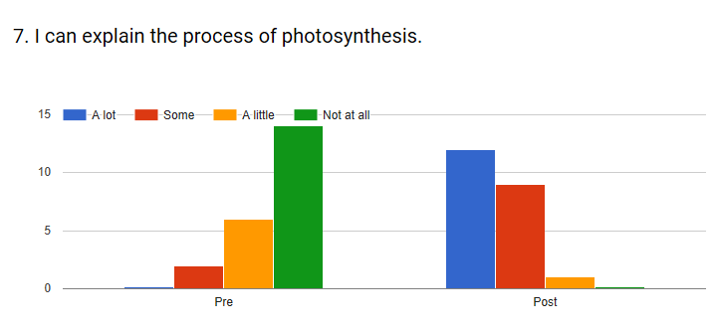
In the pre-test 63,6% of the students can’t explain the photosynthesis process but in the post-test 59,1% can explain “a lot”, 36,4% “some” and only one student can explain “a little”.
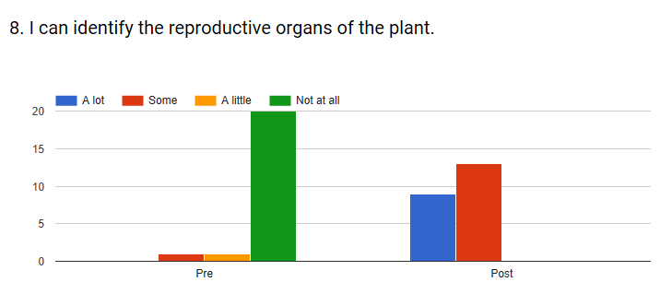
Before the lesson only 9% of the students can identify “some” or “a little” the reproductive organs of a plant. After the lesson all the students can identify “a lot” or “some”.
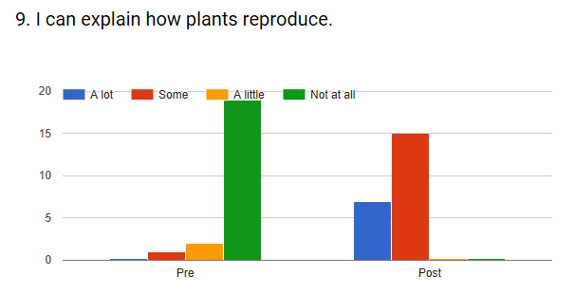
Before the lesson 86,4% of the students can’t explain how plants reproduce. After the lesson 68,2%, pupils self-assessed with “some” and 31,8% with “a lot”.

October 2018

