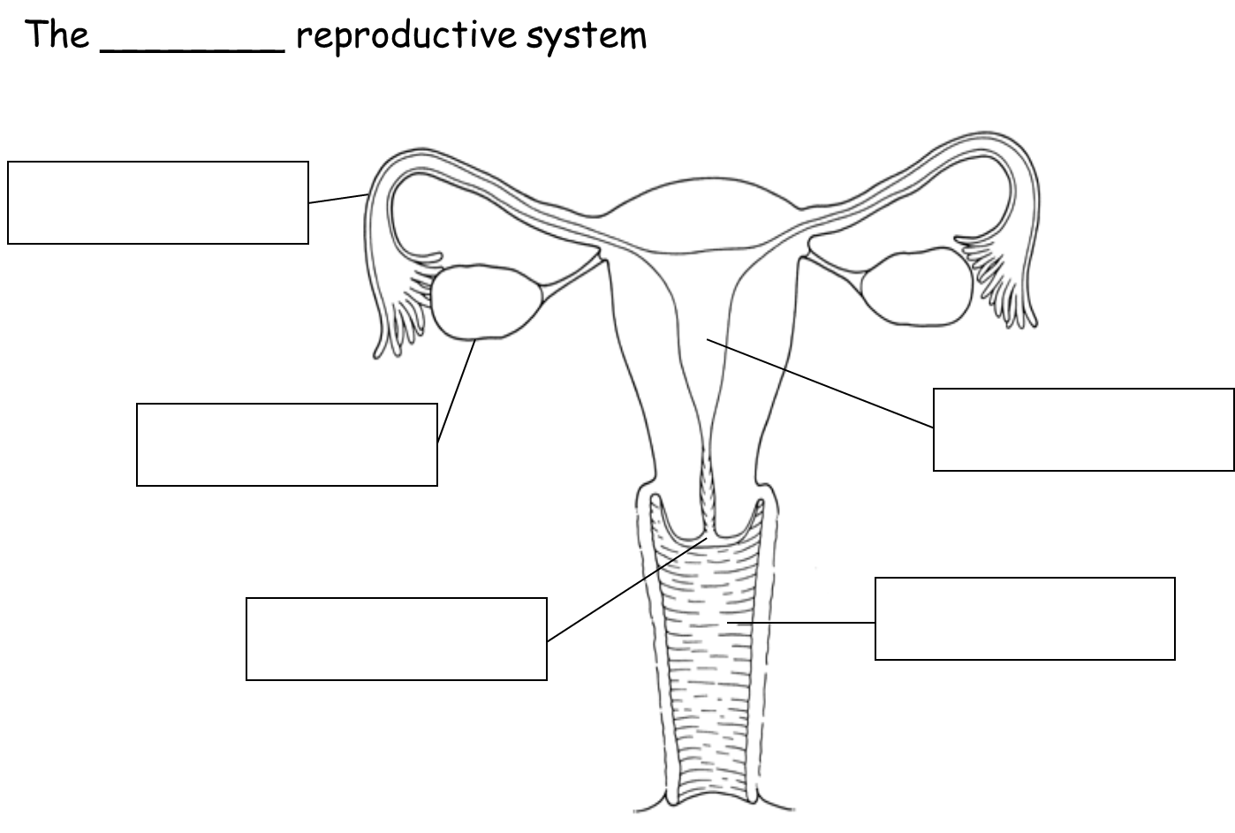
Complete the Human Reproductive System worksheet

