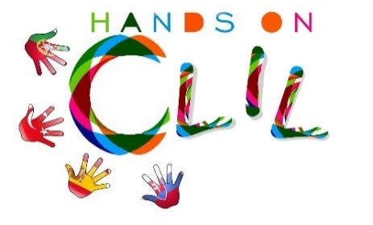
SCHOOL LOGO

CLIL LESSON PLAN
CLIL PATHWAY: SCIENCE | LEVEL: 1st year / Primary
CLIL MODULE: The Seasons | CLIL TOPIC: Winter
LESSON: 2 | TIME: 90 m
TEACHING AIMS | MATERIALS
- identify the four seasons;  - raise a discussion on the different seasons.  - describe different events that happen in each season. | - Flashcards for winter  - Winter Bingo templates  - Dice  - Song “I’m a little snowman”  - Whiteboard and projector  - Coloured pencils  - Scissors
LEARNING OUTCOMES - 4Cs
CONTENT | COGNITION
- to develop and practise words and simple sentences connected to winter;  - express likes and dislikes; | - memorize vocabulary  - identify winter items  - understand the changes in nature related to the seasons
CULTURE | COMMUNICATION
- understand different events/traditions that happen in each season; | Language Function: Listening / Speaking / Spoken Interaction  Vocabulary: days of the week; months; numbers; weather; colours; winter; snowman; cold; snow; scarf; boots; coat; umbrella; gloves; hat; nose; little; buttons; eyes, nose; dice.  Verb(s): imperative for instructions and present simple - to be/ to have got/ to listen/ to like/ to look/ to celebrate/ to build/ to draw/ to play/ to put/ to colour/ to cut out/ to dance/ to sing/ to close and open/  Language structure: What’s the weather like? / What day is it today? /What’s the temperature? / What’s this? This is…/ Let’s…/ Do you like…? Yes, No…/ What colour is it? / Is it big/small…?/ Roll the dice!/ Draw the…/ Colour the…/ Cut out the…/ I have got…/ Display the cards/ Turn the card upside down/…
ACTIVITIES
Step 1 – tune pupils into English with the morning classroom routine – the class helper will set the classroom date, weather and time charts with the help of the classmates (video Emília);
Step 2 – To help pupils understand what the lesson is about – the teacher talks with the children about the weather changes, the type of clothes everybody is wearing and leads the class into the conclusion that it is Winter;
Step 3 – The teacher presents, one by one, flashcards about things in Winter and asks the children to name them in Portuguese or in English. Then she displays them again and says the words for learners to repeat in chorus. They play a memory game with the flashcards (the children memorize the positions of the flashcards, they close their eyes, the teacher takes one of the flashcards out, they open their eyes and a volunteer says the names of the items including the one missing, the game continues until there are no more flashcards displayed). The discussion continues with likes and dislikes about winter, including the Christmas festivity proximity.
Step 4 – Predicting that the snowman will be one the favourite items about winter, she asks the children to describe a snowman and she draws one on the board according to the learners’ ideas. Following, she asks the students to listen to the snowman song, then they learn the song and perform a choreography with the help of the teacher;
Step 5 – Following the song the teacher shows the children a new game “The snowman dice game” and they play it;
Step 6 – To check the children’s progress, the teacher asks the students if they like playing Bingo and suggests that they prepare their class game, “Winter Bingo” and then play it. She hands out templates of the game, the children colour them, cut them out and then play.
Step 7 – To end lesson according to the end of the class routine.

EVALUATION
- Immediate feedback after oral classroom report

Author | School: Mrs Emília Queirós/ Mrs Olga Susana
EB1 da Barroca
2017/2019

