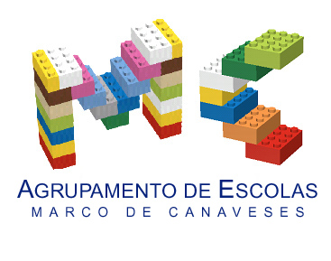

CLIL LESSON PLAN
CLIL PATHWAY: SCIENCE | LEVEL: 6th grade
CLIL MODULE: The amazing World of Plants | CLIL TOPIC: How do plants make their food
LESSON: 2 & 3 | TIME: 90’
TEACHING AIMS | MATERIALS
- To describe the phenomena of transpiration, photosynthesis and cellular respiration  - To understand the relationship between light and photosynthesis  - To understand the process of photosynthesis | - PPT on Plants Photosynthesis  - Worksheet with the phenomena of transpiration, photosynthesis and cellular respiration  - Worksheet to order the process of photosynthesis  - Infographic describing the phenomena of transpiration, photosynthesis and cellular respiration
LEARNING OUTCOMES - 4Cs
CONTENT | COGNITION
- The process of photosynthesis  - The phenomena of transpiration, photosynthesis and cellular respiration | - Understand the phenomena of transpiration, photosynthesis and cellular respiration  - Use prediction to state what plants need to grow into a healthy plant and what is going to happen to a plant in different situations  - Use deduction to confirm the above  - Synthesize new knowledge by explaining the processes related to plants by means of an Infographic creation
CULTURE | COMMUNICATION
- How to take care of plants and why that is important  - How to be responsible and accurate in carrying on an investigation | Language Function: The phenomena of transpiration, photosynthesis and cellular respiration  Vocabulary: oxygen, autotrophs, sunlight, carbon dioxide, water and minerals, raw sap, photosynthesis, air, nutrients, chlorophyll, breathe, breathing, respiration, cellular, glycose, light …  Verb(s): present simple/ 3rd person singular: plants take/ capture/ make/ release  Language structure:  - I think …. is a ….  - Picture A is a …. because ….  - Wh questions: Why… because/ What…  - Language to express their predictions
ACTIVITIES
Step 1 – To tune pupils into English
- Teacher /pupils greet each other in English.
- Pupils open the lesson /write the date on their Science notebooks in English.

Step 2 – Talking about how plants make their food
- Teacher starts by asking what does a plant need to grow? and asks pupils to draw on their notebooks a diagram of what a plant needs. Asks pupils to share and compare their diagrams with their partner.

Step 3 – The phenomena of transpiration, photosynthesis and cellular respiration
- Teacher hands out a copy of the Infographic she made on the phenomena of transpiration, photosynthesis and cellular respiration and asks pupils to compare it with the one produced by them and add to their diagram the missing and relevant information, according to them.

Step 4 – Applying knowledge
- The teacher delivers a handout where pupils have to order the photosynthesis process and complete a gap filling text with the phenomena of transpiration, photosynthesis and cellular respiration.

Step 5 – To end lesson
- Students are invited to create their own Infographic on the contents taught so far about Plants.
EVALUATION
- Peer assessment of the infographic
- Classroom observation

Author | School: Fernanda Monteiro & Helena Serdoura
Agrupamento de Escolas de Marco de Canaveses
Abril 2018

