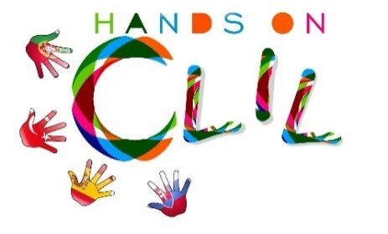
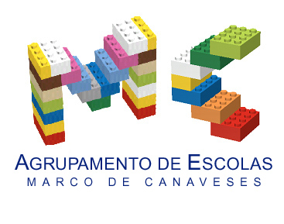

CLIL LESSON PLAN
CLIL PATHWAY: PHYSICAL EDUCATION | LEVEL: Grade 6
CLIL MODULE: Summer Olympic Sports | CLIL TOPIC: Badminton
LESSON: 1 | TIME: 45´
TEACHING AIMS | MATERIALS
- To be able to perform the skill with maximum efficiency in terms of fluency, time and energy  - To develop the motor skills needed to perform/ play badminton appropriately | - Rackets  - Shuttlecocks  - Net
LEARNING OUTCOMES - 4Cs
CONTENT | COGNITION
- Be able to perform specific badminton related skills, serving, forehand and backhand shots  -Be able to demonstrate proper footwork that correspond to specific shots  - Be able to show basic coordination, movement, stability and balance skills | - Understand and apply rules  - Recognise basic strategies/tactics for singles and doubles play  - Be able to evaluate specific skills and give feedback to other students  - Anticipation -Reacting to opponents shot  - Solve problems and make correct decisions
CULTURE | COMMUNICATION
- Be able to display sportsmanship and values of fair play  -Be able to communicate with other students  -Learn to be a good team player  -Display a positive attitude | Language Function:  Vocabulary:  Body parts: foot/ feet, legs, knee, arms, thumb, index, middle finger, …  Badminton material: racquets, shuttlecock, net, grip of the racket,  Verb(s): imperative: lean, bend, hold/ to hit, to throw  Language structure: to hit across, pick up, can you show me how…
ACTIVITIES
Step 1 – To tune pupils into English
The teacher greets pupils in English and informs they are going to start a new content based on 3 key words – racquets, shuttlecock and net brainstorming what sport are they going to talk about. After having pupils guessing BADMINTON the teacher asks them to fill in a pre-test to see how much they know about this sport.

Step 2 – To help pupils understand what the lesson is about
The teacher does a brief introduction explaining that Badminton has become an Olympic Sport since 1992 and it was rediscovered by the English at the of 19th century. Badminton is a racquet sport played using racquets to hit a shuttlecock across a net. It is played in “singles” (one player per side) or “doubles” (two players per side).

Step 3 – Demonstrating basic Badminton techniques

PLAYERS POSITION
The teacher demonstrates using her own body what is the correct player’s posture. As she explains and demonstrates it, the whole class, in circle, mimes her actions:
- Feet apart and side-by-side
- Both legs bent at the knee
- Body weight well distributed over the feet
- Lean your body forward slightly
- Bend both arms in from of your body
- Hold the racquet to head’s position

HOLDING A RACQUET
The teacher distributes a racquet to each student and explains how to hold it properly:
- Needs to stay firm in your hand
- Hold the grip of the racquet as if you were shaking someone’s hand
- Use ONLY your thumb, index, and middle finger to control the racquet
- The thumb and the index finger form a V
- Your last 2 fingers should rest comfortably on the badminton grip to balance the weight of the racquet

HOLDING A SHUTTLECOCK
It is now time to show how to hold the shuttlecock. The teacher explains and shows that pupils have to:
- Hold the shuttlecock between the feathers and the head, between the index finger and thumb
- Use these fingers to angle the shuttlecock so that it points towards your badminton racquet

Step 4 – Practice time – hitting technique
Pupils learn how to hold the racquet and the shuttlecock starting to do some hitting’s. For the hitting technique the teacher demonstrates to pupils that when hitting the shuttlecock, it is important that they do not only use their forearm but the whole arm and shoulder.
The main part of the lesson is dedicated to technical exercises with racket and shuttle or fun/competitive games designed to reinforce the teaching points.

Step 6 – To end lesson
Summarise the main teaching points and cool down. Pupils tidy-up before leaving the class to the changing room.

EVALUATION
- Classroom observation
- Completion of post-test
BIBLIOGRAPHY
In https://sites.google.com/site/bilingualphysicaleducation/pe-teachers-support-area (seen on 1st March 2018)
In https://www.badmintonbible.com/shots/serve-and-return/serve-return/basics/stance (seen on 1st March 2018)
In https://www.masterbadminton.com/badminton-gripping-technique.html (seen on 1st March 2018)

Author | School: Agrupamento de Escolas de Marco de Canaveses
Teresa Silva/ Helena Serdoura
Março 2018

