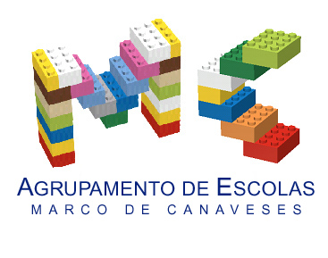

CLIL LESSON PLAN
CLIL PATHWAY: SCIENCE | LEVEL: Pre-school
CLIL MODULE: Healthy diet | CLIL TOPIC: Beans, how delicious!
LESSON: 3 | TIME: 45m
TEACHING AIMS | MATERIALS
- raise awareness on the importance of legumes for a good health;  - learn new vocabulary related to healthy food;  - understand how plants grow and survive; | - white sheets of paper  - pencils  - spoons  - small bags  - legumes
LEARNING OUTCOMES - 4Cs
CONTENT | COGNITION
- name and describe (size and colour) selected legumes;  - name healthy ingredients;  - meals of the day;  - observe plant growth | - classify types of food  - recognize different types of legumes  - identify healthy recipes  - exemplify healthy recipes  - understand the basic plant growth needs
CULTURE | COMMUNICATION
- understand the importance of a healthy diet;  - learn how to identify a healthy meal | Language Function: Listening / Speaking / Spoken Interaction  Vocabulary: days of the week; months; numbers; weather/ vocabulary related to food such as legumes, vegetables, fruit, meat, fish or others; healthy/unhealthy food; diet; ingredient; menu; meal; lunch; dinner; cotton balls, yogurt container, water, window, light, growth,…  Verb(s): imperative for instructions and present simple - to be/ to have got/ to listen/to prepare/ to eat/ to like/ to look/ to sell / to climb/ to run /to grow/ to put/…  Language structure: What’s the weather like? / What day is it today? /What’s the temperature?/ What time is it? What’s this? This is…/ Let’s…/ Do you like…? Yes, No…/ Is it…? Yes, No/ What is happening? It is ok! It’s growing! It’s dying!
ACTIVITIES
Step 1 – To tune pupils into English the teacher acts according to the usual morning routine (check lesson plan 1);
Step 2 – To help pupils understand what the lesson is about the teacher introduces them a guest to, tells them that she is a nutritionist and explains what that is;
Step 3 – The nutritionist talks with the children about a healthy diet and the importance of legumes. Together they will write a menu, with ingredients and amounts, for a whole week that includes beans, that the kids and their families would prepare at home (picture of the spoons);
Step 4 – the teacher suggests that the children show the beans germination (pictures) to their guest and children will notice that some of the bean seeds had died (picture of the dead beans). They will reflect upon what might have happened – lack of water or light;
Step 5 – End of the lesson according to the end of the morning routine – the teacher rings the bell and the class goes to the toilet to prepare for lunch.

EVALUATION
- Immediate feedback after oral classroom report

Author | School: Júlia Soaress/ Olga Susana
JI Ramalhais | 2017/2019

