PRE /POST-TEST in SCIENCE – The Human Reproductive System
GROUP OF STUDENTS: 6TH Grade - 21 students

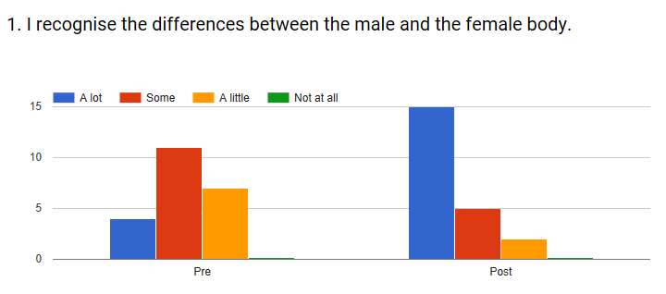
We can see that a lot of students recognise the differences between male and female body after the lesson, 68% to 18,2% at the beginning.
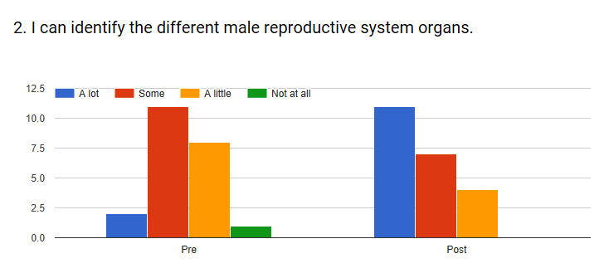
At the end of the lesson, 86,4% of the students can identify a lot or some of the male reproductive system organs.
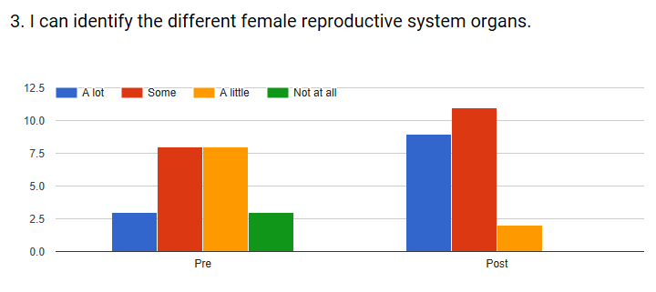
At the end of the lesson, 86,4% of the students can identify a lot or some of the female reproductive system organs. At the beginning 50% identified a little or not at all and at the end only 1% self-assessed with “a little”.
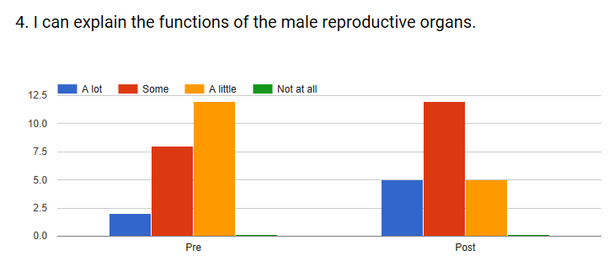
Before the lesson, 45,5% of the students can explain a lot or some of the functions of the male reproductive organs; at the end the percentage rose to 77,3% while some fell to 22,3%.

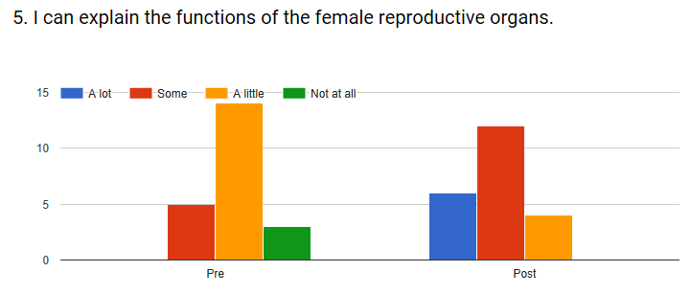
Before the lesson, 22,7% of the students can explain some functions of the female reproductive organs and 63,6% can explain “a little”; at the end the percentage rose to 54,5% of “some” and 27,3% of “a lot”, while “not at all” fell to 0% and “a little” to 18,2%.

June 2018

