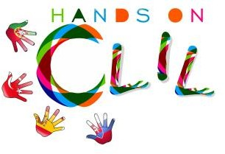

PRE /POST-TEST in SCIENCE – Human Body
The aim of this questionnaire (Knowledge Assessment Questionnaire) is to assess the impact of Science Content Learning by means of bilingual methodology within Primary Education.

1. I recognize the different organs of our different body systems.
Pre -  A lot  Some | - A little | - Not at all
Post -  A lot  Some | - A little | - Not at all

2. I can describe process of respiration/breathing.

 | Pre -  A lot  Some | - A little | - Not at all
 | Post -  A lot  Some | - A little | - Not at all

- I can describe the process of the circulatory system.
Pre -  A lot  Some  A little  Not at all
Post -  A lot  Some  A little  Not at all

- I can identify the organs of the excretory system.

Pre -  A lot  Some  A little  Not at all
Post -  A lot  Some  A little  Not at all

- I can explain the process of the digestive system.
Pre -  A lot  Some  A little  Not at all
Post -  A lot  Some  A little  Not at all

