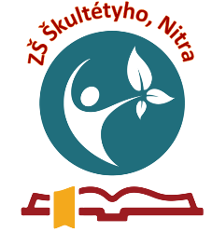
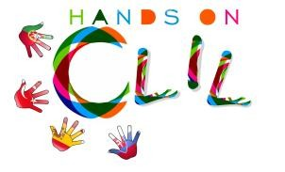
CLIL LESSON PLAN
CLIL PATHWAY: PHYSICAL EDUCATION | LEVEL: Primary education  5th grade
CLIL MODULE: The Amazing World of Football | CLIL TOPIC: Passing ball
LESSON: 2 | TIME: 45min
TEACHING AIMS | MATERIALS
- to understand instructions  - to understand how particular games are important for main play as football it is.  - to understand individual aim for the goals  - to show particular steps correctly  -to explain importance of correct movement of all body during the game  - to automatize precision of passing ball  - to form respect in collective activities | - cones  - balls  - whistle  - gym/pitch  - audio-visual material  - distinguish T-shirts  - stop watch
LEARNING OUTCOMES - 4Cs
CONTENT | COGNITION
- to understand instructions  - to compete individual or collective development of passing ball skills, control ball skills | - to identify and sort movements  - to classify movements of lower and upper body parts  - to organise warm-up activity  - to recognise and analyse incorrect (wrong) movements
CULTURE | COMMUNICATION
- to recognise importance of collective competition games  - to lead pupils to fair play  - to lead pupils to respect the team and opponents | Language Function:  - talking about sport  Vocabulary:  - ball  - circle  - stop watch  - kick off  - out  - in  - football pitch  - left and right  - rule  - hand  Verb(s):  -start, stop, have to, need, run, crouch, lead, go ahead, follow, listen, push, go back, come, watch out, move, pass, repeat, kick, bend  Language structure:  I have to follow rules.  I can push the ball.  I can pass the ball.  I can stop the ball.
ACTIVITIES
Step 1 – To tune pupils into English
Teacher/pupils greet each other in English.
Pupils open the lesson/ tell the teacher how many pupils are ready for the lesson.
Step 2 – To help pupils understand what the lesson is about
Teacher tells pupils what they are going to do. Talented pupils will perform exposition of correct ball passing.
Step 3 – Warm-up
Game:
Form:
- pupils make a circle
- straddle legs
- bend their bodies towards to the middle of the circle
Aids: a ball
Rules:
Students must push the ball inside the circle
The aim is to push the ball between somebodies´ legs (it´s a goal)
- When player gets two goals, he/she has to turn back in to the circle and plays the game in this more difficult position.
- When gets the third goal, he/she is out of the game.
- Winners are the two last players.

Step 4 –Development of passing ball skills
Pupils make pairs and they practice passes according to following instructions:
- Passes by instep with stopping the ball on the place 10 times
- Passes by instep without stopping the ball on the place 10 times
- Passes by direct instep with stopping the ball on the place 10 times
- Passing by direct instep without stopping the ball on the place 10 times
Step 5 – Practicing passes in game
Game BAGO (ball and go):
Form:
- Pupils are in a circle, one stands in the middle of the circle
Aids:
- A ball
Rules:
- Pupils in a circle have to pass the ball as many times as they can.
- The aim of the middle player is to interrupt the passing ball line.

Step 6 – competition of the passing the ball
Pupils do passes towards the wall/boards of the gym
Their aim is to get as many passes as they can per 1 minute
Step 7 – To end lesson
Pupils tidy up and say the farewells in English.
EVALUATION
- Immediate feedback after oral classroom report
- Completion of post-test

