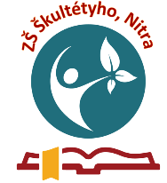
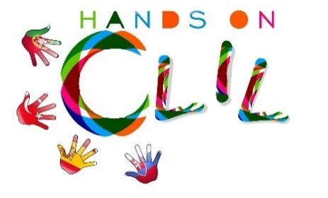

CLIL LESSON PLAN
CLIL PATHWAY: ARTS & CRAFTS | LEVEL: Primary education  3th grade
CLIL MODULE: The Amazing World of ART | CLIL TOPIC: Blueprint
LESSON: 1 | TIME: 90 min
TEACHING AIMS | MATERIALS
- to understand instructions  - to recognise blueprint as a traditional art technic  - to introduce blue print as a decoration technic used in past in fabric manufacturing | - flash cards  - audio-visual material  - bowls for colours  - paint brushes  - paint rollers  - templates  - paper  - table spoons
LEARNING OUTCOMES - 4Cs
CONTENT | COGNITION
- to understand instructions  - to complete individual development of creating own blueprints decorations  - to recognise blueprint as a type of art | - to follow the process of work  - to keep work place clean and organised  - to create own blueprint decoration  - to evaluate artistic outcome of own work
CULTURE | COMMUNICATION
- to recognise importance of keeping traditional art technics | Language Function:  -talking about traditional art  Vocabulary:  - Colours  - Paint brush  - Paint roller  - Table spoon  - Template  - Paper  - Fabric  Verb(s):  -to cover, stir, push, print, dry, clean  Language structure:  I can follow instructions.  Allow to dry.  Use the paint brush, (paint roller, template)  Tidy up your table.
ACTIVITIES
Step 1 – To tune pupils into English
Teacher/pupils greet each other in English.
Step 2 – To help pupils understand what the lesson is about
Teacher tells pupils what they are going to do. They watch short documentary about using blueprint for decorating fabric in past by folk people.
Step 3 – Warm-up
Game: What is missing.
Pupils sit on their chairs.
- The flash cards with different colours are displayed in front of them.
- Pupils sit on their chairs with eyes covered, during this time teacher takes one of the cards.
- Pupils open their eyes and guess which one it missing.
Step 4 – Introducing the world blueprint
Teacher writes the word blueprint on the board. Covers the part “blue” with flash card from previous game. Asks pupils if colour is used instead of word blue correct. Repeats the action few times with different colours. Children say the name of colour. Uses blue colour as the last one.
Step 5 – Introduce process of creating own blueprints
- Put the white colour into the bowl.
- Stir the colour over the template.
- Put the blue paper on the template ant push it with the table-spoon all over.
- Uncover the paper carefully and allow to dry.
Step 6 – Independent work
-Pupils make their ow blueprints according to instructions.
Step 7 – Exhibition
- Pupils exhibit their blueprints on display.
- They evaluate artistic value of their own work.
Step 8 – To end lesson
Pupils tidy up and say the farewells in English.
EVALUATION
- Immediate feedback after oral classroom report
- Completion of post-test

Author | School: ZŠ Škultétyho 1, Nitra, October 2018

