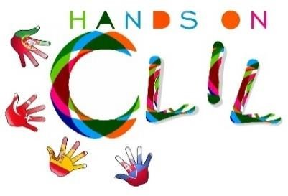

CLIL LESSON PLAN
CLIL PATHWAY: SCIENCE | LEVEL: 6th grade
CLIL MODULE: Our body | CLIL TOPIC: Human Body
LESSON: 1 | TIME: 50’
TEACHING AIMS | MATERIALS
- To identify and name the different organs of the circulatory system and I can describe the process of circulation.  - To identify and name the different organs of the Respiratory system and  - To describe the process of respiration/breathing.  - To identify and name the organs of the excretory system.  - Explain the function of it and understand and explain how it works.  - To identify and name the different organs of the digestive system and I can describe the process of circulation.  - To learn about other complex systems in our body and how they work. | - Pre text  - Brainstorming  - Body systems worksheet.
LEARNING OUTCOMES - 4Cs
CONTENT | COGNITION
- To name and identify the different organs of our different body systems.  - To connect different systems into each other. | - Name and identify the different organs of the different body systems.  - Understanding and learning the different functions of each organ in every system.  - Connection between systems.
CULTURE | COMMUNICATION
- Developing awareness about the importance of taking care of our body.  - Establishing relations between life style and body function.  - To be conscious of the importance of healthy/unhealthy habits and their consequences. | Language Function:  - Talking about organs and their functions to develop awareness of our own body.  - Systems involved:  - Circulatory system.  - Digestive system.  - Respiratory system.  - Excretory system.  Vocabulary:  Digestive process, digestive tube, helper glands, digestive juices, digestion, mouth, salivary glands, saliva, bolus, pharynx, oesophagus, stomach, gastric juices, small intestine, intestinal juice, pancreatic juice, bile, liver, chyle, absorption, villi., capillaries, circulation, veins, heart, arteries, blood cells, plasma, red blood cells, White blood cells, platelets, vena cava, aorta, carbon dioxide, lungs, thoracic cavity, gas exchange, pharynx, trachea, bronchi, alveoli, bronchioles, larynx, pulmonary arteries, pulmonary veins, kidneys, ureters, bladder, urethra, sweat glands, pore.  Language structure:  - Present Simple  - Wh questions: Who, whose, what, which, where, when, why and how.

ACTIVITIES
Lesson 1:

Step 1 – To tune pupils into English
- Teacher /pupils greet each other in English.
- The teacher says the learning intention of the lesson and writes it in the whiteboard.

Step 2- To help pupils understand what the lesson is about and fill in a pre-test
- Teacher tells pupils what they are going to do in the class.
- The students fill in a pre-test.

Step 3 – Checking pre-test’s answers.
- Evaluation and comparison of the answers from the pre-test, and evaluation of the previous knowledge of the topic.

Step 4 - Brainstorming
- Teacher asks questions to the students about what they can remember about our body.
- The students to build a mind map about the Human body.

Step 5 - Worksheet
- The students work in teams of four using 1-2-4 strategy for the reading activity.
- They have to guess which body systems are described in the diagrams.

Step 6 – Whole class reading
- All the class listen to the classmates when they read individually, and if there are dubts, they clarify them in big group.

Step 7 – Cooperative work
- In groups, students complete the matching activity.

EVALUATION
- Immediate feedback after oral classroom report.
- Checking activities in class.
- Completion of team work assessment sheet.
Author | School: Silvia Fogueda / Maria Pilar Nicolau
Ceip Puig d’en Valls
January 2019

