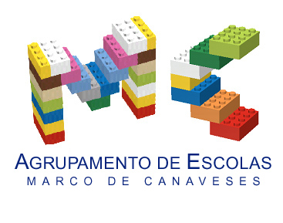

CLIL LESSON PLAN
CLIL PATHWAY: SCIENCE/ARTS &CRAFTS | LEVEL: 1st year / Primary
CLIL MODULE: The Seasons | CLIL TOPIC: Autumn
LESSON: 1 | TIME: 90 m
TEACHING AIMS | MATERIALS
- identify the four seasons;  - raise a discussion on the different seasons.  - describe different events that happen in each season. | - realia: baskets, apples, chestnuts, husks, walnuts, persimmons, corn, leaves and grapes;  - word cards with vocabulary and colours related to Autumn  - puppet characters Lucy and John  - chestnuts, apples, walnuts, persimmons and grapes templates to colour  - brown fabric
LEARNING OUTCOMES - 4Cs
CONTENT | COGNITION
- to develop and practise words connected to autumn  - name and describe (size and colour) selected fruits  - express likes and dislikes | - classify types of fruits  - identify different colours  - understand the changes in nature related to the seasons
CULTURE | COMMUNICATION
- understand that most of food habits are related to what can be harvested in each season;  - understand different events that happen in each season. | Language Function: Listening / Speaking / Spoken Interaction  Vocabulary: days of the week; months; numbers; weather; basket, apple, chestnut, husk, walnut, persimmon, corn, leaf/leaves; grapes; colours  Verb(s): imperative for instructions and present simple - to be/ to have got/ to listen/ to eat/ to like/ to look/ to grow/ to put/…  Language structure: What’s the weather like? / What day is it today? /What’s the temperature? / What time is it? What’s this? This is…/ Let’s…/ Do you like…? Yes, No…/ What colour is it? / Is it big/small…?
ACTIVITIES
Step 1 – tune pupils into English with the morning classroom routine – the class helper will set the classroom date, weather and time charts with the help of the classmates (video);
Step 2 – to help pupils understand what the lesson is about, the teacher talks with the children about Autumn and the Autumn baskets, that she previously had asked their parents to bring to school, and asks the leaners to name the elements in those baskets in Portuguese or in English. The discussion continues with festivities related do Autumn that the community celebrates like the “corn harvest” and “Magusto”;
Step 3 - the teacher takes one of the baskets, says the names of the fruits in English and the students listen and repeat. The teacher continues exploring the fruits in the basket with the students: (“Look! What’s this? This is an apple. Is this an apple? Yes/No. What colour is the apple? It’s yellow…I love apples. Do you like apples?”).
Step 4 – the teacher asks the children if they would like to build an autumn panel outside the classroom and divides the class into groups of five. Each group will choose what to do to help build the panel: cut out and colour the apples/ walnuts/persimmons/ grapes/chestnuts; cut out the tree, collect leaves in the playground… The teacher organizes the tasks and the children start working.
Step 5 – when all the work is finished each group starts setting the panel.
Step 6 – To end lesson according to the class routine.

EVALUATION
- Immediate feedback after oral classroom report

Author | School: Mrs Emília Queirós/ Mrs Olga Susana
EB1 da Barroca
2017/2019

