SUPER SCIENTITST: EXCRETORY SYSTEM TEST.  NAME: .....................................................................................................................  DATE: ........................................................................................................................ | SCIENCE:

1.- TEST. Answer the following questions.
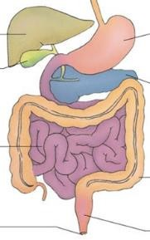
- MATCH ( ) the functions with the organs/systems:

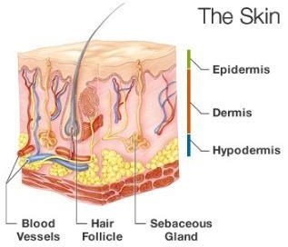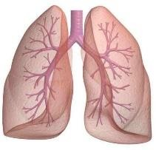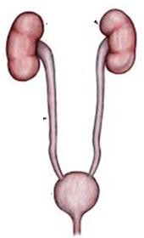To REMOVE harmful GASES when * DIGESTIVE SYSTEM we exhale (carbon dioxide).

  - To EXPEL the UNDIGESTED FOOD * URINARY SYSTEM our body does NOT need.

  - To REMOVE dead cells, salt and * LUNGS unused water from SWEATING.

  - To REMOVE WASTE and keep our * SKIN
body CLEAN.

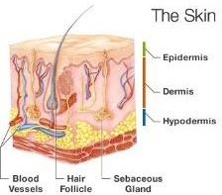
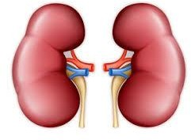
- Which is NOT part of the EXCRETORY SYSTEM?

Skin Kidney

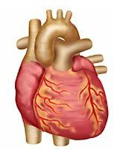
Heart Lungs

- The main function of the URINARY SYSTEM is to:

- A) REMOVE waste and extra fluid from our body
- B) KEEP waste in the body
- C) MAKE you poop

- What very important JOB do KIDNEYS have?

- A) To REABSORB useful nutrients
- B) To FILTER waste out of the BLOOD
- C) ALL of the above

- Kidney SHAPE is like
Apples Beans Oranges
- How many KIDNEYS a human has?
2
3
4

- Urine is carried from the KIDNEYS to the BLADDER by two thin TUBES called:

- A) Ureters
- B) Tubulars
- C) Capillaries

- URINE IS STORED here until you’re ready to pee:

- A) Kidneys
- B) Bladder
- C) The garage

- URINE EXITS THE BLADDER and the body through a TUBE called the:

- A) Ureter
- B) Urinary tract
- C) Urethra

- If your pee is LIGHT YELLOW, it means that:

- A) You ARE hydrated
- B) You are NOT hydrated
- C) You are NOT getting enough sun

- Urine is made of:

- A) Water and nutrients
- B) Water and lemonade
- C) Water and waste products

2. Label the diagram of the EXCRETORY SYSTEM.

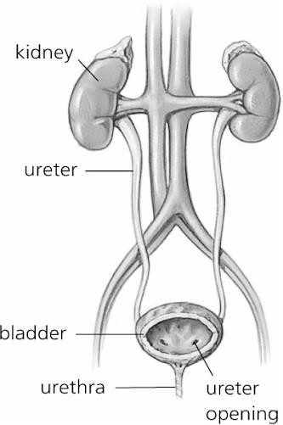
U
B
U
K

