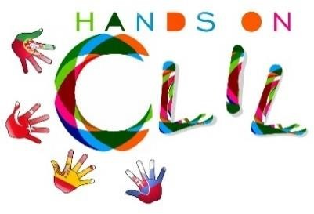

CLIL LESSON PLAN
CLIL PATHWAY: SCIENCE | LEVEL: 6th grade
CLIL MODULE: Our body | CLIL TOPIC: Human Body
LESSON: 2 | TIME: 50’
TEACHING AIMS | MATERIALS
- To identify and name the different organs of the circulatory system and I can describe the process of circulation.  - To identify and name the different organs of the Respiratory system and  - To describe the process of respiration/breathing.  - To identify and name the organs of the excretory system.  - Explain the function of it and understand and explain how it works.  - To identify and name the different organs of the digestive system and I can describe the process of circulation.  - To learn about other complex systems in our body and how they work.  - To be able to talk and build up sentences in English about the different body systems and their functions.  - To work autonomously and pro-actively, developing collaboratively group strategies (in pairs or little groups) | - Brainstorming  - Body systems worksheet.  - Amazing Science Books  - Arts& Crafts materials and supplies.  - Laptops and tablets.
LEARNING OUTCOMES - 4Cs
CONTENT | COGNITION
- To name and identify the different organs of our different body systems.  - To explain the function every body system has to make our body work.  - To improve knowledge about other complex systems in our body.  - To connect different systems into each other. | - Name and identify the different organs of the different body systems.  - Understanding and learning the different functions of each organ in every system.  - Connection between systems.  - Selecting and organising specific information.  - Analysing it and report it back to the class.
CULTURE | COMMUNICATION
- Developing awareness about the importance of taking care of our body.  - Establishing relations between life style and body function.  - To be conscious of the importance of healthy/unhealthy habits and their consequences. | Language Function:  - Talking about organs and their functions to develop awareness of our own body.  - Systems involved:  - Circulatory system.  - Digestive system.  - Respiratory system.  - Excretory system.  Vocabulary:  Digestive process, digestive tube, helper glands, digestive juices, digestion, mouth, salivary glands, saliva, bolus, pharynx, oesophagus, stomach, gastric juices, small intestine, intestinal juice, pancreatic juice, bile, liver, chyle, absorption, villi., capillaries, circulation, veins, heart, arteries, blood cells, plasma, red blood cells, White blood cells, platelets, vena cava, aorta, carbon dioxide, lungs, thoracic cavity, gas exchange, pharynx, trachea, bronchi, alveoli, bronchioles, larynx, pulmonary arteries, pulmonary veins, kidneys, ureters, bladder, urethra, sweat glands, pore.  Language structure:  - Present Simple  - Wh questions: Who, whose, what, which, where, when, why and how.

ACTIVITIES
Step 1 – To tune pupils into English
- Teacher /pupils greet each other in English.
- The teacher says the learning intention of the lesson and writes it in the whiteboard.

Step 2 - To help pupils understand what the lesson is about
- Teacher tells pupils what they are going to do in the class.
- The students have to prepare in teams of 4 a project about the human body.
- They can choose more than one.
- They have to be original because they have worked the human body two years ago.

Step 3 - Project
- The teacher asks the students what they are going to do in their project.
- The students share their ideas with the teacher.

Step 4 – Investigation
- The students use laptops, tablets, science books...to investigate the contents.

EVALUATION
- Immediate feedback after oral classroom report.
- Checking the project process.
- Completion of team work assessment sheet.
Author | School: Silvia Fogueda / Maria Pilar Nicolau
Ceip Puig d’en Valls
January 2019

