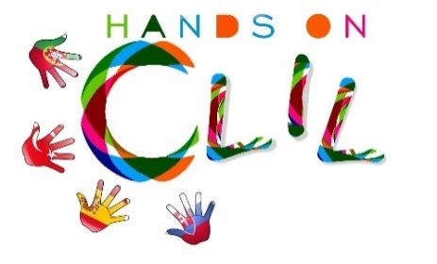
SCHOOL LOGO

CLIL LESSON PLAN
CLIL PATHWAY: ARTS & CRAFTS | LEVEL:
CLIL MODULE: The Amazing World of Traditional Arts & Crafts | CLIL TOPIC:
LESSON: | TIME:
TEACHING AIMS | MATERIALS
- | -
LEARNING OUTCOMES - 4Cs
CONTENT | COGNITION
- | -
CULTURE | COMMUNICATION
- | Language Function:  Vocabulary:  Verb(s):  Language structure:
ACTIVITIES
Step 1 – To tune pupils into English
Step 2 – To help pupils understand what the lesson is about
Step 3 –
Step 4 –
Step 5 –
Step 6 – To end lesson

EVALUATION
- Immediate feedback after oral classroom report
- Completion of post-test

Author | School:___________________________

