THE PHOTOSYNTHESIS

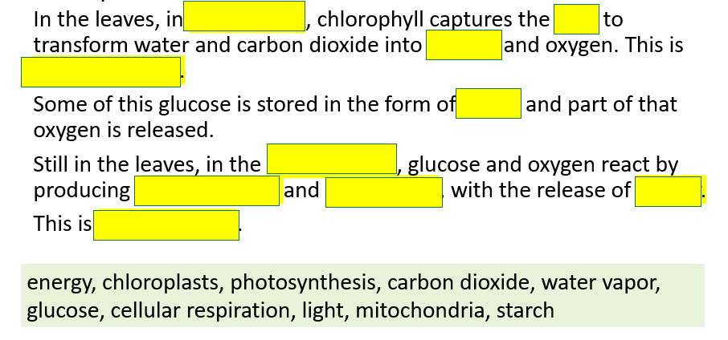
- Complete the text:

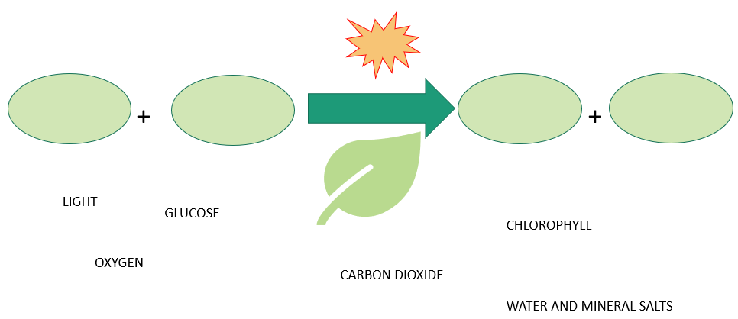
- Complete the diagram with the correct words.

